

AN EFFICIENT NOVEL APPROACH FOR PREDICTING STARTUP COMPANY SUCCESS RATES USING ADVANCED MACHINE LEARNING PARADIGMS
VenturePulse: an outcome estimate with feature drivers and comparable historical startups
A project report submitted in partial fulfilment of the requirements for the award of the degree of
BACHELOR OF TECHNOLOGY
in
COMPUTER SCIENCE AND ENGINEERING
Submitted by
Orchu Shirisha | 23K91A05H6
Mudavath Raghavendar | 23K91A05G1
Majgi Vaishnavi | 23K91A05E0
Polishetty Poojitha | 23K91A05J4
Batch C10 (CSE-C)
Under the esteemed guidance of
P Prasanna
[DESIGNATION]
DEPARTMENT OF COMPUTER SCIENCE AND ENGINEERING
[COLLEGE NAME]
[COLLEGE ADDRESS]
Academic year [ACADEMIC YEAR]

CERTIFICATE
This is to certify that the project report entitled "An Efficient Novel Approach for Predicting Startup Company Success Rates Using Advanced Machine Learning Paradigms" is a bonafide record of the work carried out by Orchu Shirisha (23K91A05H6), Mudavath Raghavendar (23K91A05G1), Majgi Vaishnavi (23K91A05E0), Polishetty Poojitha (23K91A05J4), in partial fulfilment of the requirements for the award of the degree of Bachelor of Technology in Computer Science and Engineering, during the academic year [ACADEMIC YEAR], under my supervision.

Project Guide | Head of the Department | Principal
P Prasanna | [HOD NAME] | [PRINCIPAL NAME]
[DESIGNATION] | Department of Computer Science and Engineering | [COLLEGE NAME]

External Examiner: [NAME AND SIGNATURE]
Place: [PLACE]
Date: [DATE]

DECLARATION
We hereby declare that the project report entitled "An Efficient Novel Approach for Predicting Startup Company Success Rates Using Advanced Machine Learning Paradigms", submitted to the Department of Computer Science and Engineering, [COLLEGE NAME], in partial fulfilment of the requirements for the award of the degree of Bachelor of Technology in Computer Science and Engineering, is a record of original work carried out by us under the guidance of P Prasanna, [DESIGNATION]. The results embodied in this report have not been submitted to any other university or institution for the award of any degree or diploma.

Orchu Shirisha 23K91A05H6
Mudavath Raghavendar 23K91A05G1
Majgi Vaishnavi 23K91A05E0
Polishetty Poojitha 23K91A05J4

Place: [PLACE]
Date: [DATE]

ACKNOWLEDGEMENT
We express our sincere gratitude to our project guide, P Prasanna, [DESIGNATION], for valuable guidance, encouragement and constructive suggestions throughout this project.
We thank [HOD NAME], Head of the Department of Computer Science and Engineering, for providing the facilities and support needed to complete this work, and [PRINCIPAL NAME], Principal, [COLLEGE NAME], for the encouragement given to us.
We thank the project coordinators and all faculty and staff members of the department for their help, and our families and friends for their constant support.
We also acknowledge the authors of the base paper and of the related papers cited in this report, the creators of the public startup dataset, and the developers of the open-source software used in this project (Python, scikit-learn, pandas, XGBoost, sentence-transformers, FastAPI, React and Vite).

Orchu Shirisha
Mudavath Raghavendar
Majgi Vaishnavi
Polishetty Poojitha

ABSTRACT
Most startups fail, yet early judgement of their prospects still rests largely on intuition, and a bare probability gives a founder nothing to act on. This project builds VenturePulse, a local web application that estimates whether an early-stage startup is more likely to reach SUCCESS (acquisition or IPO) or FAILURE (closure). Structured indicators (funding, rounds, milestones, relationships, sector, location) are preprocessed and, with an optional business description embedded by a sentence encoder, fused into one vector. Four classifiers are compared over five repeated stratified 80/20 splits; the best by balanced accuracy is served together with its feature drivers and a balanced table of comparable historical startups. A FastAPI service and a React interface provide the screens.
The shipped model was trained on a synthetic fallback of 1,400 startups, so its balanced accuracy of 0.749 ± 0.025 is a pipeline check only. On the real public table (922 startups, structured features only) Random Forest and XGBoost are best: balanced accuracy 0.746 ± 0.031 and 0.746 ± 0.026, ROC-AUC 0.816 ± 0.022 and 0.806 ± 0.019, against 0.709 ± 0.025 and 0.789 ± 0.017 for Logistic Regression. The accuracy of 85 to 92 % claimed by the base paper is not reproduced (best 0.775 ± 0.031). Removing four fields recorded around the outcome window lowers the Random Forest ROC-AUC to 0.719 ± 0.018. Retrieval alone matches Logistic Regression; the text channel could not be tested on real data. POST /predict takes a median of 198 ms and 51 automated checks pass.
Keywords: Startup Success Prediction, machine learning, predictive analytics, business analytics, classification algorithms, random forest, decision tree, logistic regression, feature engineering, artificial intelligence.

TABLE OF CONTENTS
CERTIFICATE i
DECLARATION ii
ACKNOWLEDGEMENT iii
ABSTRACT iv
TABLE OF CONTENTS v
LIST OF FIGURES vii
LIST OF TABLES ix
LIST OF ABBREVIATIONS x
CHAPTER 1: INTRODUCTION 1
1.1 Domain and Background 1
1.2 Motivation 2
1.3 Problem Statement 2
1.4 Need for the Project 3
1.5 Objectives 3
1.6 Scope 4
1.7 Contributions 4
1.8 Summary of the Results 5
1.9 Limitations and Assumptions 5
1.10 Organisation of the Report 6
CHAPTER 2: LITERATURE SURVEY 7
2.1 Overview 7
2.2 Analysis of the Base Paper 7
2.3 The Method Paper and the Reference Paper 9
2.4 Related Work by Theme 10
2.5 Datasets and Algorithms Used in This Project 12
2.6 Strengths and Limitations of the Surveyed Approaches 13
2.7 Further Sources Named in the Batch Survey 13
2.8 Research Gap 13
CHAPTER 3: FEASIBILITY STUDY 15
3.1 Technical Feasibility 15
3.2 Economic Feasibility 16
3.3 Operational Feasibility 16
3.4 Schedule Feasibility 16
3.5 Advantages and Constraints 17
3.6 Risk Analysis 18
3.7 Feasibility Summary 18
CHAPTER 4: SYSTEM REQUIREMENTS AND ANALYSIS 19
4.1 Existing System and Its Limitations 19
4.2 Proposed System and Its Advantages 19
4.3 Functional Requirements 20
4.4 Non-Functional Requirements 20
4.5 Hardware Requirements 21
4.6 Software Requirements 21
4.7 User Roles 22
4.8 Constraints and Assumptions 22
4.9 Data Requirements 22
4.10 Traceability of Requirements to Objectives 23
CHAPTER 5: SYSTEM DESIGN 24
5.1 Design Goals 24
5.2 System Architecture 25
5.3 High-Level Workflow 26
5.4 Data Flow Diagrams 26
5.5 UML Diagrams 28
5.6 Data Design 29
5.7 Algorithm Design 31
5.8 Module Design 32
5.9 User Interface Design 33
5.10 Design Decisions and Their Consequences 34
CHAPTER 6: METHODOLOGY AND SOFTWARE IMPLEMENTATION 35
6.1 Overall methodology 35
6.2 Dataset 36
6.3 Preprocessing and feature construction 38
6.4 Algorithm choice and justification 39
6.5 Mathematical formulation 40
6.6 Model architecture and training configuration 41
6.7 Application architecture 42
6.8 API design 43
6.9 Security and error handling 44
6.10 Installation and execution 45
CHAPTER 7: SYSTEM TESTING 46
7.1 Testing strategy 46
7.2 Unit and component testing 46
7.3 Integration testing of the API 47
7.4 Functional testing 47
7.5 Security, validation and edge-case testing 48
7.6 Performance testing 50
7.7 User interface testing 51
7.8 User acceptance testing 51
7.9 Defects and limitations found by testing 51
7.10 Limits of the testing done 52
CHAPTER 8: RESULTS AND OUTPUT SCREENS 53
8.1 What was measured, and on which data 53
8.2 Output screens 54
8.3 Model performance 59
8.4 Comparison with the base papers 66
8.5 Sample input and output 67
8.6 Success and failure analysis 68
8.7 Limitations of the results 69
8.8 Objectives against outcomes 69
CHAPTER 9: CONCLUSION 71
9.1 Summary 71
9.2 Objectives achieved 71
9.3 Key findings 71
9.4 Practical applications 72
9.5 Known limitations 72
CHAPTER 10: FUTURE SCOPE 73
10.1 Improvements to the model 73
10.2 Improvements to the application 73
10.3 Scalability and deployment 74
10.4 Further research 74
REFERENCES 75
APPENDIX A: IMPORTANT CODE 77
A.1 Fused representation and balanced retrieval (`app/ml/retrieval.py`) 77
A.2 Cleaning and the preprocessing pipeline (`app/ml/preprocessing.py`) 77
A.3 The classifiers (`app/ml/models.py`) 78
A.4 Prediction, explanation and risk label (`app/services/predictor.py`) 78
A.5 Request validation (`app/main.py`) 79
APPENDIX B: INSTALLATION AND USER GUIDE 80
B.1 Requirements and start 80
B.2 Using the screens 80
B.3 Checks and troubleshooting 81
APPENDIX C: ADDITIONAL SCREENS 82

LIST OF FIGURES
Figure 1: Class balance of the two datasets: the real table (922 startups) has SUCCESS as the majority class, the synthetic fallback (1,400) has FAILURE as the majority. 5
Figure 2: System architecture of VenturePulse: presentation, application and domain tiers over two stores. 25
Figure 3: High-level workflow: the training path (first start or scripts/train.py) and the inference path (every POST /predict). 26
Figure 4: Level 0 data flow diagram: the system as one process with three external entities. 26
Figure 5: Level 1 data flow diagram: five processes and four data stores. 27
Figure 6: Level 2 data flow diagram: the steps inside 2.0 Predict outcome and 3.0 Retrieve and explain (predict_one). 27
Figure 7: UML class diagram of the main classes and modules. 28
Figure 8: Sequence diagram of one POST /predict request, from the Analyze screen to the model and back. 28
Figure 9: Use case diagram: two actors and eight use cases of VenturePulse. 29
Figure 10: Entity-relationship diagram of the data model; the product has no SQL database. 29
Figure 11: Flowchart of the core algorithm: validation, fusion, classification, balanced retrieval and the risk label. 31
Figure 12: Evaluation protocol: (A) the study that selects the shipped model and (B) the studies on the real public table. 32
Figure 13: Sign-in screen with the demo account. 34
Figure 14: Analyze screen with a submitted example filled in. 34
Figure 15: Evaluation protocol used for model selection and for the reported metrics. 36
Figure 16: Median and 95th-percentile latency of the endpoints (milliseconds). 50
Figure 17: Class balance of the two tables: success is the minority class in the synthetic table and the majority in the real table. 53
Figure 18: Landing page in the dark theme: headline "Will this startup succeed?", a live terminal card, the four-pass explanation and the six capabilities. 54
Figure 19: The same landing page in the light theme; the numbers (1,400 start-ups, 42.5 % success, 0.749) are read live from the API. 54
Figure 20: Sign-in screen with the demo account prefilled: API online, model Logistic Regression, 1,400 records. 55
Figure 21: Analyze screen before anything is typed: funding and traction, company profile, investor signals and the description box. 55
Figure 22: Dashboard: dataset counters, the selected model with its five validation scores, the class distribution, the model comparison chart and the pipeline configuration. 55
Figure 23: Analyze screen filled with the submission used throughout this chapter (a software start-up in California with USD 2.5 million raised in two rounds). 56
Figure 24: Result screen: SUCCESS with confidence 83.3 % (Lower risk), the five key contributing features, the 25 / 25 evidence split and the table of comparable historical start-ups. 57
Figure 25: Model performance screen: comparison table of four models, bar charts, precision-recall scatter, the confusion matrix of Logistic Regression, retrieval-size and representation studies, and the top-15 coefficients. 58
Figure 26: Startup insights screen: totals, success rate by industry, median funding by outcome, correlations with success and success rate by state, all computed from the 1,400 loaded records. 59
Figure 27: Balanced accuracy, ROC-AUC and F1 of the five models on the real table (error bars: standard deviation over five splits). 60
Figure 28: Random Forest, mean confusion matrix per test fold (rows: actual class, columns: predicted class). 60
Figure 29: Three rankings of the most informative features on the real table. 63
Figure 30: Balanced accuracy and ROC-AUC with and without relationships, milestones and the two milestone-age fields. 64
Figure 31: Retrieval vote by number of neighbours: synthetic table with the fused vector (left) and real table with structured features only (right). 64
Figure 32: Reported figures of the papers and of this project; datasets and protocols differ, so the bars are not comparable one to one. 66
Figure 33: Landing page, top: headline, calls to action and the live terminal card (dark theme). 82
Figure 34: The same top section in the light theme. 82
Figure 35: Landing page, "How it works": the four passes from entering the signals to an explained estimate. 82
Figure 36: Result screen, top: outcome SUCCESS, confidence 83.3 %, Lower risk, the key contributing features and the 25 / 25 evidence split (k = 50). 82
Figure 37: Result screen: table of comparable historical start-ups with similarity, outcome, industry, state, funding, rounds and summary, and the submitted inputs below it. 83
Figure 38: Model performance, upper part: comparison table of the four models with the best marked, balanced accuracy and F1 bars, the precision-recall scatter and the confusion matrix of Logistic Regression. 83
Figure 39: Model performance, lower part: retrieval-size comparison, structured-versus-text-versus-combined representation study and the top-15 coefficients (green pushes towards SUCCESS, red towards FAILURE). 84

LIST OF TABLES
Table 1: Abbreviations used in this report x
Table 2: Organisation of the report 6
Table 3: What the base paper [1] reports 8
Table 4: Summary of the literature (works read in full or confirmed) 11
Table 5: Strengths and limitations of the main approaches 13
Table 6: Technical feasibility checks and what was measured 15
Table 7: Project phases (plan) and their products 16
Table 8: Risks, outcome and mitigation 18
Table 9: Functional requirements and how they are realised 20
Table 10: Non-functional requirements and the measured outcome 20
Table 11: Hardware used for development and measurement 21
Table 12: Software used 21
Table 13: Input fields of POST /predict 22
Table 14: Objectives, requirements and where they are verified 23
Table 15: Stored artefacts 30
Table 16: Modules and their responsibilities 32
Table 17: Screens 33
Table 18: Design decisions 34
Table 19: The two data sources 37
Table 20: The 37 structured features 38
Table 21: Algorithms and why they are used 39
Table 22: Classifiers and their exact settings (app/ml/models.py) 41
Table 23: Constants (app/config.py) 41
Table 24: Endpoints 43
Table 25: Test layers and results 46
Table 26: The seven pytest tests 47
Table 27: Smoke-test checks 47
Table 28: Functional scenarios 48
Table 29: The 29 edge, validation and security cases 48
Table 30: Endpoint latency in milliseconds 50
Table 31: Findings 51
Table 32: The two tables 53
Table 33: Real table, 5 x 80/20 splits, structured features (mean ± std) 59
Table 34: Real table, 70:30 split x 5 seeds (mean ± std) 61
Table 35: Imbalance strategies on the real table (mean ± std) 61
Table 36: Logistic Regression: threshold sweep on the real table (pooled test predictions of the five splits) 61
Table 37: Random Forest, number of trees (class-weighted, real table) 62
Table 38: Logistic Regression (class-weighted), reliability of the predicted P(success) on the real table 62
Table 39: Top eight features on the real table 63
Table 40: Effect of removing the four post-hoc fields (real table, 5 x 80/20) 63
Table 41: Retrieval-only classifier on the real table (structured features, mean ± std) 64
Table 42: Shipped application, synthetic table, fused features, 5 x 80/20 (mean ± std) 65
Table 43: Same models, structured features only, on each table (5 x 80/20) 65
Table 44: Trained on all 1,400 synthetic rows, tested on all 922 real rows 65
Table 45: Reported results of the papers and of this project 66
Table 46: Sample input 67
Table 47: Sample output (JSON fields of POST /predict, as shown on the result screen) 67
Table 48: The five most similar historical start-ups returned for this input (from the result screen) 67
Table 49: Random Forest accuracy by industry, one test split (seed 42, 185 start-ups) 68
Table 50: Objectives of the project and what was achieved 69
Table 51: The six objectives and what was achieved 71
Table 52: Common problems 81

LIST OF ABBREVIATIONS
Table 1: Abbreviations used in this report
Abbreviation | Expansion
ADASYN | Adaptive Synthetic Sampling
AI | Artificial Intelligence
API | Application Programming Interface
AUC | Area Under the Curve
CPU | Central Processing Unit
CSV | Comma-Separated Values
DFD | Data Flow Diagram
ER | Entity-Relationship
GPU | Graphics Processing Unit
HTTP | Hypertext Transfer Protocol
IPO | Initial Public Offering
JSON | JavaScript Object Notation
kNN | k-Nearest Neighbours
LR | Logistic Regression
ML | Machine Learning
NFR / FR | Non-Functional / Functional Requirement
PR-AUC | Area under the Precision-Recall curve
RF | Random Forest
REST | Representational State Transfer
ROC | Receiver Operating Characteristic
SHAP | SHapley Additive exPlanations
SMOTE | Synthetic Minority Over-sampling Technique
UI | User Interface
UML | Unified Modeling Language
VC | Venture Capital
XGBoost | Extreme Gradient Boosting

CHAPTER 1: INTRODUCTION
This chapter introduces the domain of the project, the motivation for building the startup outcome prediction system, the problem it addresses, the objectives set for it, the scope that was actually delivered, the contributions, and the limitations and assumptions that govern every result reported later. It closes with a map of the rest of the report.

1.1 Domain and Background
A startup is a young company that tries to grow quickly around a new product or business model, usually with money from angel investors and venture capital. Startups drive innovation, create jobs and open new markets, but most of them do not survive. The base paper of this batch repeats the commonly quoted figure that nearly nine in ten fail within the first few years because of a lack of capital, a poor fit with the market, weak management and strong competition [1]; the method paper that this project follows closely quotes a similar failure rate of about 90 % and treats an exit through acquisition or an initial public offering as success [2].
Investors and founders still judge most early-stage ventures by experience and intuition. That works when the person has seen many similar companies, but it is subjective, hard to repeat and open to bias [1]. At the same time, structured data about funding rounds, team, sector and location exists from the very first months of a company's life. Machine learning (ML) can learn which combinations of these indicators historically preceded success and which preceded closure.
Predicting startup success is therefore a supervised classification problem on mostly tabular data. Studies reported through the base paper use logistic regression, Random Forest, support vector machines and gradient boosting, and find that ensembles of trees usually do best [1, 7, 8]. Recent work adds text, such as the free-text description a startup writes about itself, and uses language models to compare a new startup with similar past ones [2, 14], or builds leakage-safe temporal panels with interpretable models [3]. A recurring warning is look-ahead bias: when a model sees information that became known only after the outcome, its accuracy is unrealistically high [9, 29].
This project, VenturePulse, takes that background into an application. A user enters the funding, team and ecosystem indicators of a startup and, optionally, a short business description. The system returns an estimated outcome (SUCCESS or FAILURE) with a probability, the features that pushed the estimate up or down, and the comparable historical startups behind it. The technical core is a structured preprocessing pipeline, four compared classifiers, a sentence embedding of the description [25, 26] fused with the structured vector, and a balanced nearest-neighbour search over the training startups [30].

1.2 Motivation
Three observations motivate the project. First, a wrong early judgement is expensive. Capital that is committed to a venture that was visibly weak, or withheld from one that was visibly strong, cannot be recovered. A cheap, repeatable and explainable second opinion, built from the same indicators every time, helps to reduce inconsistency even if it is imperfect.
Second, a bare number is not enough. A founder or an analyst who is told that a startup has a 0.83 chance of success learns nothing that can be acted on. The project therefore attaches to each prediction the factors that drove it and a table of the most similar historical startups with their outcomes, so that the reader can judge whether the comparison is sensible.
Third, published studies often leave a reader unable to judge how far the numbers can be trusted. The declared base paper, for example, reports accuracies of 85 to 92 % for its best ensembles but, in the version available to us, gives neither the size of its dataset nor a table of per-model results [1]. The team decided to measure everything itself, on a real public table, to separate what was measured on real data from what was measured on the synthetic data that the shipped application had to fall back on, and to say plainly where the evidence is weak.

1.3 Problem Statement
Given the funding history, team and ecosystem indicators, sector, location and (optionally) a short business description of an early-stage startup, estimate whether it is more likely to reach SUCCESS (acquisition or IPO) or FAILURE (closure), report a confidence score, name the features and the comparable historical startups that drive the estimate, and state plainly how reliable such an estimate is.
The project's own problem analysis lists four difficulties that the design must respect:
• Startup success is judged subjectively, leading to inconsistent investment decisions.
• Failure causes become obvious only after capital has already been committed.
• Success is rare in the data, so naive models under-predict the positive class.
• A prediction without stated drivers gives a founder nothing to act upon.

1.4 Need for the Project
A usable early-stage screening aid has to satisfy several needs at once, and existing work tends to satisfy only some of them. It has to learn from historical outcomes instead of opinion. It has to cope with imbalance between successful and failed startups, because a model that favours the majority class looks accurate while being useless for the minority. It has to name the drivers of each prediction, because a founder cannot act on an unexplained score. It has to run on an ordinary computer without paid services, so that a student team, a small fund or an incubator can reproduce it. And it has to be honest about its reliability.
The survey in Chapter 2 shows that the base paper stops at a Flask form with a probability [1], and that the batch survey names the gap: systematic feature engineering around funding velocity and team composition, with explicit handling of the rare-success class. The project is built to address that gap as far as the available data allow, and to report plainly where it could not.

1.5 Objectives
The six objectives approved for the project are:
1. Collect a startup dataset covering funding history, team background, sector, location and outcome.
2. Clean the data and engineer features capturing funding velocity, team experience and market context.
3. Address class imbalance between successful and failed startups.
4. Train and compare Logistic Regression, Decision Tree, Random Forest and boosting ensembles.
5. Identify the features that most strongly separate successful from failed startups.
6. Evaluate using accuracy, precision, recall, F1-score and ROC-AUC.
Chapter 8 measures each objective against the outcome. In short: the real public table of 922 startups was collected and analysed, while the shipped application runs on a synthetic fallback of 1,400 rows with the same schema (objective 1, partly met); cleaning and log-scaling of funding were done, but funding velocity is only approximated by the age fields and the number of rounds, and no team-experience or market-context data exist in either dataset (objective 2, partly met); class imbalance was handled with balanced class weights and compared with oversampling (objective 3); four classifiers plus a second boosting model were trained and compared (objective 4); the separating features were identified with three methods (objective 5); and accuracy, precision, recall, F1 and ROC-AUC were all measured on the real data (objective 6), although ROC-AUC was not recorded for the fused model that the application ships.

1.6 Scope
In scope are the following items, all of which exist in the delivered code base:
• a structured preprocessing pipeline with de-duplication, target mapping, median and most-frequent imputation, scaling, one-hot encoding of state and industry, and a log-scaled funding feature (37 encoded features);
• four classifiers (Logistic Regression, Decision Tree, Random Forest, XGBoost) compared over five repeated stratified 80/20 splits, with the best by balanced accuracy served;
• a 384-dimensional sentence embedding of the optional business description (company names masked), fused with the structured vector and searched by cosine similarity over training startups only, with balanced k = 10, 20, 30 or 50;
• deterministic explanations (top signed coefficients or importances plus retrieval statistics) and a three-level risk label;
• a FastAPI service with prediction, model-metric, insight, configuration, feature-importance and demonstration sign-in endpoints, and the original server-rendered pages;
• a React web application with a landing page, a demonstration sign-in and four screens (Dashboard, Analyze with its result view, Model performance, Insights), about 3,045 lines of JavaScript and styles;
• 51 automated checks and scripts that regenerate every measured number in this report from the real public table.
Out of scope are investment advice, founder-level and market-level data collection, temporal (out-of-time) validation, deployment to a public server, multi-user accounts and databases, and any field study with real investors or founders.

1.7 Contributions
The contributions are modest and are stated as such:
1. An end-to-end startup-outcome application that returns the prediction, the feature drivers and the comparable historical startups together, with a React front end and local-only inference.
2. A fused structured-plus-text representation with balanced, training-only cosine retrieval, adapted from the retrieval idea of the method paper without a large language model, and with company names masked to avoid memorisation.
3. A reproducible benchmark on the real public table (922 startups) with ten studies: model comparison, class imbalance, decision threshold, calibration, forest size, the 70:30 protocol of the base paper, synthetic-to-real transfer, a leakage ablation, a retrieval-only classifier and per-industry errors.
4. Findings that are useful beyond this implementation: the ensemble ranking of the base paper is reproduced but its 85 to 92 % accuracy level is not; fields recorded around the outcome window raise ROC-AUC by about 0.1; retrieval alone matches logistic regression; and synthetic text can leak the label.

1.8 Summary of the Results
On the real table, with five repeated 80/20 splits and structured features only, Random Forest and XGBoost are the best models: balanced accuracy 0.746 ± 0.031 and 0.746 ± 0.026, ROC-AUC 0.816 ± 0.022 and 0.806 ± 0.019, accuracy 0.773 ± 0.036 and 0.775 ± 0.031. Logistic Regression reaches balanced accuracy 0.709 ± 0.025 and ROC-AUC 0.789 ± 0.017. These figures are well below the 85 to 92 % accuracy claimed by the base paper, whose dataset is not specified. The shipped application reports a balanced accuracy of 0.749 ± 0.025 for Logistic Regression, but that number comes from the synthetic fallback whose descriptions differ in wording between the two classes; it is a check of the pipeline, not evidence of real-world skill.
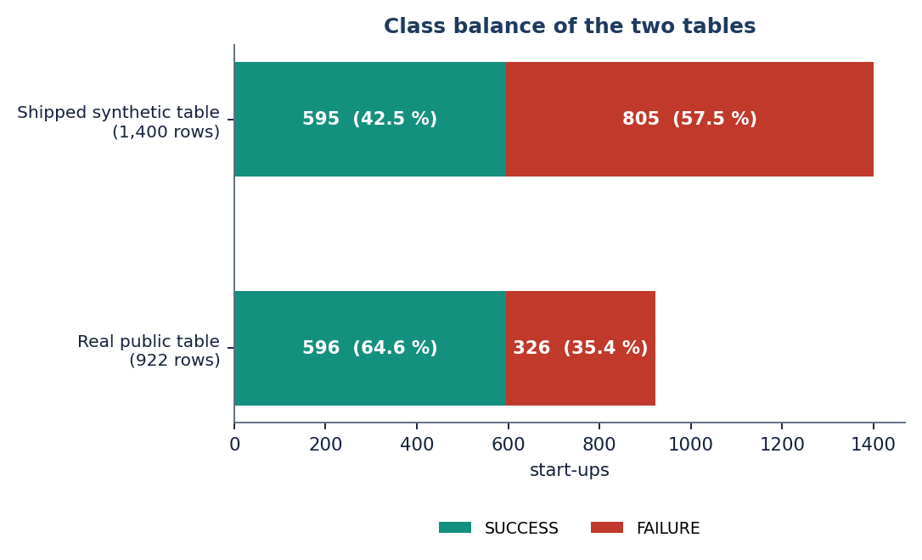
Figure 1: Class balance of the two datasets: the real table (922 startups) has SUCCESS as the majority class, the synthetic fallback (1,400) has FAILURE as the majority.

1.9 Limitations and Assumptions
The main limitations are listed here and discussed in detail in Chapters 7 and 8.
• The shipped model was trained on synthetic data because the public dataset could not be downloaded without a login when the application was built; all real measurements come from a separate study of the same pipeline.
• The real table has no free-text description, so the text channel and the fusion were not evaluated on real data.
• No dates are available, so no temporal split could be made and look-ahead bias cannot be excluded; four fields (relationships, milestones and two milestone ages) are partly recorded after the outcome.
• The real table is small (922 rows), concerns US companies only and gives test folds of 185 rows, so differences of a few points between models are within noise.
• Founder experience, team size and market-trend data named in the abstract are not part of either dataset.
The assumptions are that the labels of the public table (acquired = success, closed = failure) are correct, that the historical relationships between indicators and outcomes carry over to the companies being scored, that the inputs entered by a user are truthful, and that the machine used for measurement (an Intel Core i5-12500 with 15.7 GB of memory and no graphics processor) is representative of an ordinary laptop.

1.10 Organisation of the Report
Table 2: Organisation of the report
Chapter | Content
1 Introduction | Domain, motivation, problem, objectives, scope, contributions, limitations
2 Literature Survey | The base paper, the method and reference papers, related work by theme, datasets and algorithms, research gap
3 Feasibility Study | Technical, economic, operational and schedule feasibility
4 System Requirements and Analysis | Existing and proposed system, functional and non-functional requirements, hardware, software, user roles
5 System Design | Architecture, workflow, data flow diagrams, UML, data model, modules, user interface
6 Methodology and Software Implementation | Data, preprocessing, models, fusion and retrieval, application, API, security, installation
7 System Testing | Unit, integration, functional, security, validation, performance tests and their limits
8 Results and Output Screens | Measured results, output screens, comparison with the base papers, objectives versus outcomes
9 Conclusion | Summary, findings and applications
10 Future Scope | Improvements, further data, deployment and research

CHAPTER 2: LITERATURE SURVEY

2.1 Overview
This chapter reviews the work on which the project builds and against which it must be judged. It starts with the base paper declared for the batch [1] and analyses it in detail. It then describes the two further papers that were supplied with the batch and that shaped the design, the method paper of Maarouf, Bakiaj and Feuerriegel [2] and the interpretable-learning paper of Mashhadi, Saghezchi and Kashani [3], and groups the remaining related work by theme. It describes the datasets and algorithms the project itself uses, summarises strengths and limitations, lists the sources named in the batch literature survey, and ends with the research gap.
Two comments on method. Numerical results are quoted only where we read them in the paper itself (the base paper and the two papers just named) or where a web record of the paper was read (references 16 and 17). Works [4] to [15] are known to us only through the reference list and the literature review of the base paper; they are described "as summarised by [1]", with the details that [1] gives and nothing more, and no figure of their own is reproduced.

2.2 Analysis of the Base Paper
The declared base paper is "Startup Success Prediction Using Machine Learning and Ensemble Techniques" by Panjwani, Shrivastava, Hande, Meshram, Verma and Gotmare of Priyadarshini College of Engineering, published in the International Journal for Research in Applied Science and Engineering Technology in April 2026 [1]. It proposes a web-based startup success prediction system and compares four classifiers on preprocessed startup data.

2.2.1 Problem and motivation
The paper starts from the high failure rate of startups (nearly 90 % within the first few years, citing its own references) and from the subjectivity of investor judgement. It lists four objectives: to analyse the key factors influencing startup success, to develop and compare several ML models, to identify the most accurate and reliable model, and to provide a decision-support tool for investors and entrepreneurs. Its literature review distinguishes ML prediction studies, feature-based analyses, bias and data challenges (look-ahead bias, imbalance, scarce early-stage data) and advanced techniques (ensembles, PCA, text and language models), and ends with five research gaps: limited handling of bias and imbalance, absence of scalable real-time systems, poor integration of data sources, restricted use of textual data, and a lack of systems that are easy for entrepreneurs and investors to use.

2.2.2 Methodology
The system has a data-processing layer, a model layer and an application layer. Preprocessing consists of mean or mode imputation and removal of inconsistent records, label or one-hot encoding of categorical fields such as location and industry, standard scaling of numeric fields such as funding amount and workforce, and ADASYN oversampling for class imbalance. The selected features are the amount and number of funding rounds, team size and experience, location and industry, and online and social-media presence. Four models are trained: Logistic Regression as the baseline, Random Forest, Support Vector Machine and Gradient Boosting, with hyper-parameter tuning. The data are split 70:30 into training and test sets, and the models are judged by accuracy, precision, recall, F1-score and ROC-AUC. The backend is a Flask application with a REST interface and the front end is a simple HTML, CSS and JavaScript form that returns a probability and a SUCCESS or FAILURE label.

2.2.3 Data and results reported
The data are described as startup information from public sources such as Crunchbase and Kaggle, with funding amount, number of rounds, industry type, number of employees and location; no number of rows, no class balance and no list of columns is given. In the results section the paper states that Random Forest and Gradient Boosting performed best, that the top model's accuracy lay between 85 and 92 %, that the Support Vector Machine performed well but was slower than Logistic Regression, and that Logistic Regression was the less accurate baseline. Feature importance is reported only as a list: funding amount and number of rounds, team size and experience, industry type and location.
Table 3: What the base paper [1] reports
Item | Content in the paper
Models compared | Logistic Regression, Random Forest, Support Vector Machine, Gradient Boosting
Imbalance handling | ADASYN oversampling
Split | 70:30 training : test
Metrics named | Accuracy, precision, recall, F1-score, ROC-AUC
Best models | Random Forest and Gradient Boosting
Headline accuracy | 85 to 92 % for the top-performing model (no per-model table)
Dataset size, class balance, columns | Not stated
Per-model values of precision, recall, F1, ROC-AUC | Not stated
Application | Flask backend, HTML/CSS/JavaScript front end, real-time prediction

2.2.4 Strengths and limits
The paper states a clear workflow, names the standard metrics, includes the imbalance problem and look-ahead bias in its discussion, and ships a working web application. It also concedes its own limits: dependence on high-quality data, imbalance and missing values, no real-time data and little attention to external market conditions. What a reader cannot check is the central claim. Without a dataset size, a table of per-model results or a statement of how leakage was avoided, the 85 to 92 % figure cannot be compared with anything, and a model that sees fields recorded after the outcome would reach that level without being useful.

2.2.5 Relation to this project
The project keeps the base paper's overall design (preprocessing, several classifiers, standard metrics, a web application) and its model list, and adds what the paper names as missing: an explicit comparison of imbalance handling, explanations for each prediction, use of text and of comparable startups, and a measured, reproducible evaluation with the leakage question stated openly. Chapter 8 compares its own numbers with the paper's claim in the 70:30 protocol of the paper, and says plainly that the datasets differ or are unknown.

2.3 The Method Paper and the Reference Paper

2.3.1 Predicting startup success with in-context learning
Maarouf, Bakiaj and Feuerriegel observe that many investors hold data on only a few dozen startups, which makes supervised ML unstable, and propose k-nearest-neighbour in-context learning (kNN-ICL) [2]. For a new startup, the k most similar past startups are retrieved and shown, with their outcomes, to a large language model in the prompt, in the spirit of few-shot learning [31]; no model is trained. Their database holds 4,034 Crunchbase startups, of which 1,418 (35.15 %) are successful and 2,616 are not. Inputs are structured fields (age, founders, industry, presence on professional platforms, founder attributes) and the free-text self-description; company names are replaced by a placeholder so that the model cannot rely on what it memorised. Evaluation uses five repeated stratified 80/20 splits with the mean and standard deviation reported, and balanced accuracy as the main metric because successful startups are the minority.
At k = 50 shots, kNN-ICL reaches a balanced accuracy of 0.713 and an F1-score of 0.632, against 0.631 and 0.488 for regularised Logistic Regression, 0.634 for Random Forest and 0.618 for XGBoost, and 0.696 for vanilla in-context learning with randomly chosen examples. Performance rises with k and saturates near 50. In an appendix, a fused language model trained on 20,172 startups reaches 0.743 balanced accuracy and 0.678 F1, which shows that more data still helps. This project takes three things from the paper: the evaluation protocol (five repeated stratified 80/20 splits with balanced accuracy as the primary metric), the idea of retrieving comparable startups and showing them with their outcomes, and the masking of company names. It does not use a language model for the decision.

2.3.2 Interpretable machine learning for funding, patenting and exits
Mashhadi, Saghezchi and Kashani build a Crunchbase firm-quarter panel for 2010 to 2023, matched to patent records, and forecast three outcomes: a new funding round within 12 months, growth of the patent stock within 24 months and an exit (IPO or acquisition) within 36 months [3]. Preprocessing is fitted on a development window (2010 to 2019) and applied unchanged to later cohorts to avoid leakage. Imbalance is handled with inverse-prevalence weights and SMOTE-NC, and Logistic Regression, Random Forest, XGBoost, LightGBM and CatBoost are compared by the area under the precision-recall curve (PR-AUC), with AUROC as a tie-breaker. The best models reach AUROC 0.921 (patents, PR-AUC 0.631), 0.817 (next funding, PR-AUC 0.220) and 0.872 (exit, PR-AUC 0.559). SHAP analyses identify the time since the last funding round and the age of the firm as the leading drivers of funding and exit, and reliability curves show optimism at high scores, for which the authors recommend isotonic recalibration.
The paper matters here for three reasons. It uses the same model family as the batch objectives (logistic regression, Random Forest and boosting). It treats class imbalance with weights and oversampling and reports PR-AUC, which is more informative than ROC-AUC for rare outcomes. And it shows what a leakage-safe protocol looks like, which the public table used in this project does not allow because it carries no dates.

2.4 Related Work by Theme

2.4.1 Machine-learning prediction of startup success
As summarised by the base paper [1], Krishna et al. applied Random Forest and Bayesian networks to startup data and stressed funding-related features and growth milestones [4]; Razaghzadeh Bidgoli et al. compared Random Forest, Gradient Boosting, Support Vector Machine and Logistic Regression and found ensembles above 80 % accuracy [7]; Li analysed large startup data with Support Vector Machine and Random Forest [8]; Camelo Martinez used logistic regression and found team size, funding amount and market conditions to be important, with accuracy up to 76 % [5]; and Ross et al. built an ensemble model, CapitalVX, combining several data sources, with accuracy up to 90 % [11]. Tomy and Pardede stress uncertainty in startup settings [12]. These descriptions are those of [1]; the original papers were not re-read.

2.4.2 Features, bias and interpretability
Jafari et al. grouped predictors of startup success into investor structure, digital presence, funding history and business characteristics, finding finance and online traction most important [10]; Zbikowski and Antosiuk proposed a bias-free approach on Crunchbase data and drew attention to look-ahead bias [9]; Choi used PCA to improve model accuracy [13]; and Bonaventura et al. showed that a startup's position in the network of investors and companies influences its success [15] (all as summarised by [1]). The more general warning about information that is not available at prediction time is formulated in the data-mining literature on leakage [29], and Mashhadi et al. show how to respect it [3].

2.4.3 Text, retrieval and language models
Maarouf et al. earlier proposed a fused large language model that combines structured variables with the text self-description [14] (reported through [1] and, with a balanced accuracy of 0.743 on the common test set, through [2]). The kNN-ICL paper replaces the trained model by retrieval and prompting [2]. This project uses the retrieval half of the idea with a compact sentence encoder, MiniLM [26] within the Sentence-BERT framework [25], and a classical nearest-neighbour rule [30], so that everything runs on a laptop.

2.4.4 Economic evidence on venture finance
Gius analysed 67 venture competitions and found that startups were more likely to succeed when the judges disagreed more about their quality, mostly when the idea was unique [16]. Bhandari used a questionnaire answered by 120 respondents in Nepal and a regression to relate venture capital, access to capital, networking and market conditions to startup success [17]. These studies explain why funding and relationship indicators matter, but they are association studies and not predictors.
Table 4: Summary of the literature (works read in full or confirmed)
Work | Approach | Data | Reported result | Limitation
Panjwani et al. 2026 [1] (base paper) | LR, Random Forest, SVM, Gradient Boosting on funding, team, industry and location features; ADASYN oversampling; 70:30 split; Flask web application | Crunchbase / Kaggle startup data (size not stated) | Best ensembles: accuracy 85-92 % (no per-model table) | No dataset size, no table of results; no ROC-AUC values; no leakage control stated
Maarouf et al. 2026 [2] | kNN-based in-context learning: retrieve the k most similar past startups and show them with outcomes to an LLM; compared with LR, RF, XGBoost | 4,034 Crunchbase startups (1,418 successful, 35.15 %), 5 x 80/20 stratified splits | Balanced accuracy 0.713 (F1 0.632) at k=50 vs LR 0.631, RF 0.634, XGBoost 0.618; fused LLM trained on 20,172 startups 0.743 | Needs an LLM; data-scarce setting; text descriptions required
Mashhadi et al. 2026 [3] | Interpretable ML (LR, RF, XGBoost, LightGBM, CatBoost) with inverse-prevalence weights and SMOTE-NC; SHAP; leakage-safe temporal splits | Crunchbase firm-quarter panel 2010-2023 matched to USPTO data | AUROC 0.921 (patents, 24 mo), 0.817 (next funding, 12 mo), 0.872 (exit, 36 mo); PR-AUC 0.631 / 0.220 / 0.559 | Panel data and patent matching not available to this project; no web tool
Bidgoli et al. 2024 [7] (as summarised by [1]) | Comparison of RF, Gradient Boosting, SVM and LR on startup data | Not restated in [1] | Ensembles above 80 % accuracy, ahead of conventional models (per [1]) | Details not re-read; reported through [1]
Zbikowski and Antosiuk 2021 [9] (as summarised by [1]) | Bias-free business-success prediction from Crunchbase; attention to look-ahead bias | Crunchbase | Shows that using future information gives unrealistic accuracy (per [1]) | Details not re-read; reported through [1]
Ross et al. 2021 [11] (as summarised by [1]) | CapitalVX: ensemble model combining several data sources for startup selection and exit prediction | Multiple sources | Up to 90 % accuracy (per [1]) | Details not re-read; reported through [1]
Choi 2024 [13] (as summarised by [1]) | PCA-enhanced ML models for startup success | Not restated in [1] | PCA improved classification accuracy (per [1]) | Details not re-read; reported through [1]
Gius 2025 [16] | Judge disagreement in 67 venture competitions as a predictor of startup success | 67 venture competitions | More disagreement among judges predicts a higher chance of success, mostly when the idea is unique | Competition entrants, not a general population; not an ML classifier
Bhandari 2025 [17] | Questionnaire survey with correlation and multiple regression on venture capital, access to capital, networking and market conditions | 120 survey respondents in Nepal | Positive association of venture capital with startup success and growth | Association from a small survey; no prediction

2.5 Datasets and Algorithms Used in This Project

2.5.1 Datasets
Two datasets are involved and they must not be confused. The public "Startup Success Prediction" table [32] has 923 rows and 49 columns of US startups, with a status of acquired (success) or closed (failure). After the application's own de-duplication 922 rows remain: 596 success (64.6%) and 326 failure. It has no free text. Because the Kaggle download needs a login, the same table was obtained from a public copy and is used for all real measurements. The shipped application, in contrast, runs on a synthetic fallback of 1,400 rows (595 success, 805 failure) with the same schema and a description generated from templates. Chapter 6 describes both.

2.5.2 Algorithms
• Logistic Regression is a linear model whose coefficients can be read directly; it is the baseline in the base paper and, here, the model served by the application [1].
• Decision Tree is a single rule-based model, easy to explain but unstable.
• Random Forest averages many decorrelated trees and reduces over-fitting [18].
• XGBoost and HistGradientBoosting build trees one after another to correct the previous errors [19, 20].
• Class weighting and oversampling handle imbalance at the algorithm and data level; SMOTE and ADASYN are the usual synthetic oversamplers [22, 23, 24].
• Sentence embeddings and cosine retrieval turn the description into a 384-dimensional vector and find the nearest training startups [25, 26, 30].
• Metrics: balanced accuracy, F1, ROC-AUC and PR-AUC [28, 27].

2.6 Strengths and Limitations of the Surveyed Approaches
Table 5: Strengths and limitations of the main approaches
Approach | Strengths | Limitations
Ensembles of trees on structured data [1], [7], [11] | Handle mixed data and non-linear effects; strong in all surveyed comparisons | Hard to explain; accuracy claims depend on data and leakage control
Logistic Regression [1], [5] | Transparent coefficients; cheap; calibrated probabilities | Misses interactions; lower accuracy in [1]
Oversampling (SMOTE, ADASYN) [1], [3] | Simple; widely used | Synthetic points can add noise; changes the data, not the loss
Leakage-aware protocols [3], [9] | Realistic out-of-time estimates; interpretable | Need dated panel data and patent matching
Text and language models [2], [14] | Use the business description; work with few labelled examples | Need a language model; text must be available
Economic and survey studies [16], [17] | Explain why funding and networks matter | Association only; small or special samples

2.7 Further Sources Named in the Batch Survey
The batch literature survey (5.LITERATURE SURVEY) lists five sources. The first is the base paper itself. The sources by Gius [16] and Bhandari [17] were confirmed by web search and are described above. The remaining two, an empirical study of the impact of venture capital on startup success rates across industries (European Economic Letters, 2024) [34] and a book chapter on the role of SICTIC in the Swiss startup ecosystem (2026) [35], could not be located; only their titles, years and venues are recorded, no result is quoted from them, and they are listed in the references for completeness. All five are economic or venture-finance studies; none is a machine-learning classifier, which is why the ML design of this project rests on [1] to [3].

2.8 Research Gap
The surveyed work applies ensemble methods to startup success prediction. The gap is systematic feature engineering around funding velocity and team composition, with explicit handling of the rare-success class.
Read against the surveyed papers, the gap has five parts, each of which the project addresses to the extent the data allow:
1. Evidence and reporting. The base paper gives accuracy ranges without a dataset or a table. The project measures every model on a stated public table over repeated splits and reports means and standard deviations.
2. Feature engineering. Funding velocity and team composition are named but not built. The project uses the funding-timing fields, the number of rounds and the relationship counts of the public table, and states that team-experience and market data are not available.
3. The rare-success class. The batch assumes success is rare. The project handles imbalance with balanced weights, compares oversampling, and finds that on the real table success is the majority class, which changes what the trade-offs mean.
4. Explanation. A prediction that names no drivers cannot be acted on. Each prediction here carries signed feature contributions and the comparable startups behind it.
5. Leakage. Bias and look-ahead are named as gaps in [1] and solved only with dated panels in [3]. The project cannot solve it without dates, but quantifies how much of the real-data performance depends on four fields recorded around the outcome window.

CHAPTER 3: FEASIBILITY STUDY
A feasibility study asks whether a project can be built and used with the resources at hand. For this project the question was answered partly by analysis and partly by building the system, so most entries below carry a measured value rather than an estimate. Where a question could not be answered favourably, the entry says so.

3.1 Technical Feasibility
The technical risk lay in four places: whether four classifiers and a sentence encoder could be trained and served on an ordinary computer without a graphics processor; whether a prediction that includes embedding a description and searching the training startups is fast enough for an interactive page; whether the required public data could be obtained; and whether the model reaches a useful level on real startups. The development machine is Intel Core i5-12500 (6 cores, 12 threads), 15.7 GB RAM, Windows 11 Pro, CPU only (no GPU). On that machine:
Table 6: Technical feasibility checks and what was measured
Question | Measurement | Verdict
Can the models be trained on a CPU? | All five models, five splits and the ten studies on the real table (922 rows) ran in 139 s; the leakage, retrieval and per-industry studies in 14 s | Feasible
Are predictions fast enough? | POST /predict median 148 ms (k = 10) and 198 ms (k = 50); 95th percentile 583 ms at k = 50; read-only endpoints 3 to 14 ms | Feasible
Is the sentence encoder usable offline? | all-MiniLM-L6-v2 (384 dimensions) runs on the CPU; it is downloaded once, and a deterministic hashing fallback of the same width is used if it cannot be loaded | Feasible (first run needs a download)
Can the real data be obtained? | The Kaggle download needs a login; the identical 923-row table was fetched from a public copy (922 rows after de-duplication) | Feasible, with a workaround
Is the accuracy useful? | Real table, 5 x 80/20 splits: Random Forest balanced accuracy 0.746 ± 0.031, ROC-AUC 0.816 ± 0.022 | Moderately useful; upper bound (Chapter 8)
Is the model small enough to ship? | The served model files total about 4.5 MB (best model 4 KB, preprocessor 6 KB, training vectors 2.1 MB, stored embeddings 2.0 MB, training frame 0.4 MB) | Feasible

The weakest answer is the fifth. The real table is small, its test folds have 185 rows, and four of its fields are partly recorded around the outcome window; when they are removed the ROC-AUC of the best models drops from about 0.82 to about 0.72 (Chapter 8). Technical feasibility of building and running the system is therefore established; technical feasibility of the 85 to 92 % accuracy claimed by the base paper is not, on this data.
A smaller risk is the dependency chain. The first saved models had been written with newer library versions than those pinned in requirements.txt and could not be loaded; they were retrained with the pinned versions (scikit-learn 1.5.2, pandas 2.2.3), and run.bat builds its own virtual environment from that file.

3.2 Economic Feasibility
The system uses only free and open-source software, runs on one local computer and needs no cloud account, no graphics processor and no paid data. Its cost is therefore the development time of four students and the electricity of the machine, which we did not meter and do not estimate. The costs that would appear in a real deployment, namely data licences (for example a Crunchbase subscription), hosting and maintenance, are outside the project and are listed under future scope.
The benefit side is qualitative: a repeatable second opinion that costs a fraction of a second per startup, can be re-run on new data by a non-expert, and shows its reasons. We did not measure savings or investment outcomes, and no claim of financial benefit is made.

3.3 Operational Feasibility
Operationally the system is a small web application. One batch file (run.bat) creates the environment, trains the model if the saved files are missing, and starts the backend on port 8410 and the interface on port 5410. A user signs in with the demonstration account, fills one form and reads one result page. The form has defaults for every field, so a prediction can be requested with nothing typed (tested in Chapter 7), and invalid values are refused with a clear message. The interface works in light and dark themes and at narrow widths. The main operational constraint is the data: the person who enters the indicators must know them, and the model was trained on US startups of a past period, so predictions for other markets or periods are less reliable.

3.4 Schedule Feasibility
The project was carried out in phases that follow the objectives. The table lists the phases and their products; calendar dates are left as placeholders because the academic calendar of the institution is not recorded in the batch files.
Table 7: Project phases (plan) and their products
Phase | Work | Product | Period
1 Problem and survey | Base paper, literature survey, objectives | Abstract, survey, objectives | [DATES]
2 Data | Obtain public table, synthetic fallback with the same schema, cleaning and target mapping | data/, app/ml/dataset.py, preprocessing.py | [DATES]
3 Models | Four classifiers, five repeated splits, representation and retrieval studies | app/ml/models.py, evaluation.py, evaluation_results.json | [DATES]
4 Retrieval and explanation | Sentence embedding, fusion, balanced cosine retrieval, explanations | embeddings.py, retrieval.py, predictor.py | [DATES]
5 Application | FastAPI service, original pages, React interface, demonstration sign-in | app/main.py, api_extra.py, frontend/ | [DATES]
6 Verification | Unit, smoke and edge tests; latency; screenshots | tests/, scripts/ | [DATES]
7 Real-data study | Ten studies on the real table; leakage ablation; documentation | run_experiments.py, extra_experiments.py, this report | [DATES]

3.5 Advantages and Constraints

Advantages
• Runs locally on a normal computer: no cloud account, no GPU, no API key and no licence fee.
• Fast at prediction time: a median of 148 to 198 ms for a complete prediction with retrieval of comparable startups.
• Every prediction carries its reasons: signed feature contributions, a risk label and a table of comparable historical startups with outcomes and similarity scores.
• Four classifiers are compared under one protocol; the best by balanced accuracy is served and the comparison is visible in the application.
• Reproducible and measured: scripts regenerate every real-data number, and 51 automated checks guard the application.

Constraints
• The real-data performance is moderate (Random Forest ROC-AUC 0.816 ± 0.022) and partly depends on fields recorded around the outcome window.
• The shipped model was trained on synthetic data; the application's own dashboard numbers describe that data.
• The text channel could not be tested on real data, because the real table has no descriptions.
• No temporal validation, no founder or market data, one US dataset of 922 rows.
• Demonstration sign-in only; one local user; no database.

3.6 Risk Analysis
The risks that were identified at the start, what happened to each, and what was done about it are listed below. They are the reasons for several design decisions described in Chapters 5 and 6.
Table 8: Risks, outcome and mitigation
Risk | What happened | Mitigation
The public dataset cannot be downloaded without a login | The shipped application had to start on a synthetic fallback with the same schema; the metadata and the dashboard note record this | The identical table was fetched from a public copy for all real measurements; the report separates the two datasets
Synthetic descriptions leak the label | Text-only classification of the synthetic table reaches 0.599 balanced accuracy because success and failure templates differ in wording | Synthetic text results are reported as a pipeline check; the text channel is listed as untested on real data
Look-ahead bias in the real table | Four fields (relationships, milestones, two milestone ages) are partly recorded around the outcome; the table has no dates | A leakage ablation quantifies the effect (ROC-AUC about 0.82 to 0.72 for Random Forest); real figures are called an upper bound
Small data and noisy comparisons | 922 rows and 185-row test folds; Random Forest, XGBoost and HistGradientBoosting lie within one standard deviation | Five repeated splits with means and standard deviations; no ranking is claimed inside the noise
Library versions break the saved models | Models saved with newer scikit-learn and pandas could not be loaded | Models were retrained with the pinned versions; run.bat builds its own environment
Sentence encoder unavailable offline | Possible on a first run without a connection | Deterministic hashing fallback of the same width, flagged in the response

3.7 Feasibility Summary
The project is technically feasible on a laptop, economically feasible because it uses only free software, operationally feasible because one start script and one form are enough, and feasible within a semester-length schedule. Its only limited feasibility is a scientific one: with the data that could be obtained, the accuracy claimed in the base paper cannot be reached or verified, and the honest result is a working, explained and measured system of moderate accuracy.

CHAPTER 4: SYSTEM REQUIREMENTS AND ANALYSIS

4.1 Existing System and Its Limitations
Today an early-stage startup is assessed in one of three ways. Investors and founders judge it from experience and intuition, which is quick but subjective, inconsistent and open to bias [1]. Analysts compare it with a handful of remembered peers, which is slow and cannot be repeated by someone else. And some published systems train a classifier on startup data and return a probability, as the base paper does with a Flask form [1].
The limitations that follow are the ones named in the batch problem statement and the survey:
• Subjective judgement leads to inconsistent decisions.
• Failure causes become obvious only after capital has been committed.
• Success is rare in many datasets, so naive models under-predict it; imbalance is rarely examined (the base paper uses ADASYN without a comparison).
• A bare probability gives a founder nothing to act on: no drivers, no comparable cases.
• Reported accuracy levels cannot be checked when the data and the per-model results are not given, and leakage of post-outcome information is not controlled.

4.2 Proposed System and Its Advantages
The proposed system, VenturePulse, is a local web application over an ML pipeline. A user enters the indicators of a startup; the system scales and encodes them, embeds the optional description, fuses the two representations, estimates the outcome with the best of four compared classifiers, retrieves comparable startups from the training set in a balanced way and explains the estimate. The advantages follow from that design:
• The estimate comes with its reasons (signed feature terms) and its evidence (comparable startups with outcomes and similarity scores).
• Imbalance is handled explicitly with balanced class weights and a balanced retrieval quota, and compared with oversampling in a separate study.
• Evaluation follows a stated protocol (five repeated stratified 80/20 splits, balanced accuracy as the primary metric) that is the same as in the method paper.
• Everything runs locally and quickly, with no paid service.
• The measurements are repeatable by script, and the report states plainly which numbers come from synthetic and which from real data.

4.3 Functional Requirements
Table 9: Functional requirements and how they are realised
ID | Requirement | Realisation | Screen
FR-1 | Predict SUCCESS or FAILURE for one startup from 9 numeric fields, 7 flags, state, industry and an optional description | POST /predict; Analyze screen | Analyze
FR-2 | Refuse values outside the allowed ranges and a description over 2,000 characters; accept only k in {10, 20, 30, 50} | Pydantic validation, HTTP 422 | Analyze
FR-3 | Show the outcome, the success and failure probabilities, the confidence and a risk label | Result card; Lower risk / Moderate risk / Higher uncertainty | Result
FR-4 | Name the features that drive the estimate | Top five signed coefficients or importances | Result
FR-5 | Show comparable historical startups with similarity, outcome, industry, state, funding, rounds and summary | Balanced top-k cosine retrieval over training rows; sortable, paged table | Result
FR-6 | Show the split of retrieved cases by outcome | Evidence donut chart (SUCCESS / FAILURE counts) | Result
FR-7 | Show the model comparison, confusion matrix, representation study and retrieval-size study | GET /api/model-metrics | Model performance
FR-8 | Show dataset insights: industry success rates, funding distributions, correlations | GET /api/insights | Insights
FR-9 | Show the feature weights of the served model | GET /api/feature-importance | Performance
FR-10 | Offer a demonstration sign-in that protects the React screens | POST /api/auth/login, GET /api/auth/me, HMAC-signed token | Login
FR-11 | Report that the service is alive and which model it serves | GET /api/health; status indicator | All screens
FR-12 | Keep the original server-rendered pages working | GET /, /dashboard, /predict, /performance, /insights; POST /predict-form | Legacy pages
FR-13 | Offer light and dark themes and keyboard navigation | Theme toggle; command palette (/) and key shortcuts | All screens

4.4 Non-Functional Requirements
Table 10: Non-functional requirements and the measured outcome
Requirement | Target | Measured or evidence | Status
NFR-1 Response time | A prediction feels instant | Median 148 ms (k = 10) and 198 ms (k = 50); p95 594 / 583 ms | Met
NFR-2 Read endpoints | Dashboards load without delay | health 3.0 ms, model-metrics 3.5 ms, insights 14.5 ms (median) | Met
NFR-3 Accuracy | Reported on held-out data with several metrics and a comparison of models | Real table: balanced accuracy up to 0.746 ± 0.026, ROC-AUC up to 0.816 ± 0.022 | Reported, moderate
NFR-4 Input safety | Bad input is refused with a clear message and changes nothing | 13 predict-payload cases and 2 form cases, all as expected | Met
NFR-5 Leakage control | Retrieval and preprocessing use training data only | Preprocessing fitted on the training split; retrieval searches training rows only; company names masked | Met in the application; not possible for dates
NFR-6 Privacy | Inputs stay on the user's computer | No external prediction service; the only download is the encoder, once | Met
NFR-7 Usability | Usable by a non-expert, light and dark, narrow screens | Defaults for every field; labels, hints, error sentences; responsive layout | Met
NFR-8 Portability | Runs on a normal Windows PC | Python 3.11, Node 24; run.bat; other systems untested | Met on Windows only
NFR-9 Maintainability | Small modules with one job each | Separate dataset, preprocessing, embeddings, retrieval, models, evaluation, services | Met
NFR-10 Testability | Automated tests | 7 unit, 15 smoke and 29 edge checks pass | Met

The accuracy requirement is a reporting requirement, not a target number. Objective 6 asks for accuracy, precision, recall, F1 and ROC-AUC, and these are reported with means and standard deviations. No target such as 85 % was set, because the achievable level on the available data was not known before the experiments.

4.5 Hardware Requirements
The system was developed and measured on one machine. We report its specification and do not invent a minimum; a smaller machine may work but was not tested.
Table 11: Hardware used for development and measurement
Item | Specification
Processor | Intel Core i5-12500, 6 cores, 12 threads
Memory | 15.7 GB RAM
Graphics processor | none used (CPU-only PyTorch)
Storage | about 4.5 MB for the served model files; 208 KB for the real table
Display | any browser window; the screenshots were taken at a width of 1440 pixels
Operating system | Windows 11 Pro

4.6 Software Requirements
Table 12: Software used
Component | Version | Role
Python | 3.11.9 | Language of the pipeline and the API
scikit-learn [21] | 1.5.2 | Preprocessing, Logistic Regression, Decision Tree, Random Forest, metrics, splits
pandas, NumPy, SciPy, joblib | 2.2.3, 1.26.4, 1.13.1, 1.4.2 | Tables, arrays, similarity, model files
XGBoost [19] | 2.1.3 | Boosted-tree classifier
sentence-transformers, PyTorch | 3.3.1, 2.5.1 (CPU) | all-MiniLM-L6-v2 embeddings of the description
FastAPI, uvicorn, Jinja2, python-multipart | 0.115.6, 0.34.0, 3.1.5, 0.0.20 | Web service, original pages, form posts
pytest, httpx | 8.3.4, 0.28.1 | Automated tests
Node.js and npm | 24.19.0 and 11.17.0 | Build and development server of the interface
React, Vite, Tailwind CSS, Recharts, GSAP, Framer Motion | 18.3, 6.4, 4.3, 3.10, 3.15, 14.6 | Web interface, charts and motion
Playwright with Chrome | 1.49.1 | Capturing the output screens

4.7 User Roles
The system has one kind of user. The analyst (an investor, an incubator officer or a founder) enters the indicators of a startup, reads the estimate, the drivers and the comparable startups, and looks at the model performance and insight pages to judge how far to trust the result. The model owner is the person who retrains or replaces the model by running the training script on a new table; this is done from the command line, not from the interface. The demonstration sign-in does not separate roles: it only protects the React screens with a signed token and a single account. A multi-user system would need real accounts, roles and storage, and is listed under future scope.

4.8 Constraints and Assumptions
1. The training data are US startups of a past period; the model is not validated on other markets or on recent years.
2. The input fields follow the public table: ages are in years, funding in US dollars, state from ten codes plus Other, industry from ten names plus Other.
3. The description is optional, at most 2,000 characters, and is truncated before it is embedded; an empty description is replaced by a short industry sentence.
4. The first prediction downloads the sentence encoder if it is not cached; if it cannot be loaded the application uses a hashing fallback and records this in the response.
5. The estimate is a statistical screening aid, not investment advice, and the interface says so on every result.
6. The shipped model is trained on the synthetic fallback unless the public CSV is placed in data/raw/.

4.9 Data Requirements
The prediction request has 20 fields. The ranges below are enforced by the API (HTTP 422 outside them) and are the same in the React form. Ages are measured in years from the founding of the company, as in the public table.
Table 13: Input fields of POST /predict
Field | Type and range | Default | Meaning
funding_total_usd | number, 0 to 1e10 | 1,000,000 | Total funding raised in US dollars (also used as log1p)
funding_rounds | number, 0 to 20 | 2 | Number of funding rounds
age_first_funding_year / age_last_funding_year | number, 0 to 30 | 1.5 / 2.5 | Company age at the first and the latest funding round
age_first_milestone_year / age_last_milestone_year | number, 0 to 30 | 1.0 / 2.0 | Company age at the first and the latest milestone
relationships | number, 0 to 200 | 4 | Number of investor, advisor and partner relationships
milestones | number, 0 to 50 | 2 | Number of recorded milestones
avg_participants | number, 0 to 50 | 3 | Average number of investors per round
has_VC, has_angel, has_roundA to has_roundD, is_top500 | boolean (7 flags) | false | Venture-capital or angel backing, the funding rounds reached, membership of a top-500 list
state | one of CA, NY, MA, TX, WA, IL, CO, FL, PA, OR, Other | CA | Location; unknown values are ignored by the one-hot encoder
industry_type | one of Software, E-Commerce, FinTech, HealthTech, EdTech, CleanTech, Media, Mobile, AI, Biotech, Other | Software | Sector
description | text, at most 2,000 characters | empty | Optional business description; company names are masked; empty text is replaced by an industry sentence
k | 10, 20, 30 or 50 | 50 | Number of comparable startups to retrieve

The training data have the same columns plus the outcome (status: acquired or closed, mapped to SUCCESS or FAILURE). Rows with an unknown status are dropped, duplicates are removed, numeric fields are coerced and missing values are imputed (median for numbers, most frequent for flags, a constant for categories).

4.10 Traceability of Requirements to Objectives
Table 14: Objectives, requirements and where they are verified
Objective | Requirements | Verified in
1 Collect a dataset | FR-1, FR-8; data requirements 4.9 | Chapter 6 (data), Chapter 8
2 Clean data, engineer features | FR-2; NFR-5 | Chapter 6 (preprocessing), Chapter 7
3 Address class imbalance | NFR-5; balanced weights and quotas | Chapter 8 (imbalance study)
4 Train and compare models | FR-7; NFR-3 | Chapter 8 (model comparison)
5 Identify separating features | FR-4, FR-9 | Chapter 8 (feature importance)
6 Evaluate with five metrics | NFR-3 | Chapter 8 (tables of results)

CHAPTER 5: SYSTEM DESIGN
This chapter describes how VenturePulse is organised: its design goals, architecture, data flow, main classes, stored data, core algorithm, modules and user interface. Every diagram was drawn from the real code (app/, scripts/ and frontend/src/) and reads the way the program runs.

5.1 Design Goals
• One fitted preprocessor, one model, one set of training vectors. They are created together and stored together, so training and prediction cannot disagree.
• A prediction plus its evidence. Every result carries the probability of both outcomes, the features that drove the model and the comparable historical startups, so that the number is never shown alone.
• Leakage-safe retrieval. The comparable startups are searched among training rows only, the company name is masked in descriptions, and the evaluation fits every transformation on the training part of each split.
• Runs on a student laptop. CPU only, open-source packages, no external prediction service and no API key; everything stays on localhost.
• Measured, not promised. The performance and insights screens read the numbers from the stored evaluation files and the loaded training table, so the screens cannot show a figure that was not computed.

5.2 System Architecture
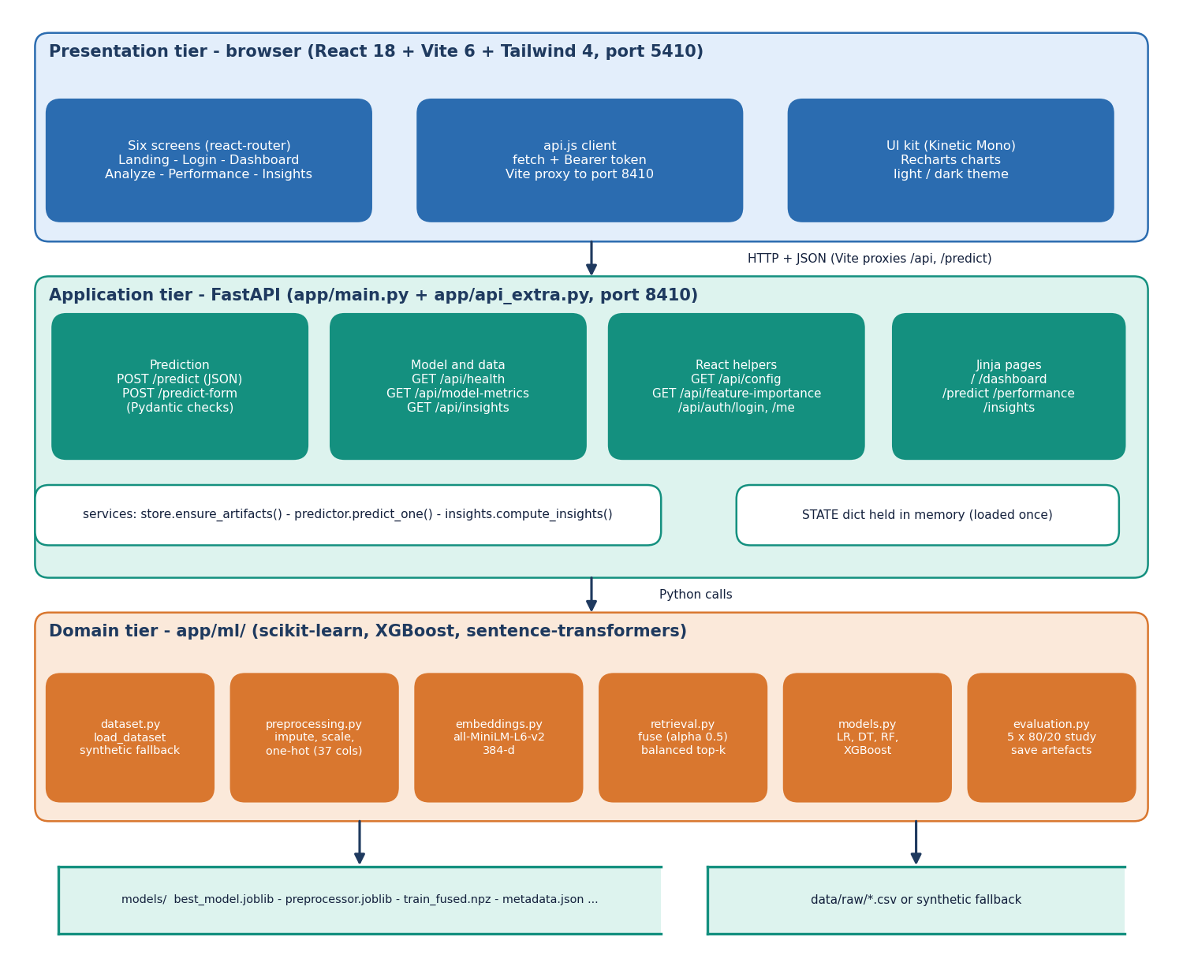
Figure 2: System architecture of VenturePulse: presentation, application and domain tiers over two stores.
There are three tiers over two stores. The presentation tier is a React 18 application (Vite 6, Tailwind CSS 4, Recharts, port 5410) with six screens: the landing page, the sign-in and the four application screens under /app. The Vite server proxies /api and /predict to the backend, so the browser talks to one origin. The application tier is a FastAPI service on port 8410: app/main.py (209 lines) holds the original routes and the validation model, app/api_extra.py (160 lines) adds the read-only routes and the demo sign-in for the React screens, and three services keep the routes thin. The domain tier in app/ml/ has six modules (dataset, preprocessing, embeddings, retrieval, models and evaluation). The two stores are the models/ folder and the startup CSV or synthetic fallback; no SQL database is used. The original Jinja pages (/dashboard, /predict, /performance, /insights) are served by the same backend and use the same services, so the two front ends show the same numbers.

5.3 High-Level Workflow
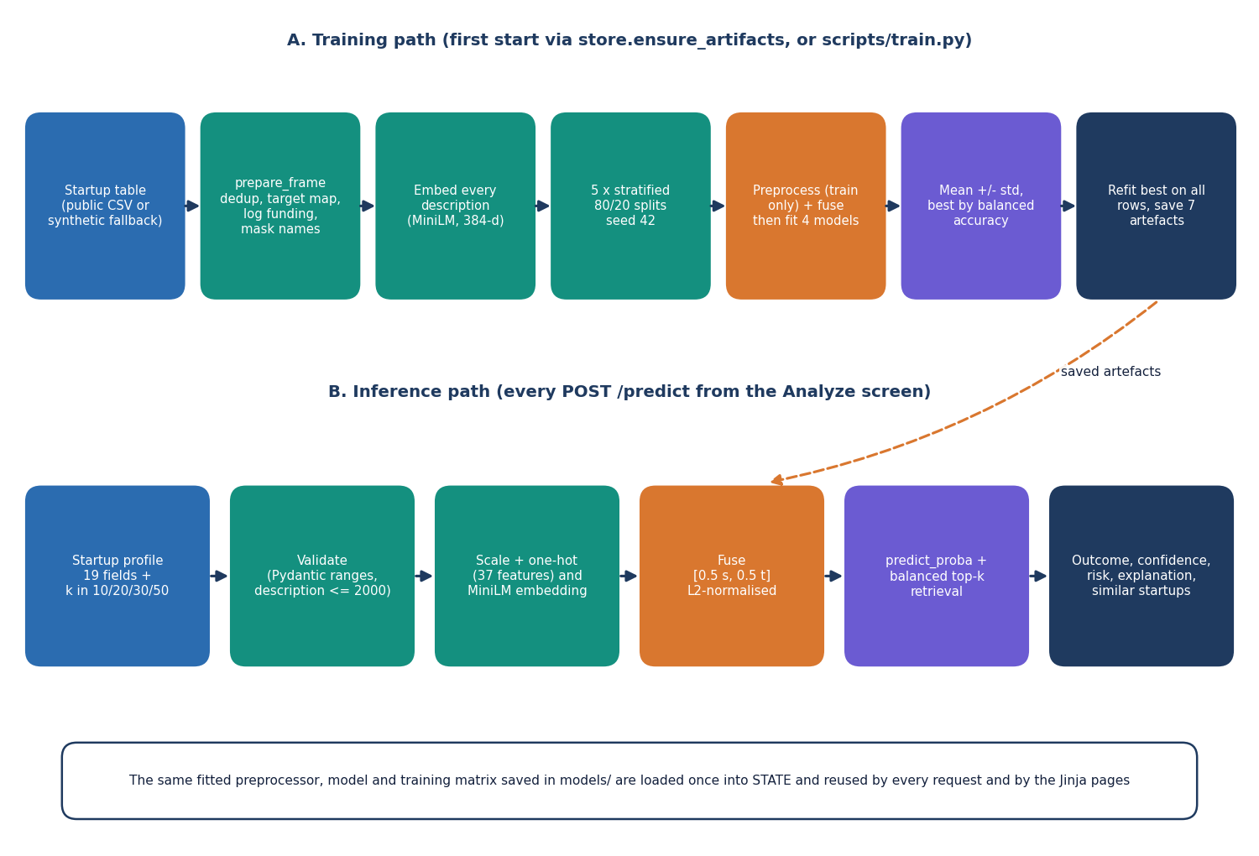
Figure 3: High-level workflow: the training path (first start or scripts/train.py) and the inference path (every POST /predict).
The offline path prepares the data, compares four classifiers over five repeated splits, selects the best by balanced accuracy and stores the artefacts; it runs automatically on the first start if any artefact is missing. The online path applies the stored objects to one submitted startup. Both paths use the same fusion function, so a submitted startup is represented exactly like a training row. On the development machine one prediction takes a median of 148 ms at k = 10 and 198 ms at k = 50 (measured through HTTP on 127.0.0.1).

5.4 Data Flow Diagrams
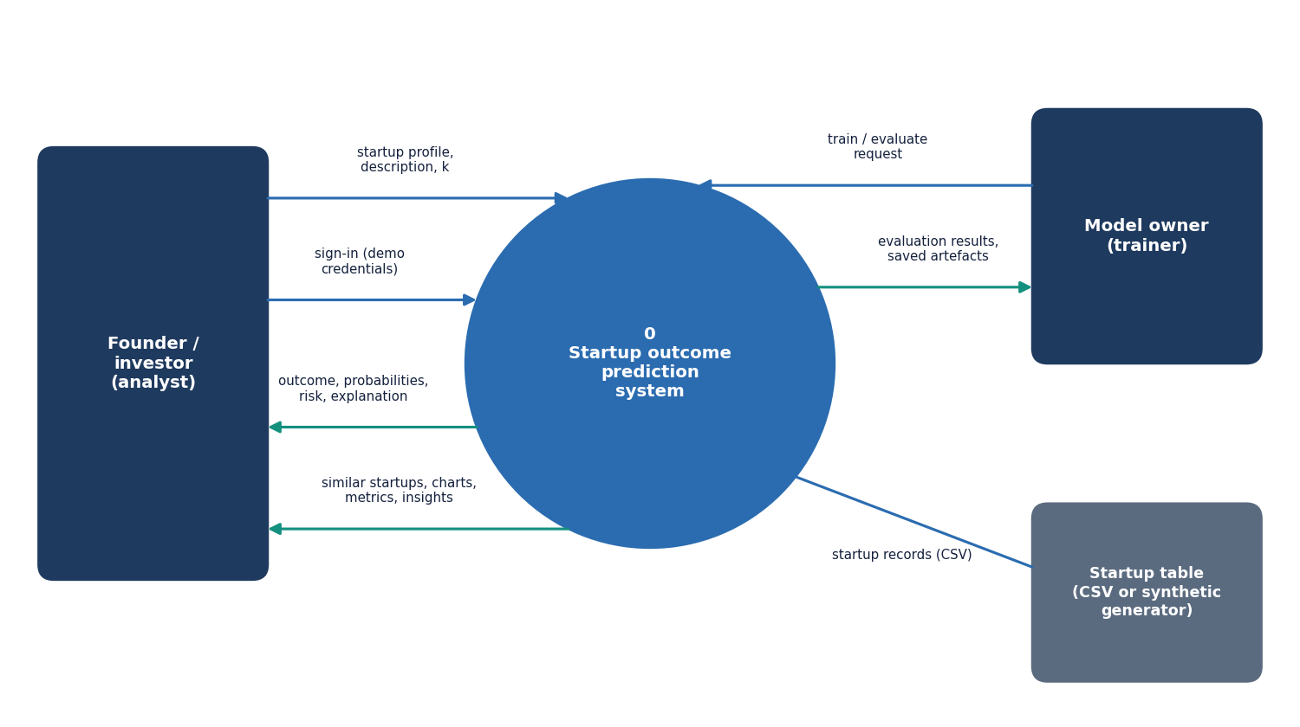
Figure 4: Level 0 data flow diagram: the system as one process with three external entities.
Level 0. The founder or investor sends credentials and a startup profile and receives an outcome estimate with evidence; the model owner sends a train and evaluate request and receives the evaluation results and the saved artefacts; the startup table supplies the records.
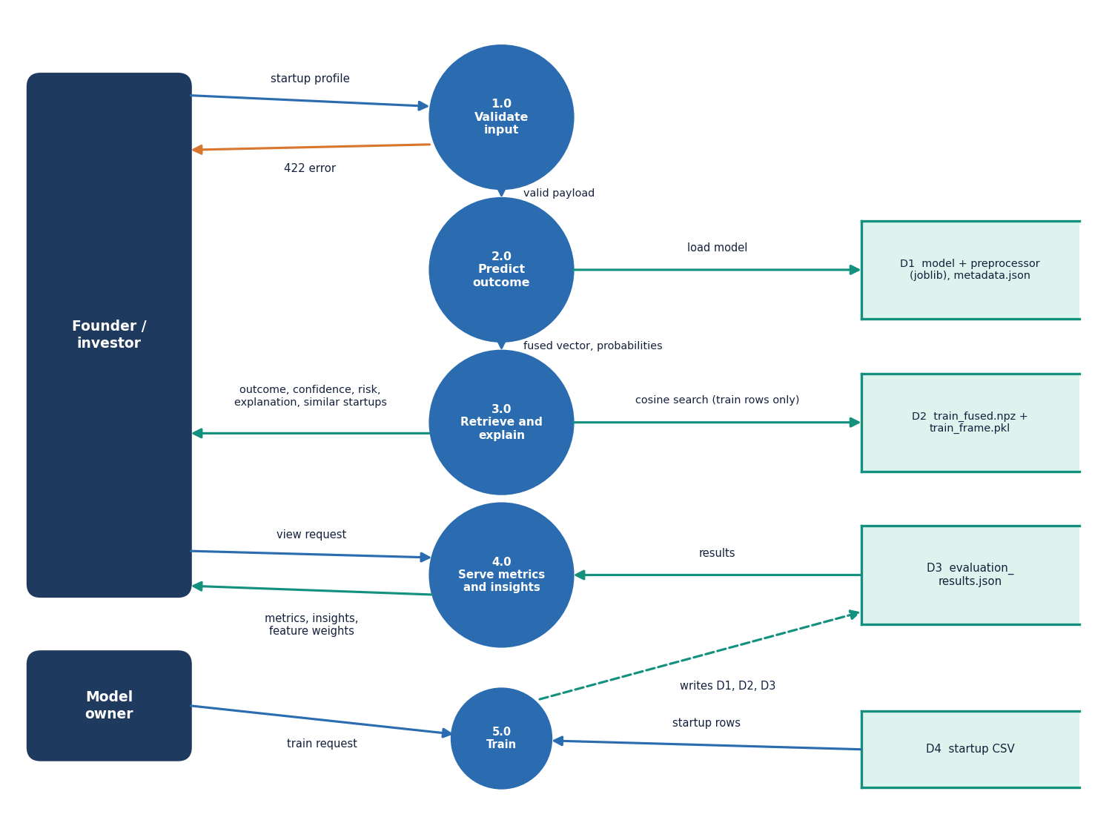
Figure 5: Level 1 data flow diagram: five processes and four data stores.
Level 1. Five processes: 1.0 Validate input, 2.0 Predict outcome, 3.0 Retrieve and explain, 4.0 Serve metrics and insights and 5.0 Train. The stores are D1 (model, preprocessor and metadata), D2 (fused training matrix and training table), D3 (evaluation results) and D4 (the startup CSV). Process 5.0 is the only one that writes D1, D2 and D3; the others only read them.
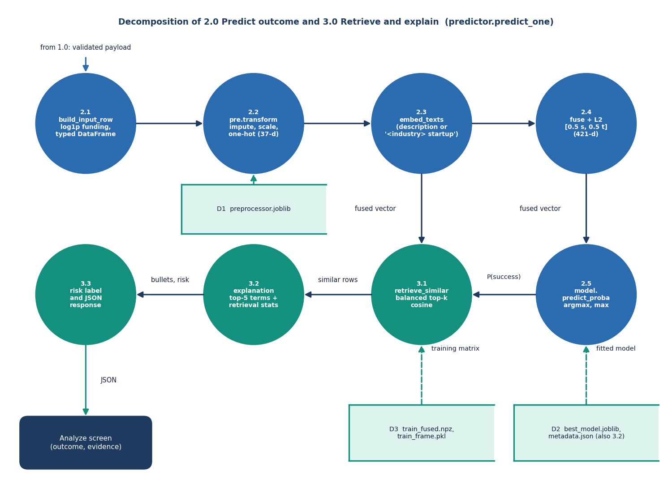
Figure 6: Level 2 data flow diagram: the steps inside 2.0 Predict outcome and 3.0 Retrieve and explain (predict_one).
Level 2. Process 2.0 follows predict_one through five steps: build the input row (2.1), transform the structured values (2.2), embed the description (2.3), fuse (2.4) and classify (2.5). Process 3.0 has three: retrieve the comparable startups (3.1), build the explanation (3.2) and add the risk label and the JSON response (3.3). Steps 2.5 and 3.1 both use the fused vector and are independent of each other.

5.5 UML Diagrams
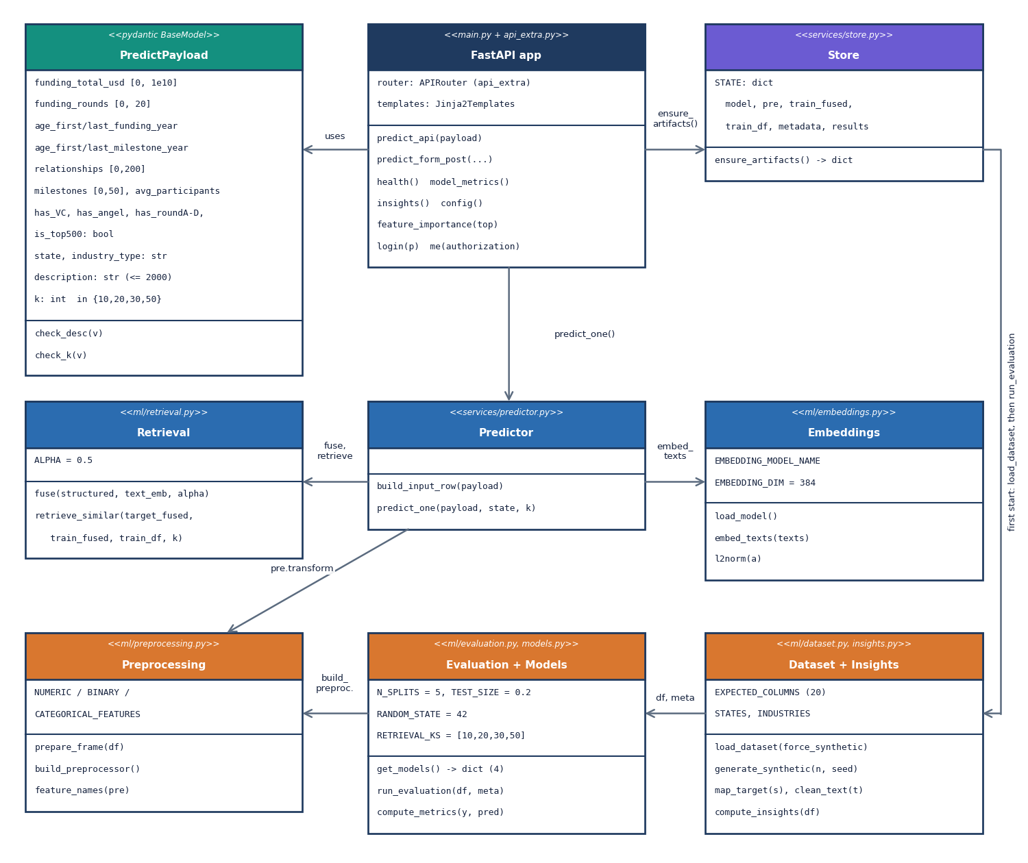
Figure 7: UML class diagram of the main classes and modules.
Class diagram. PredictPayload validates the input. The Store module owns the loaded artefacts in STATE; Predictor converts a payload into a result using Preprocessing, Embeddings and Retrieval and the best model; Evaluation + Models is the only code that fits and saves models; Dataset + Insights loads or generates the table and summarises it. The model objects themselves are standard scikit-learn and XGBoost classes.
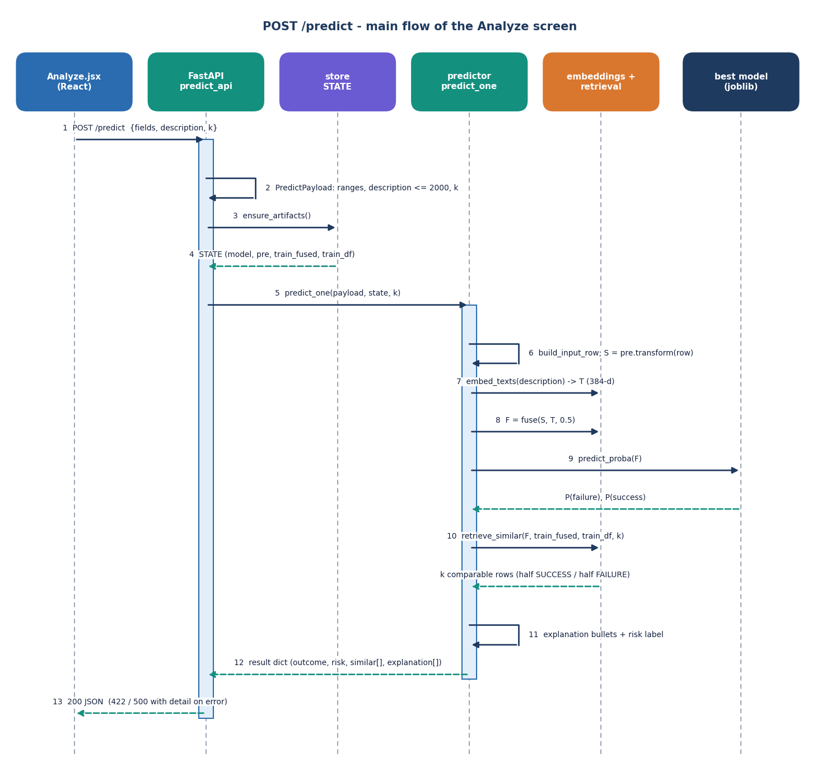
Figure 8: Sequence diagram of one POST /predict request, from the Analyze screen to the model and back.
Sequence: one prediction. The page posts the payload, FastAPI validates it, the predictor builds the row, transforms, embeds, fuses and classifies, retrieval picks the comparable startups, and the explanation is built from the model weights. The measured end-to-end time is a median of 198 ms at k = 50 (95th percentile 583 ms, maximum 716 ms over 30 requests).
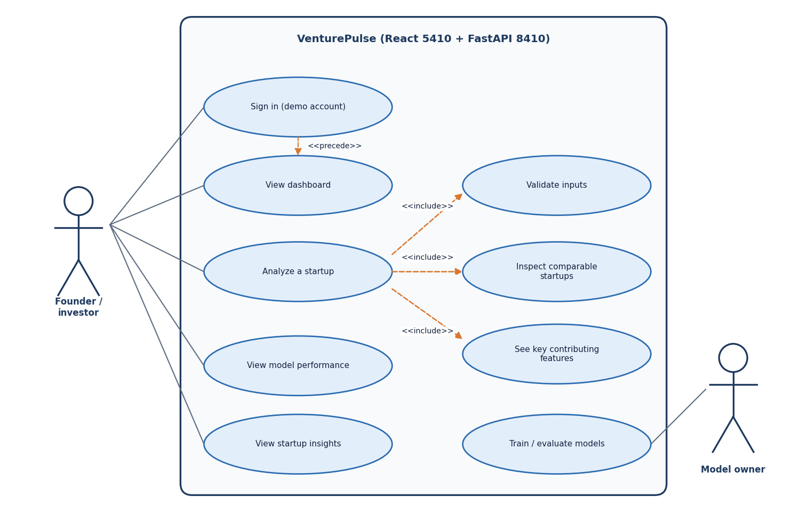
Figure 9: Use case diagram: two actors and eight use cases of VenturePulse.
Use cases. After signing in, the founder or investor views the dashboard and analyses a startup (which includes validation, the comparable startups and the key features), and opens the model performance and insights screens. The model owner trains and evaluates the models from the scripts. The product has one demo account and no role model.

5.6 Data Design
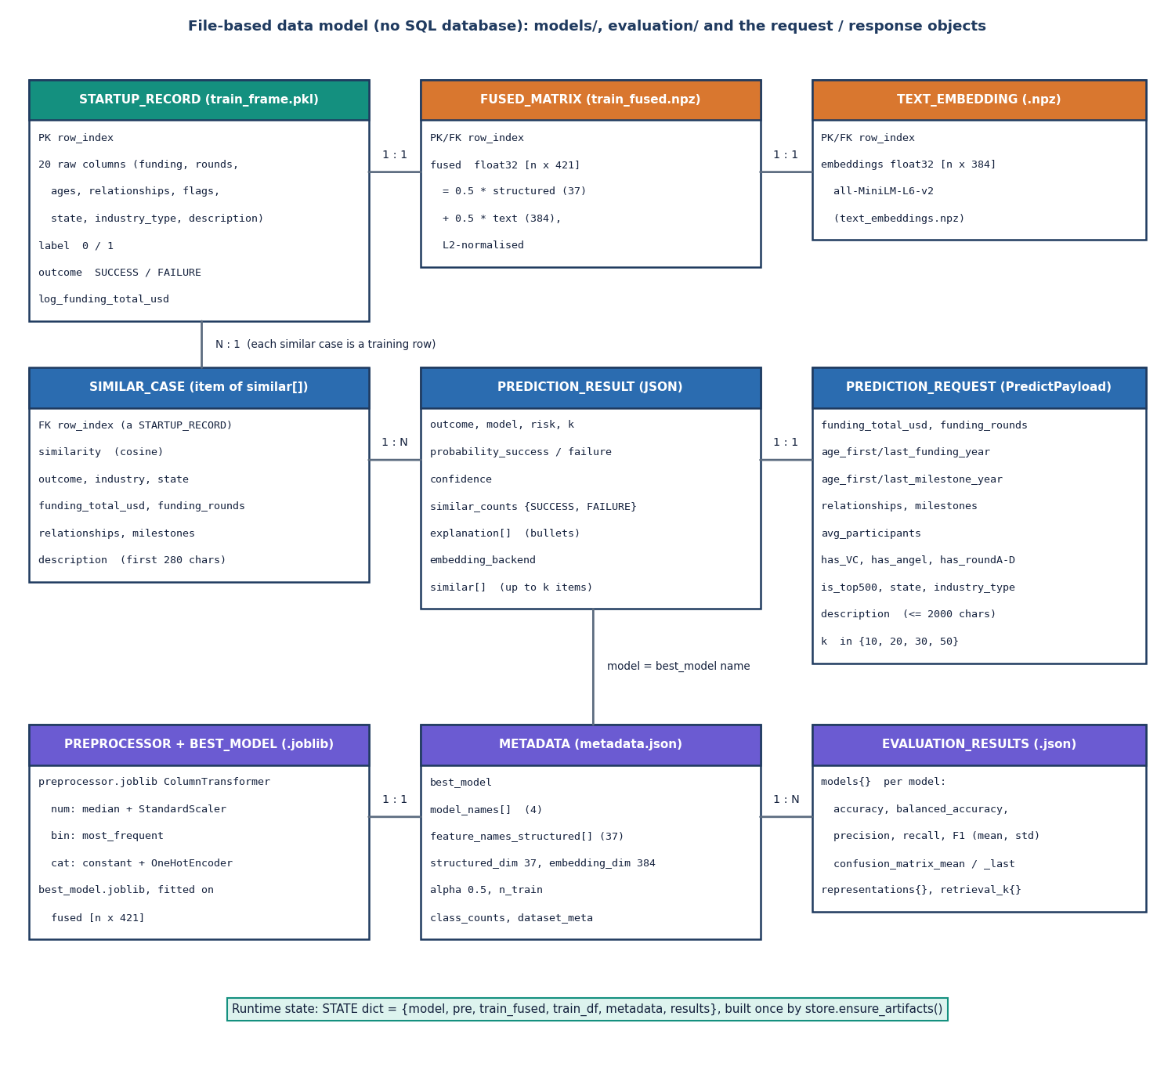
Figure 10: Entity-relationship diagram of the data model; the product has no SQL database.
The product has no SQL database because it keeps no per-user records; the diagram shows the file-based data model. The startup table, the fused matrix and the embeddings are aligned row by row; the preprocessor and the model are fitted from them; the metadata and evaluation files describe them; requests and results are transient.
Table 15: Stored artefacts
Artefact | Location | Content
Historical table | models/train_frame.pkl | 1,400 rows x 23 columns (inputs, description, status, label, outcome, log funding)
Fused training vectors | models/train_fused.npz | 1,400 x 421 float32 (37 structured + 384 text values), unit length
Text embeddings | models/text_embeddings.npz | 1,400 x 384 MiniLM vectors
Preprocessor | models/preprocessor.joblib | ColumnTransformer: median imputer + scaler, most-frequent imputer, one-hot encoder
Best model | models/best_model.joblib | Logistic Regression (selected by balanced accuracy)
Metadata | models/metadata.json | best model, feature names, alpha, embedding backend, class counts, dataset source and the synthetic-fallback flag
Evaluation results | evaluation/evaluation_results.json | mean and standard deviation of five metrics for each model, representation study, retrieval-k study
Real-data results | evaluation/real_results.json, extra_results.json | Studies on the 922-row public table (Chapter 8)

The shipped artefacts were produced from the synthetic fallback table (data/raw/SYNTHETIC_FALLBACK.txt and the synthetic_fallback flag in the metadata say so). If a CSV of the public table is placed in data/raw/ and the artefacts are deleted, the next start retrains on it without a code change. The description column of the historical table is the only free text; company names matching a simple pattern are replaced by "this company" and the text is cut at 2,000 characters.

5.7 Algorithm Design
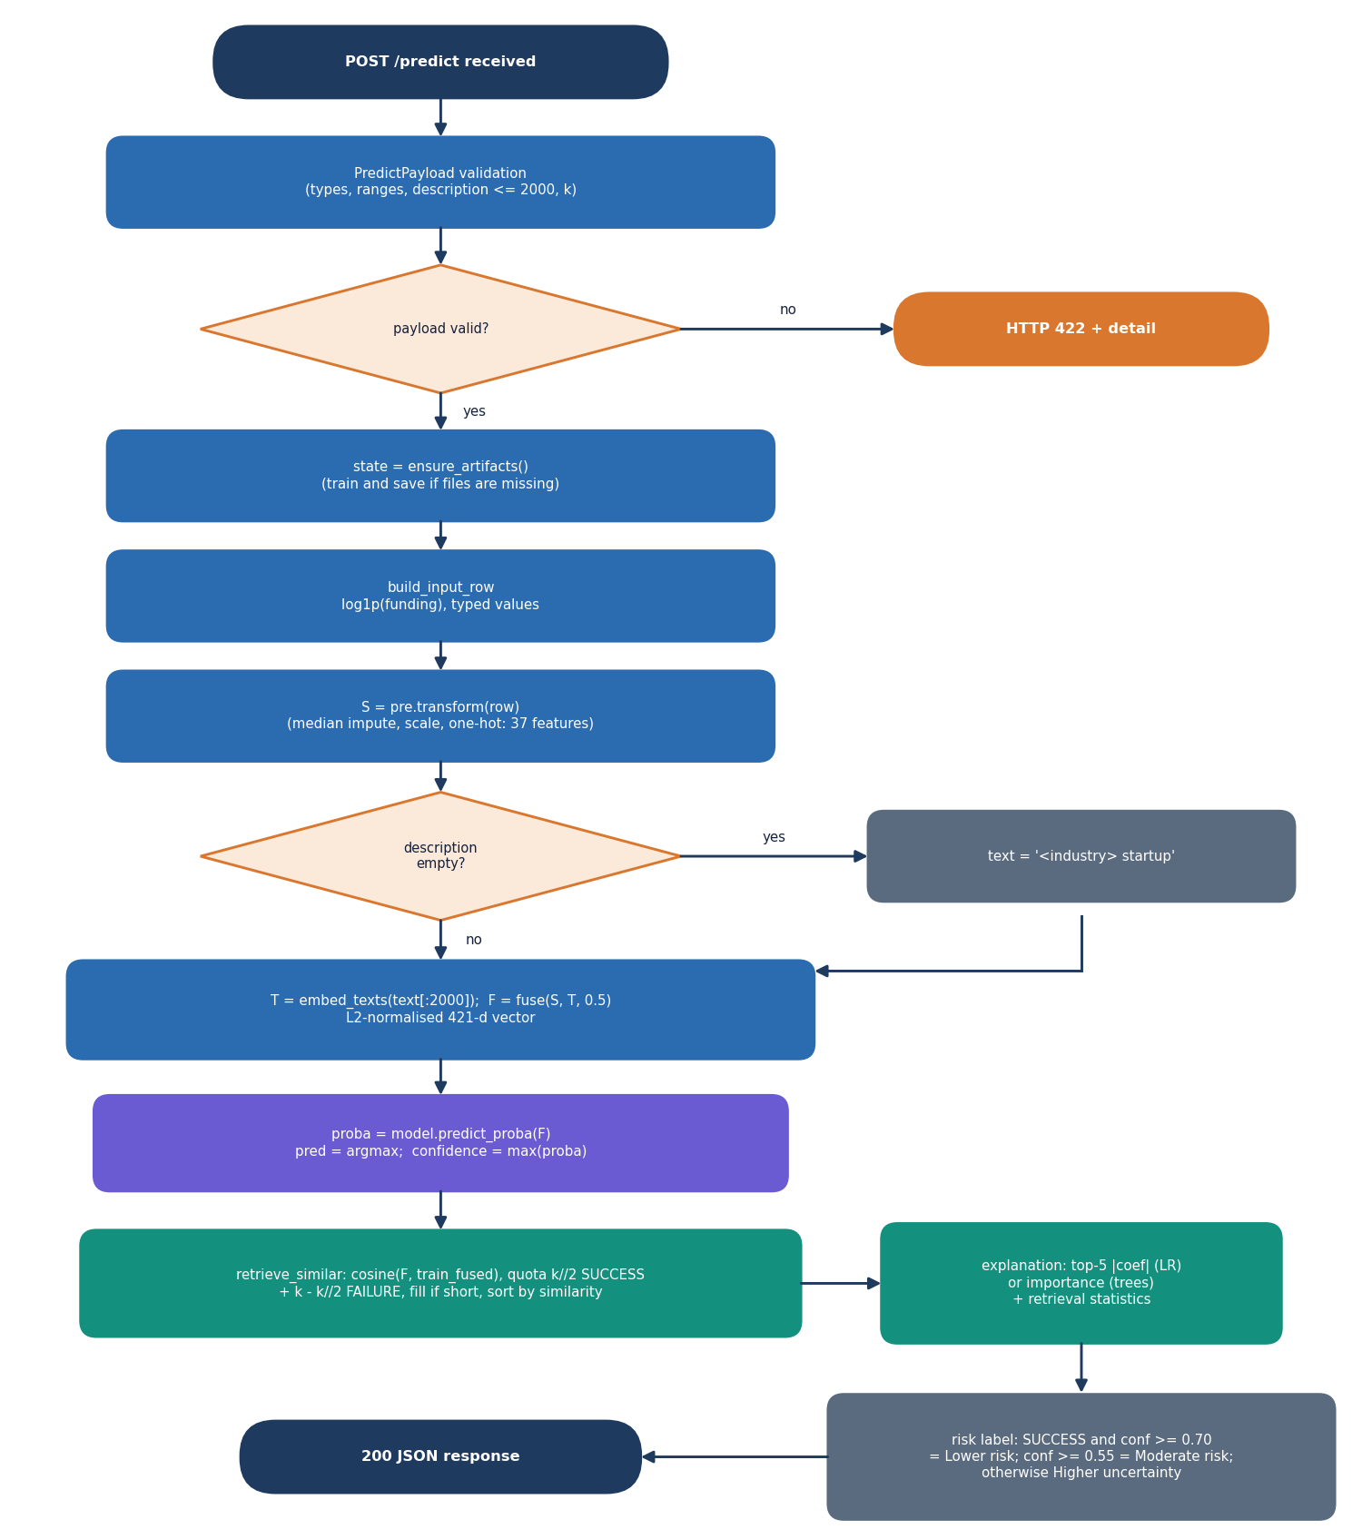
Figure 11: Flowchart of the core algorithm: validation, fusion, classification, balanced retrieval and the risk label.
Fused representation. The structured vector s is the output of the preprocessor (nine numeric fields and the log of funding scaled, seven flags, and ten state and ten industry indicator columns, 37 values). The text vector t is the 384-value MiniLM embedding of the description. Both are scaled to unit length, so each block has the same norm; the fused vector is [alpha s, (1 - alpha) t] with alpha = 0.5, scaled to unit length again, which makes cosine similarity equal to a dot product.
Classification. The model compared in the application are Logistic Regression, Decision Tree, Random Forest and XGBoost, all with class balancing. The best one by mean balanced accuracy serves the predictions; the outcome is the class with the larger probability, which for two classes means a threshold of 0.5 on P(success).
Balanced retrieval. The training vectors are sorted by cosine similarity to the fused vector of the submitted startup. The first k//2 successes and k - k//2 failures are kept, so the evidence shown is half and half even when the table is imbalanced; if one class has too few rows the quota is filled from the remaining nearest rows. The displayed list is sorted by similarity. Search uses training rows only.
Explanation and risk label. For a linear model the five features with the largest absolute coefficients are listed with the scaled value and the sign of coefficient x value (supports SUCCESS or supports FAILURE); for a tree model the five largest importances are listed. Two lines summarise the retrieval (the class counts and the top similarity, and the mean similarity to each class). The risk label is "Lower risk" if the outcome is SUCCESS with confidence at least 0.70, "Moderate risk" if the confidence is at least 0.55, and "Higher uncertainty" otherwise.
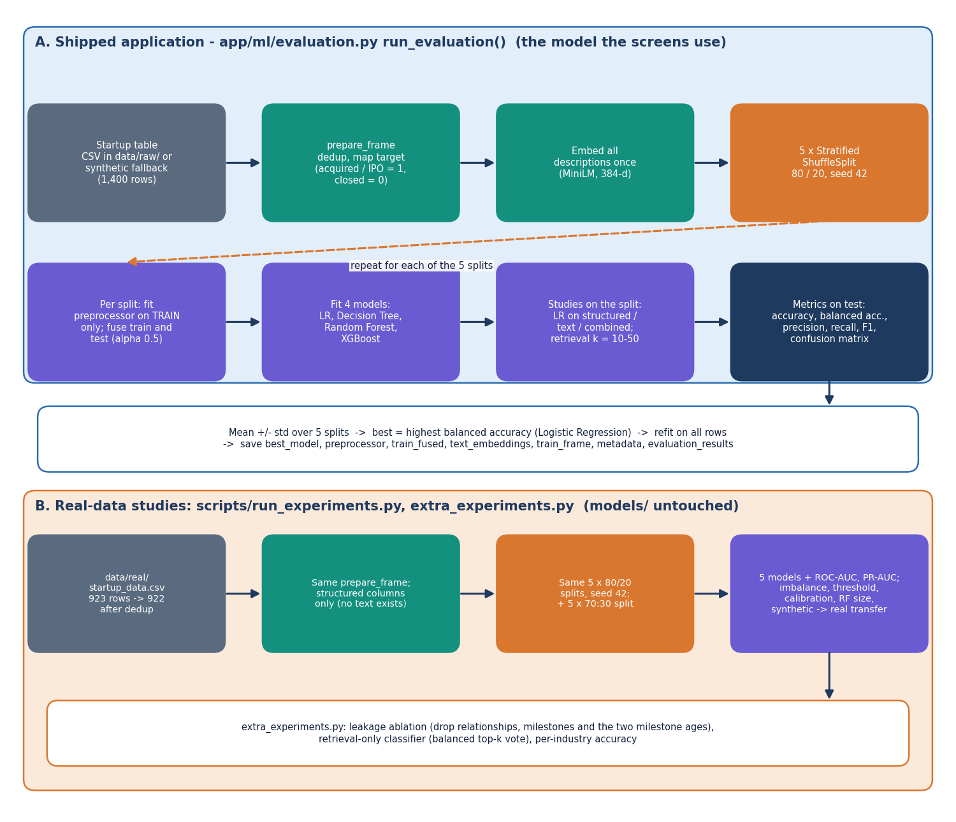
Figure 12: Evaluation protocol: (A) the study that selects the shipped model and (B) the studies on the real public table.
Evaluation. The protocol of the figure is applied to every model and every representation, and the real-data studies of Chapter 8 repeat it on the public table with extra models, imbalance strategies and a threshold sweep.

5.8 Module Design
Table 16: Modules and their responsibilities
Module | Lines | Main contents
app/main.py | 209 | FastAPI app, PredictPayload with range and k validators, /api/health, /api/model-metrics, /api/insights, POST /predict, the Jinja pages and /predict-form
app/api_extra.py | 160 | /api/config, /api/feature-importance, /api/auth/login, /api/auth/me, token functions, field ranges
app/services/store.py | 41 | ensure_artifacts: load artefacts into STATE; train first if a file is missing
app/services/predictor.py | 117 | build_input_row, predict_one: embedding, fusion, classification, retrieval, explanation, risk label
app/services/insights.py | 31 | compute_insights: counts, success rate by industry and state, median funding, correlations
app/ml/dataset.py | 237 | Local CSV / Kaggle loader, generate_synthetic, target mapping, clean_text, load_dataset
app/ml/preprocessing.py | 75 | prepare_frame (dedup, target, coercion, log funding), build_preprocessor, feature_names
app/ml/embeddings.py | 70 | MiniLM loader and embed_texts, deterministic hashing fallback, l2norm
app/ml/retrieval.py | 55 | fuse, retrieve_similar (balanced cosine top-k)
app/ml/models.py | 27 | get_models: four classifiers with their hyper-parameters
app/ml/evaluation.py | 273 | run_evaluation: 5 x 80/20 study, representation and retrieval-k studies, refit, charts, JSON
app/templates/ | 143 | Six Jinja templates (base, dashboard, predict, result, performance, insights)
frontend/src/ | 3,045 | Pages (923 lines), components (UI kit, charts), API client, auth, theme and activity log
scripts/ | 612 | run_experiments.py, extra_experiments.py, edge_tests.py, smoke_test.py, measure_latency.py, train.py

The services cache everything in STATE, so the artefacts are read from disk once per process. Server state in the React application is handled by a small useApi hook with an error-description helper that turns a failed request into a message and a hint (for example, a 422 asks the user to correct the highlighted values).

5.9 User Interface Design
The interface follows a dark, monospace-accented layout with a light theme that can be switched and is remembered in the browser. The application screens share one shell: a sidebar with the four screens and their keyboard shortcuts, a top bar with a screen-jump search box (press /) and the theme toggle, and a card showing the serving model and the number of historical startups. Colour is never the only signal: each outcome has a label and each probability bar has its value written next to it; every form field has a label and an error message.
Table 17: Screens
Route | Screen | Main elements
/ | Landing | Hero, technology strip, how it works, feature overview, link to the demo sign-in
/login | Sign in | Email and password, a button that fills the demo account, error message on a wrong password
/app | Dashboard | Four statistic cards, best validated model, class distribution donut, model comparison bars, how it works, pipeline configuration
/app/analyze | Analyze a startup | Cards for funding and traction, company profile (industry, state, k), investor signals, description (2,000 characters); result with outcome, probability bars, explanation, evidence donut, comparable startups table, submitted inputs
/app/performance | Model performance | Comparison table (mean and standard deviation), balanced accuracy and F1 bars, precision against recall, confusion matrix, retrieval-size and representation studies, feature importance
/app/insights | Startup insights | Success rate by industry and state, industry table, median funding by outcome, correlation of five fields with SUCCESS

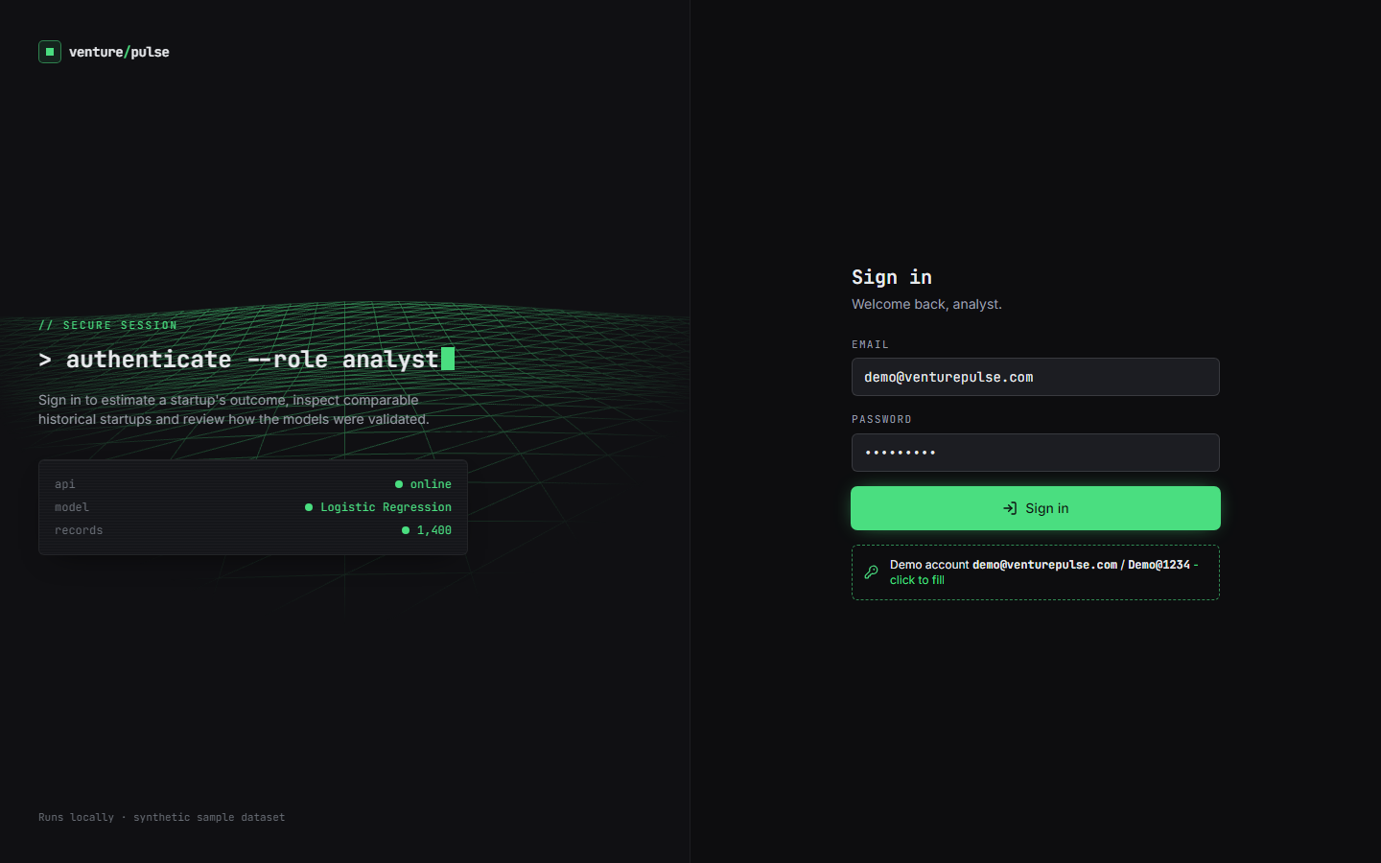  Figure 13: Sign-in screen with the demo account. | 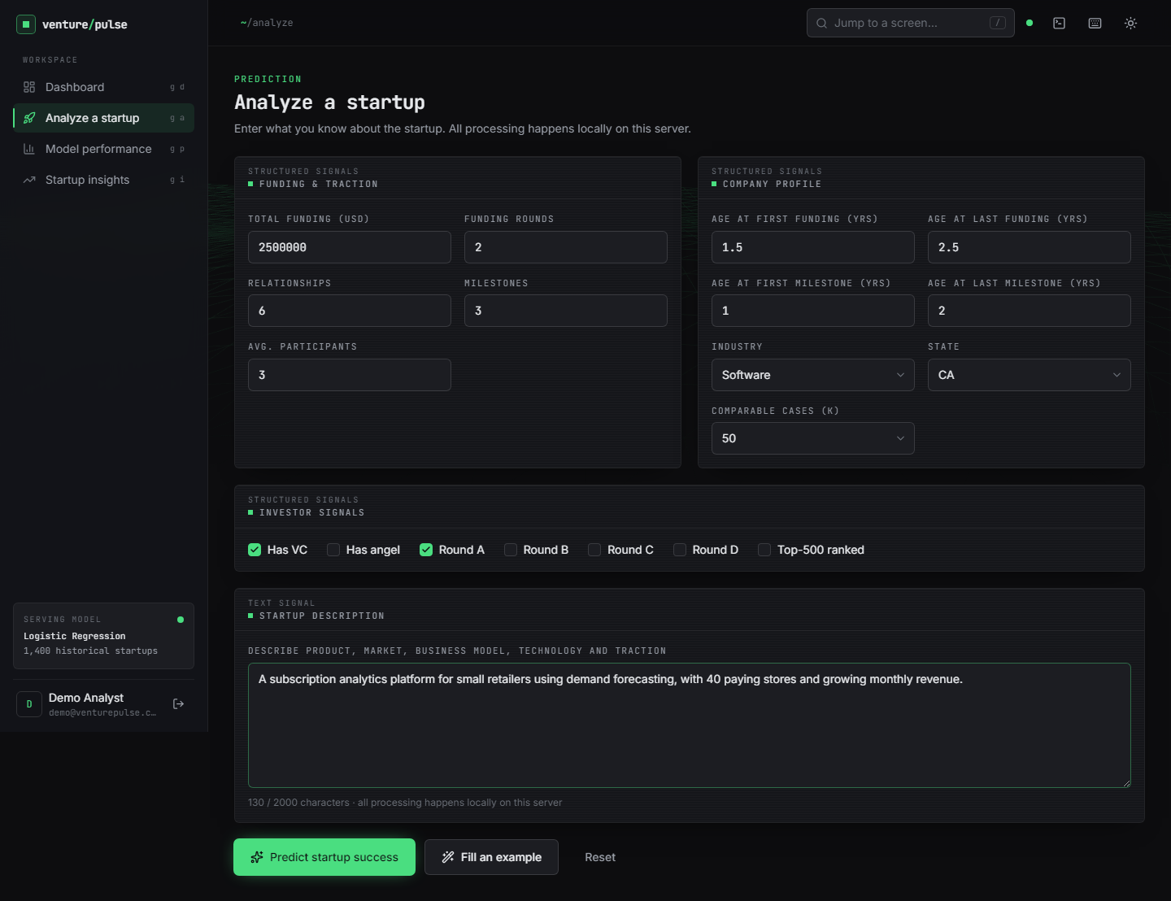  Figure 14: Analyze screen with a submitted example filled in.

The original server-rendered pages show the same four views without a sign-in and are kept so that the backend remains usable on its own. Their prediction form insists on a description (status 400 if it is empty), whereas the JSON route POST /predict accepts an empty description and embeds the industry name instead. The results of every screen are shown and discussed in Chapter 8.

5.10 Design Decisions and Their Consequences
Table 18: Design decisions
Decision | Reason | Consequence
Fuse structured and text vectors by concatenation with weight 0.5 | Gives one vector for classification and retrieval; no extra training | Both blocks count equally whatever their usefulness; alpha was fixed, not tuned
Balanced retrieval quota | Shows evidence for both outcomes even when the table is imbalanced | The displayed counts are always about k/2 each, so they do not show the real class ratio
Logistic Regression as served model | Highest balanced accuracy on the shipped (synthetic) table; transparent coefficients | On the real table Random Forest and XGBoost score higher (Chapter 8); the served model was chosen on synthetic data
Search training rows only | No test row can retrieve itself | A new startup cannot be compared with startups added after training until the artefacts are rebuilt
Artefacts as files, no database | Simple local deployment; nothing to administer | No audit trail, no per-user history; one process holds the state
Deterministic explanation | Same input gives the same text; no sampling | Coefficient-based reasons describe the model, not causes in the real world
Synthetic fallback when the public CSV is absent | The application always starts | Shipped statistics come from 1,400 generated rows and must not be read as real performance
Hash-based embedding fallback | The application still runs if the transformer cannot be loaded | Retrieval quality would drop; the backend name is returned in every result
Demo token in a header | Lets the React screens demonstrate a sign-in | Not a security boundary: one shared account, and the prediction route itself needs no token

CHAPTER 6: METHODOLOGY AND SOFTWARE IMPLEMENTATION

6.1 Overall methodology
The method is a supervised classification pipeline on a mixed table of numbers, flags and categories, extended with a text channel and an evidence channel. A startup is described by nine numeric fields (funding total and rounds, ages at the first and last funding and milestone, relationships, milestones and average participants), seven flags (venture capital, angel investors, rounds A to D and a top-500 mark), a state, an industry and, optionally, a short business description. The structured part is imputed, scaled and one-hot encoded into 37 values. The description is turned into a 384-value sentence embedding by all-MiniLM-L6-v2 [25, 26]. The two blocks are fused into one unit-length vector that is used twice: by the classifier, which gives the probability of SUCCESS, and by a nearest-neighbour search over the training startups, which gives comparable historical cases in the spirit of the retrieval idea of [2] and the classical nearest-neighbour rule [30]. The steps are:
1. Load a startup table: a local CSV of the public Kaggle table if present, otherwise the built-in synthetic generator with the same columns.
2. Prepare: remove duplicate rows, map the status to a label (acquired and IPO to SUCCESS, closed to FAILURE), coerce numbers, normalise categories and add the logarithm of the funding total.
3. Encode: median imputation and standardisation of the numbers, most-frequent imputation of the flags, one-hot encoding of state and industry, giving 37 structured values.
4. Embed the description (company names masked, at most 2,000 characters) with MiniLM and fuse it with the structured vector with weight 0.5 each.
5. Compare Logistic Regression, Decision Tree, Random Forest and XGBoost on five repeated stratified 80/20 splits, with the preprocessor fitted on the training part only.
6. Select the model with the highest mean balanced accuracy, refit it on all rows and store it with the preprocessor and the fused training vectors.
7. Serve: for a submitted startup compute the probability of SUCCESS, retrieve k comparable startups with an equal quota of each outcome, and return an explanation and a risk label.
Figure 15: Evaluation protocol used for model selection and for the reported metrics.
Two sets of measurements. The shipped application was trained on the synthetic fallback table, so the statistics it displays (Logistic Regression 0.749 balanced accuracy) test whether the pipeline recovers a signal that the generator planted. For real evidence the same code (app.ml.preprocessing, app.ml.models and the same split protocol) was run by scripts/run_experiments.py and scripts/extra_experiments.py on the real public table of 922 startups, structured features only, in 139 s on the CPU. Those runs add ROC-AUC and PR-AUC, a fifth model (HistGradientBoosting), two imbalance strategies, a decision-threshold sweep, calibration bins, a forest-size study, the 70:30 protocol of the base paper, a synthetic-to-real transfer test, a leakage ablation and a retrieval-only classifier. Chapter 8 reports them; this chapter describes how they were made.

6.2 Dataset

6.2.1 The public Startup Success Prediction table (all real measurements)
The real data is the public "Startup Success Prediction" table of [32] (listed as public domain): 923 start-ups, 49 columns, almost all in the United States. The outcome column status is acquired for 597 companies and closed for 326. The Kaggle download requires a login, so the identical 923-row CSV was fetched from a public GitHub copy into data/real/startup_data.csv; it was deliberately kept out of data/raw/ so that the shipped application is not changed. The application's own de-duplication leaves 922 rows, 596 SUCCESS (64.6 %) and 326 FAILURE. Success is therefore the majority class, the reverse of the situation assumed in the project objectives. The table has 9 numeric columns, 7 flags, a state code and an industry category code that the script maps to the ten industry names of the application (software, e-commerce, mobile, media, biotech, health technology, clean technology, education; anything else becomes Other); states outside the ten most common become Other. The table has no free-text description, so the text and retrieval channels cannot be evaluated on it.
Three of the numeric columns (relationships, milestones and the two milestone ages) are recorded at or after the end of the observation window for part of the companies, and the table has no time stamps with which to remove them. They are kept for the main results and removed in a separate ablation (Chapter 8); this is the look-ahead problem that the base paper itself cites [9, 29].

6.2.2 The synthetic fallback table (the shipped application)
If no CSV is found the loader calls generate_synthetic (seed 42), which creates 1,400 rows with the same columns: 595 SUCCESS and 805 FAILURE (the success probability of a row is 0.42). Every numeric field is drawn from a distribution whose parameters differ slightly by class (for example, successful companies get a larger mean number of rounds, milestones and relationships, and a higher chance of venture capital and later rounds). The description is built from one of nine templates: with probability 0.35 a template shared by both classes, with 0.45 a template that matches the class, and with 0.20 a template of the other class. The wording of the text therefore depends on the label by construction. The signal in this table is the one the generator planted, so a model that scores well on it shows that the pipeline recovers a planted signal, not that startups can be predicted this well. The fallback is recorded in the metadata (synthetic_fallback: true), in data/raw/SYNTHETIC_FALLBACK.txt and in the dataset note shown on the dashboard.
Table 19: The two data sources
 | Real public table | Synthetic fallback
Rows used | 922 (596 SUCCESS, 326 FAILURE) | 1,400 (595 SUCCESS, 805 FAILURE)
Share of SUCCESS | 64.6 % (majority class) | 42.5 % (minority class)
Description text | None | Template sentences, wording depends on the label
Used for | All real measurements (structured features only) | The shipped model, the dashboard, the screenshots, the representation and retrieval-size studies
Origin | Public Kaggle table, copy from a public GitHub repository | generate_synthetic, seed 42
Evaluation | 5 x 80/20 stratified splits, seed 42 (185 test rows per split) | The same protocol (280 test rows per split)

6.3 Preprocessing and feature construction

6.3.1 Cleaning and the target
prepare_frame removes duplicate rows, maps status to the label (acquired, success, IPO, true, yes and 1 to SUCCESS = 1; closed, failure, no and 0 to FAILURE = 0; any other value is dropped), converts the numeric and flag columns with to_numeric (bad values become missing), strips and normalises the state and industry strings (missing becomes Unknown), adds the column log_funding_total_usd = log(1 + funding) to reduce the heavy tail of funding amounts, and cleans the description. No outlier removal is done.

6.3.2 Structured preprocessor
Table 20: The 37 structured features
Group | Fields | Treatment | Columns
Numeric | age_first_funding_year, age_last_funding_year, age_first_milestone_year, age_last_milestone_year, relationships, funding_rounds, funding_total_usd, milestones, avg_participants, log_funding_total_usd | Median imputation, standardisation | 10
Flags | has_VC, has_angel, has_roundA, has_roundB, has_roundC, has_roundD, is_top500 | Most-frequent imputation | 7
State | CA, CO, FL, IL, MA, NY, OR, PA, TX, WA (and Other when present) | Constant imputation (Unknown), one-hot, unknown categories ignored | 10
Industry | AI, Biotech, CleanTech, E-Commerce, EdTech, FinTech, HealthTech, Media, Mobile, Software (and Other when present) | Same as state | 10

The preprocessor is a scikit-learn ColumnTransformer that is fitted on the training part of every split, so no test statistic reaches the scaler or the imputers. The 37 columns are the same for the shipped table and for the real table fitted on all 922 rows.

6.3.3 Text cleaning and embedding
The description is cleaned by clean_text: a regular expression replaces a capitalised company name followed by Inc, LLC, Labs, Technologies or Systems with "this company", whitespace is collapsed and the text is cut at 2,000 characters. Masking names follows the practice of [2], which prevents a language model from recognising a famous company. The text is embedded by sentence-transformers/all-MiniLM-L6-v2, a 22-million-parameter model that gives a 384-value vector per text on a CPU. If the model cannot be loaded, a deterministic hashing embedding of the same size is used and the backend name (sentence-transformers or hash-fallback) is returned in every result. An empty description is replaced by the text "<industry> startup".

6.3.4 Fusion
Each block is scaled to unit length and the fused vector is [0.5 s, 0.5 t], scaled to unit length again (equation in Section 6.5). The weight alpha = 0.5 is a fixed constant in app/config.py; it was not tuned.

6.3.5 Class imbalance
All classifiers are trained with balanced class weights (class_weight="balanced" for Logistic Regression, Decision Tree and Random Forest). XGBoost is used with its default class handling, and the retrieval step enforces equal quotas. The base paper oversamples with ADASYN [24]; oversampling by random duplication of the minority rows was compared with class weights on the real table (Chapter 8, where the minority class is FAILURE). SMOTE-type synthetic oversampling [23] was not implemented.

6.4 Algorithm choice and justification
Table 21: Algorithms and why they are used
Component | Choice | Reason
Baseline classifier | Logistic Regression | Transparent, fast, signed coefficients give the explanation, and it is the baseline of the base paper [1] and of [2]
Single tree | Decision Tree (depth 8) | Readable rules; high variance, so it shows what ensembling improves
Bagged ensemble | Random Forest (300 trees) [18] | Handles mixed variables and interactions with little tuning; named best model of the base paper
Boosted ensemble | XGBoost [19]; HistGradientBoosting in the real-data study | The boosting family of the objectives (gradient boosting [20]); a second boosting implementation checks that the result is not specific to XGBoost
Text representation | all-MiniLM-L6-v2 sentence embeddings | Small, runs on a CPU, no key or service; captures meaning beyond keywords; used by the base-paper family for startup descriptions
Fusion | Weighted concatenation, unit length | One vector serves the classifier and the search; cosine similarity becomes a dot product
Evidence | Balanced top-k cosine retrieval | Shows comparable startups of both outcomes; retrieval was the idea of [2]; fixes the evidence view when classes are imbalanced
Selection metric | Balanced accuracy | Insensitive to class ratio; the primary metric of [2]
Explanation | Coefficients or importances plus retrieval counts | Deterministic, no sampling, no extra library; SHAP [33] was not used

Support vector machines and gradient boosting are named in the base paper; an SVM was not implemented here because Logistic Regression already serves as the linear baseline and the objectives name Logistic Regression, Decision Tree, Random Forest and boosting ensembles. Deep networks were excluded: with 922 or 1,400 rows they would overfit and could not be tuned reliably, a point made in [2] for few-shot settings.

6.5 Mathematical formulation

6.5.1 Standardisation and the logistic model
Each numeric column is standardised with the training mean and standard deviation. Logistic Regression models the probability of SUCCESS as a sigmoid of a linear score and is fitted by minimising the class-weighted log-loss with an L2 penalty (C = 1):
z = (x - mean) / sd P(y = 1 | x) = 1 / (1 + exp(-(w . x + b))) (1)
minimise sum_i c(y_i) * [ -y_i log p_i - (1 - y_i) log(1 - p_i) ] + (1 / 2C) ||w||^2, c(y) = n / (2 n_y) (2)

6.5.2 Trees and ensembles
A tree chooses splits that reduce the Gini impurity of the child nodes. A Random Forest averages the votes of many trees grown on bootstrap samples with random feature subsets; its Gini importance is the total impurity decrease of a feature, and its permutation importance is the drop in the test ROC-AUC when one feature is shuffled. XGBoost adds trees one by one, each fitted to the gradient of the regularised objective:
G = 1 - sum_c p_c^2 y_hat(x) = sum_k f_k(x) Obj = sum_i l(y_i, y_hat_i) + sum_k [ gamma T_k + (lambda / 2) ||w_k||^2 ] (3)

6.5.3 Fused vector, cosine similarity and the retrieval vote
With s the structured vector and t the text embedding, both scaled to unit length, and alpha = 0.5, the fused vector and the similarity of two startups are
x = [ alpha s , (1 - alpha) t ] / || [ alpha s , (1 - alpha) t ] || sim(x, x') = x . x' (4)
For a submitted startup the training rows are ranked by similarity and the first k//2 SUCCESS rows and k - k//2 FAILURE rows are kept (the set N_k). The similarity-weighted vote used in the retrieval-size study and in the retrieval-only classifier is
p_vote = sum_{i in N_k} max(0, sim_i) * y_i / sum_{i in N_k} max(0, sim_i) predict SUCCESS if p_vote >= 0.5 (5)

6.5.4 Decision rule and risk label
outcome = SUCCESS if P(y = 1 | x) >= 0.5 else FAILURE confidence = max(P(y = 1), P(y = 0)) (6)
The risk label is "Lower risk" if the outcome is SUCCESS and the confidence is at least 0.70, "Moderate risk" if the confidence is at least 0.55, and "Higher uncertainty" otherwise. The threshold of 0.5 is the default; Chapter 8 shows what other thresholds would do on the real data.

6.5.5 Metrics
With TP, FP, TN and FN counted for SUCCESS as the positive class:
accuracy = (TP + TN) / n precision = TP / (TP + FP) recall = TP / (TP + FN) F1 = 2 P R / (P + R) (7)
balanced accuracy = (1/2) [ TP / (TP + FN) + TN / (TN + FP) ] (8)
ROC-AUC = P( score of a random SUCCESS > score of a random FAILURE ) = integral of TPR d(FPR) (9)
Balanced accuracy is the selection metric because it does not reward predicting the majority class. ROC-AUC [28] measures ranking quality independently of the threshold; PR-AUC [27] is stored beside it in the real-data results. Every value is the mean and the standard deviation over five splits.

6.6 Model architecture and training configuration

6.6.1 Hyper-parameters
Table 22: Classifiers and their exact settings (app/ml/models.py)
Model | Settings
Logistic Regression | solver lbfgs, class_weight balanced, max_iter 1000, C 1.0
Decision Tree | max_depth 8, min_samples_split 10, min_samples_leaf 5, class_weight balanced, random_state 42
Random Forest | n_estimators 300, class_weight balanced, min_samples_leaf 2, n_jobs -1, random_state 42
XGBoost | n_estimators 400, max_depth 6, learning_rate 0.05, subsample 0.8, colsample_bytree 0.8, reg_lambda 1.0, eval_metric logloss, random_state 42 (a scikit-learn HistGradientBoosting with the same depth and rate is the code's fallback)
HistGradientBoosting (real-data study only) | max_iter 300, max_depth 4, learning_rate 0.05, l2_regularization 1.0, random_state 42

Table 23: Constants (app/config.py)
Constant | Value | Meaning
RANDOM_STATE | 42 | Seed of the splits and the tree models
N_SPLITS / TEST_SIZE | 5 / 0.2 | Five stratified shuffle splits, 20 % test
ALPHA | 0.5 | Weight of the structured block in the fused vector
EMBEDDING_MODEL_NAME / EMBEDDING_DIM | all-MiniLM-L6-v2 / 384 | Text encoder and its output size
DEFAULT_K / RETRIEVAL_KS | 50 / [10, 20, 30, 50] | Number of comparable startups and the values the API accepts
MAX_DESC_LEN | 2,000 | Longest accepted description (characters)

6.6.2 Training and selection
run_evaluation embeds all descriptions once, runs the five splits and fits the four models on the fused vectors of each split. It also fits Logistic Regression on structured-only, text-only and combined vectors and scores the similarity-weighted vote for each k. The model with the highest mean balanced accuracy is refitted on all 1,400 rows. On the shipped table that is Logistic Regression (0.749 ± 0.025), ahead of XGBoost (0.697 ± 0.010), Random Forest (0.641 ± 0.021) and Decision Tree (0.614 ± 0.041). On the real table the order differs: XGBoost and Random Forest reach 0.746 ± 0.026 and 0.746 ± 0.031, and Logistic Regression 0.709 ± 0.025 (Chapter 8). The served model was therefore selected on synthetic data, and rebuilding the artefacts from a real CSV can select a different model without any code change.

6.6.3 Cost of training
All studies were run on Intel Core i5-12500 (6 cores, 12 threads), 15.7 GB RAM, Windows 11 Pro, CPU only (no GPU). The whole real-data study (five models, five splits, imbalance, threshold, calibration, size and transfer studies and permutation importance) took 139 s, and the extra studies 13.7 s. Training the shipped models on 1,400 rows with embeddings, five splits and charts takes a few minutes the first time, mostly for downloading and running the embedding model; later starts load the stored artefacts in seconds.

6.7 Application architecture
Backend. app/main.py creates the FastAPI application, mounts the static folder, includes the router of app/api_extra.py and defines the routes. Each route calls ensure_artifacts(), which fills the module-level STATE dictionary once per process: it loads best_model.joblib, preprocessor.joblib, train_fused.npz, train_frame.pkl, metadata.json and the evaluation results; if any of the first five files is missing it loads the dataset, prepares it and runs run_evaluation first, which is why the first start takes several minutes. predict_one is a plain function, so the same code is used by the JSON route and by the form route of the original pages.
Frontend. The React application is a set of lazily loaded pages (Landing, Login, Dashboard, Analyze, Performance, Insights) under react-router. A Guard component redirects an unauthenticated visitor from /app to /login. The sign-in token is stored in the browser's local storage (vp_token) and an axios interceptor adds it as a bearer header. Pages fetch their data with a small useApi hook; charts use Recharts; the layout is a Tailwind CSS 4 design with light and dark tokens; an activity log records every API call with its status and time. The production build splits vendor code into separate chunks (React, charts, motion, three.js for the background grid).
Size. The backend is 1,351 lines of Python, the original templates 143 lines, the React source 3,045 lines, the tests 78 lines and the experiment and test scripts 612 lines (measured with wc -l).

6.8 API design
Table 24: Endpoints
Method and path | Request | Response
GET /api/health | none | status, app, records (training rows), best_model; 500 with detail on failure
GET /api/model-metrics | none | Evaluation JSON: models (mean and std of accuracy, balanced_accuracy, precision, recall, f1, confusion matrix), best_model, representations, retrieval_k, metadata
GET /api/insights | none | total, success, failure, success_rate, industries[], states[], median funding by outcome, correlations
POST /predict | JSON payload (below) | outcome, probability_success, probability_failure, confidence, model, risk, similar[], similar_counts, explanation[], embedding_backend, k; 422 on invalid input, 500 on error
GET /api/config | none | States, industries, allowed k values, field ranges and defaults, max_description, best model, class counts, alpha, embedding backend, dataset note, demo email
GET /api/feature-importance?top=N | N (default 15) | model, kind (abs_coefficient or importance), features[] with value and, for linear models, the signed coefficient
POST /api/auth/login | email, password | token, user; 401 with detail if wrong
GET /api/auth/me | Authorization: Bearer <token> | name, email; 401 if the token is missing, altered or expired
GET /, /dashboard, /predict, /performance, /insights | none | Original server-rendered pages
POST /predict-form | Form fields | Result page; 400 with a message if the description is empty or too long, or the values are invalid

The payload of POST /predict has 20 fields, all optional with defaults: the nine numeric fields (funding_total_usd, funding_rounds, age_first_funding_year, age_last_funding_year, age_first_milestone_year, age_last_milestone_year, relationships, milestones, avg_participants), the seven flags (has_VC, has_angel, has_roundA, has_roundB, has_roundC, has_roundD, is_top500), state, industry_type, description and k.
POST /predict
{"funding_total_usd": 2500000, "funding_rounds": 2, "relationships": 6, "milestones": 3,
"has_VC": true, "has_roundA": true, "state": "CA", "industry_type": "Software",
"description": "A subscription analytics platform for small retailers ...", "k": 50}

200 OK
{"outcome": "SUCCESS", "probability_success": 0.83, "probability_failure": 0.17, "confidence": 0.83,
"model": "Logistic Regression", "risk": "Lower risk",
"similar_counts": {"SUCCESS": 25, "FAILURE": 25}, "k": 50,
"similar": [{"similarity": 0.58, "outcome": "SUCCESS", "industry": "Software", "state": "CO", ...}, ...],
"explanation": ["has_roundC: value 0.00 (scaled), weight 2.495 - supports FAILURE", ..., "Retrieved 50 comparable historical startups ..."],
"embedding_backend": "sentence-transformers"}

Measured on 127.0.0.1 with the model loaded (scripts/measure_latency.py): GET /api/health median 3.0 ms, GET /api/model-metrics 3.5 ms, GET /api/insights 14.5 ms, POST /predict 147.8 ms at k = 10 and 198.5 ms at k = 50.

6.9 Security and error handling
• Input validation. The Pydantic model rejects values outside fixed ranges: funding 0 to 1e10, rounds 0 to 20, ages 0 to 30, relationships 0 to 200, milestones 0 to 50, average participants 0 to 50; non-numeric values and a description longer than 2,000 characters are rejected; k must be one of 10, 20, 30 or 50. The response is status 422 with the field names. Unknown industries or states are accepted and handled by the one-hot encoder (unknown categories become all zeros).
• Form route. The original form refuses an empty description (400), clamps negative numbers to zero and replaces an invalid k with the default.
• Failures. Route functions catch exceptions, log them and return status 500 with a detail string; the React page turns a failed request into a message with a hint (for example, "Start the app with run.bat" when the server cannot be reached). The embedding step falls back to the hashing embedding if the transformer cannot be loaded.
• Demo sign-in. The credentials come from the environment or from .env (DEMO_EMAIL, DEMO_PASSWORD, DEMO_SECRET); the defaults are the demo account. The email and the password are compared with hmac.compare_digest. The token is a URL-safe base64 string of email|expiry|signature, where the signature is an HMAC-SHA256 of the email and the expiry; the lifetime is 12 hours and a changed or expired token is rejected with 401.
• What is not protected. The sign-in is for the React screens only: POST /predict and the original pages need no token, there is one shared account, no rate limit, no HTTPS and no audit log. Detailed exception messages are returned to the client. The application is meant to run on localhost and must not be exposed to a network as it is. No security audit or penetration test was carried out.
The 29 API edge cases of scripts/edge_tests.py (Chapter 7) check the ranges, the k whitelist, the description limit, empty and extreme values, the form route, every GET route and the token cases; all 29 pass.

6.10 Installation and execution

6.10.1 One-click start (Windows)
Install Python 3.10 or newer (3.11.9 was used) and Node.js 18 or newer, open the 8.ProjectCode folder and double-click run.bat. The script (1) checks Python and Node, (2) creates .venv, or rebuilds it if it was copied from another machine and is broken, (3) installs requirements.txt (FastAPI 0.115.6, scikit-learn 1.5.2, pandas 2.2.3, XGBoost 2.1.3, sentence-transformers 3.3.1, torch 2.5.1 and others), (4) runs npm install in frontend/ on the first run, and (5) starts the backend in a second window on port 8410, opens the browser at http://localhost:5410 and runs the Vite server on port 5410. The first start downloads the embedding model (about 90 MB) and trains the artefacts if they are missing; later starts take seconds. The ports are set in .env (BACKEND_PORT, FRONTEND_PORT).

6.10.2 By hand
python -m venv .venv
.venv\Scripts\activate
pip install -r requirements.txt
python -m uvicorn app.main:app --host 127.0.0.1 --port 8410

# second terminal
cd frontend
npm install
npm run dev

Sign in with the demo account demo@venturepulse.com / Demo@1234 (the sign-in page has a button that fills it), then use the Dashboard, Analyze a startup, Model performance and Startup insights screens. To use real data, copy the public CSV into data/raw/, delete the files in models/ and restart; the artefacts are rebuilt and the metadata then records the source.

6.10.3 Checks and scripts
.venv\Scripts\python.exe -m pytest tests -q # 7 tests
.venv\Scripts\python.exe scripts\smoke_test.py # 15 checks against a running server
.venv\Scripts\python.exe scripts\edge_tests.py # 29 API edge cases
.venv\Scripts\python.exe scripts\run_experiments.py # real-data study -> evaluation/real_results.json
.venv\Scripts\python.exe scripts\extra_experiments.py # leakage ablation, retrieval-only, per industry
.venv\Scripts\python.exe scripts\measure_latency.py # latency of the API

A Docker route (run-docker.bat, Dockerfile) starts the backend and the original pages only; it was not exercised in this documentation run.

CHAPTER 7: SYSTEM TESTING

7.1 Testing strategy
Testing covers four layers. The functions of the machine-learning layer (dataset loading, preprocessing, embeddings and fusion, balanced retrieval) and the prediction service are tested in the project's own pytest suite. The API as a whole is exercised in-process with the FastAPI test client by the smoke test, which calls every JSON endpoint and the four original pages. A third script drives deliberately awkward requests (out-of-range values, oversized text, wrong types, tampered tokens) through the same client. Finally, the React screens were used in a real browser while the documentation screenshots were captured, and latency was measured against a running server.
All tests check behaviour, not predictive quality. Predictive quality is measured on held-out data with the protocol of Chapter 6 and reported in Chapter 8; a passing test here says nothing about whether a verdict is right. The repository had seven pytest tests and a 15-check smoke test before this documentation run; scripts/edge_tests.py (29 cases) was added, bringing the total to 51 automated checks, all of which pass.
Table 25: Test layers and results
Layer | What it covers | Script | Result
Unit and component | Dataset, preprocessing, embeddings and fusion, balanced retrieval, prediction and API, original pages | pytest tests (tests/test_app.py) | 7 of 7 passed
Integration | Every JSON endpoint, demo sign-in, validation error, the four original pages | scripts/smoke_test.py | 15 of 15 passed
Validation, edge and security | Range limits, wrong types, oversized text, unknown categories, form route, token handling | scripts/edge_tests.py | 29 of 29 passed
Browser checks | Responsive widths, light and dark theme, reduced motion, keyboard use, error states | scripts/ui_checks.py | Passed when the frontend was built; not re-run here
Functional walk-through | All React screens used with a real submission (Section 7.4) | scripts/capture_screens.py | All 9 screens captured
Performance | Latency of the endpoints against a running server | scripts/measure_latency.py | Section 7.6

7.2 Unit and component testing
tests/test_app.py contains 7 tests. They run against the shipped artefacts and small synthetic inputs, so the whole group finishes in 16 to 26 seconds, most of which is loading the embedding model.
Table 26: The seven pytest tests
Test | What it asserts
test_health | GET /api/health returns 200 and status ok
test_dataset | The dataset loader returns more than 200 rows and a status column
test_preprocessing | prepare_frame creates a binary label; the fitted preprocessor returns one row per input; a missing funding value is imputed and no NaN remains
test_embeddings_and_fusion | Embeddings are 384-dimensional; fusing a 10-column structured block with them gives 394 columns
test_retrieval_balanced | retrieve_similar with k = 10 returns 10 rows, both classes present, similarity not above 1
test_predict_and_api | POST /predict returns 200, an outcome of SUCCESS or FAILURE and exactly k = 10 similar startups each with a similarity; invalid input (negative funding, k = 999) is rejected with 400 or 422
test_pages | /, /predict, /performance and /insights return 200

7.3 Integration testing of the API
scripts/smoke_test.py uses the test client, so no port is needed. Its 15 checks are listed below; all pass.
Table 27: Smoke-test checks
# | Check | Expected
1 | GET /api/health | 200 and status ok
2 | GET /api/config | ks equal to 10, 20, 30, 50; industry list contains Software
3 | GET /api/model-metrics | Four models and a best model among them
4 | GET /api/insights | Total above 200; success plus failure equals total
5 | GET /api/feature-importance?top=5 | Five features in descending order of value
6 | Login with a wrong password | 401
7 | Login with the demo account | A token is returned
8 | GET /api/auth/me with the token | 200 and the demo e-mail
9 | GET /api/auth/me without a token | 401
10 | POST /predict with a valid payload and k = 20 | 200; SUCCESS or FAILURE; 20 similar startups; probabilities sum to 1
11 | POST /predict with funding -5 and k = 999 | 422
12-15 | Original pages /dashboard, /predict, /performance, /insights | 200 each

Check 10 runs the whole inference path: preprocessing, text embedding, fusion, the classifier, balanced retrieval and the explanation builder.

7.4 Functional testing
The functional walk-through follows the main use cases of Chapter 5 (sign in, view the dashboard, predict, inspect the evidence, read the performance and insight screens). The interface was driven in Google Chrome by a Playwright script (scripts/capture_screens.py) against the running application at 1440 pixels wide in the dark theme; the screenshots in Chapter 8 are the record of that run. One real submission was used throughout: a software startup in California with USD 2.5 million raised over two rounds, six relationships, three milestones, venture-capital backing and a round A, and the description "A subscription analytics platform for small retailers using demand forecasting, with 40 paying stores and growing monthly revenue."
Table 28: Functional scenarios
Use case | Scenario | Observed result
Sign in | Open the sign-in screen, use the demo-account button, press Sign in | Dashboard opens with the confirmation "Signed in as Demo Analyst"
View dashboard | Open the dashboard | 1,400 historical startups (595 successful, 805 failed, 42.5 %), the selected model Logistic Regression with balanced accuracy 0.749 ± 0.025, a data note that the synthetic fallback is in use
Predict an outcome | Fill the form with the submission above, k = 50, press Predict startup success | SUCCESS, confidence 83.3 %, Lower risk; 25 SUCCESS and 25 FAILURE comparable startups, top similarity 0.580
Predict an outcome | Press Predict with the description empty | The form shows "Describe the startup in a few sentences" and sends nothing (checked in ui_checks.py)
Inspect evidence | Scroll the result: explanation bullets, evidence split, comparable-case table | Five feature contributions with sign, two retrieval statistics, a sortable table of 50 cases over 5 pages
Model performance | Open Model performance | Comparison table of four models, bar charts, precision-recall scatter, confusion matrix 122.2 / 38.8 / 31.0 / 88.0, retrieval-size and representation studies, top-15 coefficients
Startup insights | Open Startup insights | Industry success rates, median funding by outcome ($993K vs $592K), correlations, state table

The walk-through found no crash. It made visible that the screens describe the synthetic-trained model (Section 7.9, finding 1) and that the displayed confidence is not a calibrated probability (Chapter 8).

7.5 Security, validation and edge-case testing
scripts/edge_tests.py sends 29 requests with the FastAPI test client and compares the status code with the intended one; all 29 match. The cases fall into five groups: payload ranges and types for POST /predict, unusual but legal inputs, the form route, the read-only routes and token handling.
Table 29: The 29 edge, validation and security cases
# | Case | Route | Expected | Got | Result
1 | valid request | POST /predict | 200 | 200 | pass
2 | k not in {10,20,30,50} | POST /predict | 422 | 422 | pass
3 | negative funding | POST /predict | 422 | 422 | pass
4 | funding above 1e10 | POST /predict | 422 | 422 | pass
5 | funding rounds above 20 | POST /predict | 422 | 422 | pass
6 | relationships above 200 | POST /predict | 422 | 422 | pass
7 | description over 2000 characters | POST /predict | 422 | 422 | pass
8 | empty description (falls back to industry text) | POST /predict | 200 | 200 | pass
9 | non-numeric funding | POST /predict | 422 | 422 | pass
10 | unknown industry and state (handled by one-hot ignore) | POST /predict | 200 | 200 | pass
11 | zero funding, zero rounds | POST /predict | 200 | 200 | pass
12 | maximum values | POST /predict | 200 | 200 | pass
13 | empty body (all defaults) | POST /predict | 200 | 200 | pass
14 | form post with empty description | POST /predict-form | 400 | 400 | pass
15 | form post with bad k (falls back to default) | POST /predict-form | 200 | 200 | pass
16 | GET /api/health | GET /api/health | 200 | 200 | pass
17 | GET /api/model-metrics | GET /api/model-metrics | 200 | 200 | pass
18 | GET /api/insights | GET /api/insights | 200 | 200 | pass
19 | GET /api/config | GET /api/config | 200 | 200 | pass
20 | GET /api/feature-importance?top=5 | GET /api/feature-importance?top=5 | 200 | 200 | pass
21 | GET / | GET / | 200 | 200 | pass
22 | GET /predict | GET /predict | 200 | 200 | pass
23 | GET /performance | GET /performance | 200 | 200 | pass
24 | GET /insights | GET /insights | 200 | 200 | pass
25 | auth/me without token | GET /api/auth/me | 401 | 401 | pass
26 | login with wrong password | POST /api/auth/login | 401 | 401 | pass
27 | login with demo credentials | POST /api/auth/login | 200 | 200 | pass
28 | auth/me with token | GET /api/auth/me | 200 | 200 | pass
29 | auth/me with tampered token | GET /api/auth/me | 401 | 401 | pass

The Pydantic model rejects values outside the ranges of Chapter 6 (funding up to 1e10, rounds up to 20, relationships up to 200, description up to 2,000 characters, k in 10, 20, 30, 50) with HTTP 422 before any model is called. Unknown industries and states are accepted because the one-hot encoder ignores unseen categories; an empty description falls back to a text built from the industry name; an empty body runs on the defaults. The original form route is stricter on the description (an empty one gives 400, as does the React form before it sends anything) and silently replaces an invalid k by the default.
The demo token is an HMAC-SHA256 signature over the e-mail and an expiry time. A first version of the tampered-token check appended a character after the base64 padding and the token was still accepted, because the decoder ignores characters after the padding; that was a flaw of the test, not of the signature, and the check was corrected to change one character of the signature, after which the token is rejected (401).
These checks cover input validation, range limits and token handling. They do not amount to a security audit: the demo sign-in protects only the React screens, POST /predict and the JSON read endpoints are open on localhost, the model files are loaded with joblib (so they must come from a trusted source), no penetration test was run and no rate limiting exists.

7.6 Performance testing
scripts/measure_latency.py calls a running uvicorn server (127.0.0.1, port 8410, model already loaded). It addresses 127.0.0.1 rather than localhost, because name resolution adds about two seconds per call on the test machine. Hardware: Intel Core i5-12500 (6 cores, 12 threads), 15.7 GB RAM, Windows 11 Pro, CPU only (no GPU). The PC was otherwise idle.
Table 30: Endpoint latency in milliseconds
Endpoint | Requests | Median | Mean | p95 | Max
GET /api/health | 50 | 3.0 | 3.2 | 4.7 | 6.5
GET /api/model-metrics | 50 | 3.5 | 3.6 | 5.3 | 5.6
GET /api/insights | 30 | 14.5 | 16.3 | 24.6 | 44.4
POST /predict, k = 10 | 30 | 147.8 | 207.0 | 593.9 | 812.4
POST /predict, k = 50 | 30 | 198.5 | 263.6 | 582.9 | 716.2

The read-only endpoints answer in 3 to 15 ms at the median. A prediction costs 148 ms at the median for k = 10 and 198 ms for k = 50, because every request embeds the description with MiniLM on the CPU and compares the fused vector with all 1,400 training vectors. The tail is heavier: p95 is 594 ms and 583 ms and the slowest request took 716 ms, so a user will occasionally wait about half a second. The first request after the server starts is much slower: the first call of edge_tests.py took 11.3 s because the embedding model and the artefacts are loaded on demand.
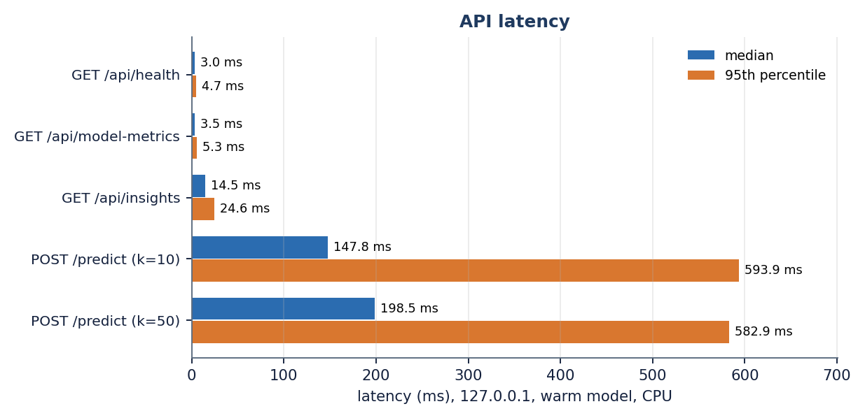
Figure 16: Median and 95th-percentile latency of the endpoints (milliseconds).
Not measured: concurrent requests, memory use, a larger training set (the retrieval cost grows linearly with the number of stored vectors), start-up time of the whole application, any GPU run. Training cost is small: the whole real-data study of Chapter 8 (five models, imbalance, threshold, size and transfer studies) ran in 139 s and the extra studies in 14 s on this CPU.

7.7 User interface testing
The React interface was built with Vite and its nine captured states (landing in two themes, sign-in, dashboard, empty and filled form, result, performance, insights) were produced by scripted browser sessions without a crash. scripts/ui_checks.py checks 360, 768 and 1440 pixel widths, the light and dark themes, reduced-motion preference, keyboard navigation and error states; it passed when the frontend was built and was not re-run for this documentation. For this run only 1440 x 900 was captured.
Only Chrome was used. There are no automated component tests for the React code, and no accessibility audit was made.

7.8 User acceptance testing
No user acceptance test was performed. The project team used the application while building it, but no group of founders, investors or students tried it and no questionnaire was used, so nothing is claimed about whether users find the estimates useful or understandable. The functional walk-through of Section 7.4 stands in for it as a check that the intended tasks can be completed; it measures neither usability nor trust.

7.9 Defects and limitations found by testing
Testing with real data and with awkward requests exposed the behaviours below. They are reported as findings; no product code was changed for this documentation.
Table 31: Findings
# | Finding | Evidence | Consequence
1 | The shipped model was trained on synthetic data | Dashboard data note; models/metadata.json has synthetic_fallback true; 1,400 generated rows | Every score the screens show (0.749 balanced accuracy) is a pipeline check, not real-world evidence
2 | The synthetic description text leaks the label | Text-only model scores 0.599 balanced accuracy on templates that differ by class | The fused 0.749 must not be read as proof that text helps in reality
3 | Displayed confidence is not calibrated | On the real table, Logistic Regression with balanced class weights predicts about 0.25 in a bin where 0.44 of the startups succeed (Chapter 8) | "Confidence 83.3 %" is the model's score, not a frequency
4 | Open endpoints | POST /predict and the JSON reads need no token | Acceptable for a local demonstration; not for a shared deployment
5 | JSON and form routes differ | JSON rejects k = 7 (422); the form silently uses the default; JSON accepts an empty description, the form refuses it | Same input can give different outcomes on the two routes
6 | Slow first request and a heavy latency tail | 11.3 s first call; p95 about 0.6 s | Warm the model at start-up before a demonstration
8 | The explanation ranks features by coefficient size | predictor.py orders by |coefficient| and labels the sign from coefficient x scaled value; an absent flag (value 0) is listed as "supports FAILURE" (has_roundC in the sample result) | The driver list describes the model, not the specific start-up; a contribution-based ranking would fix it
7 | ROC-AUC of the shipped fused model was not recorded | evaluation_results.json holds accuracy, balanced accuracy, precision, recall, F1 only | ROC-AUC is reported from the real-data study instead (Chapter 8)

7.10 Limits of the testing done
• The tests establish that the code behaves as specified for the inputs tried; they do not establish that the estimates are correct. Correctness on real startups is measured in Chapter 8 and is moderate.
• There is no load, stress or concurrency test and no multi-user test; latency figures are for one client on one idle machine and vary between runs.
• No cross-browser, mobile, accessibility, security-audit or user-acceptance testing was carried out (Sections 7.5, 7.7 and 7.8).
• The 51 automated checks run against the shipped synthetic-trained model; none re-runs the real-data experiments, which are scripts whose output files are inspected by hand.
• Tests were run on one machine with one set of package versions; the earlier failure to load model files saved with newer library versions (recorded in the README) is the kind of fault they would only find on a differing installation.

CHAPTER 8: RESULTS AND OUTPUT SCREENS

8.1 What was measured, and on which data
Two tables of start-ups are involved and the numbers of this chapter must never be read without knowing which one they come from. The shipped application runs on a synthetic fallback of 1,400 generated start-ups (595 SUCCESS, 805 FAILURE) that has the schema of the public table and a template-generated business description for each row, because the Kaggle download needed a login. The descriptions of the two classes are written from different templates, so the text channel leaks the label by construction. Scores on this table are a check that the pipeline works, not evidence of real-world skill. The real table is the public "Startup Success Prediction" data [32]: 922 start-ups after de-duplication (596 acquired = SUCCESS, 326 closed = FAILURE), all United States, 16 structured columns plus state and industry, and no description text. Every real measurement below uses it with the structured features only.
Table 32: The two tables
 | Shipped synthetic table | Real public table
Rows | 1,400 | 922
SUCCESS / FAILURE | 595 / 805 (42.5 % / 57.5 %) | 596 / 326 (64.6 % / 35.4 %)
Description text | Yes (templates; leaks the label) | None
Used for | What the application serves and its dashboards | All real-data experiments (scripts/run_experiments.py, scripts/extra_experiments.py)
Test fold size (20 %) | 280 | 185

Figure 17: Class balance of the two tables: success is the minority class in the synthetic table and the majority in the real table.
Protocol: five repeated stratified 80/20 splits with seed 42 (the protocol of [2]), preprocessing fitted on the training part only, mean ± standard deviation over the five splits. Balanced accuracy is the primary metric because the classes are unequal; accuracy, precision, recall and F1 refer to the SUCCESS class, and ROC-AUC is added for the real-data studies. With about 185 test start-ups per split, a standard deviation of 0.02 to 0.03 is expected, and differences smaller than that should not be read as a ranking. The real-data study ran in 139 s and the extra studies in 14 s on Intel Core i5-12500 (6 cores, 12 threads), 15.7 GB RAM, Windows 11 Pro, CPU only (no GPU).

8.2 Output screens
All screens were captured from the running application with a real browser session (Google Chrome driven by Playwright, 1440 pixels wide, dark theme, demo account). The data behind them is the synthetic fallback the application serves, so the dashboard, performance and insight figures describe that table; the prediction was made for one real submission typed into the form. Longer screens are shown scaled to fit the page; Appendix C shows enlarged parts of them.

8.2.1 Landing page, sign-in and the empty form
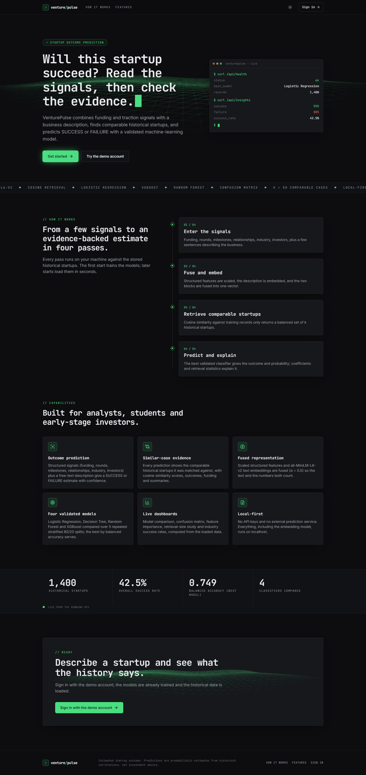  Figure 18: Landing page in the dark theme: headline "Will this startup succeed?", a live terminal card, the four-pass explanation and the six capabilities. | 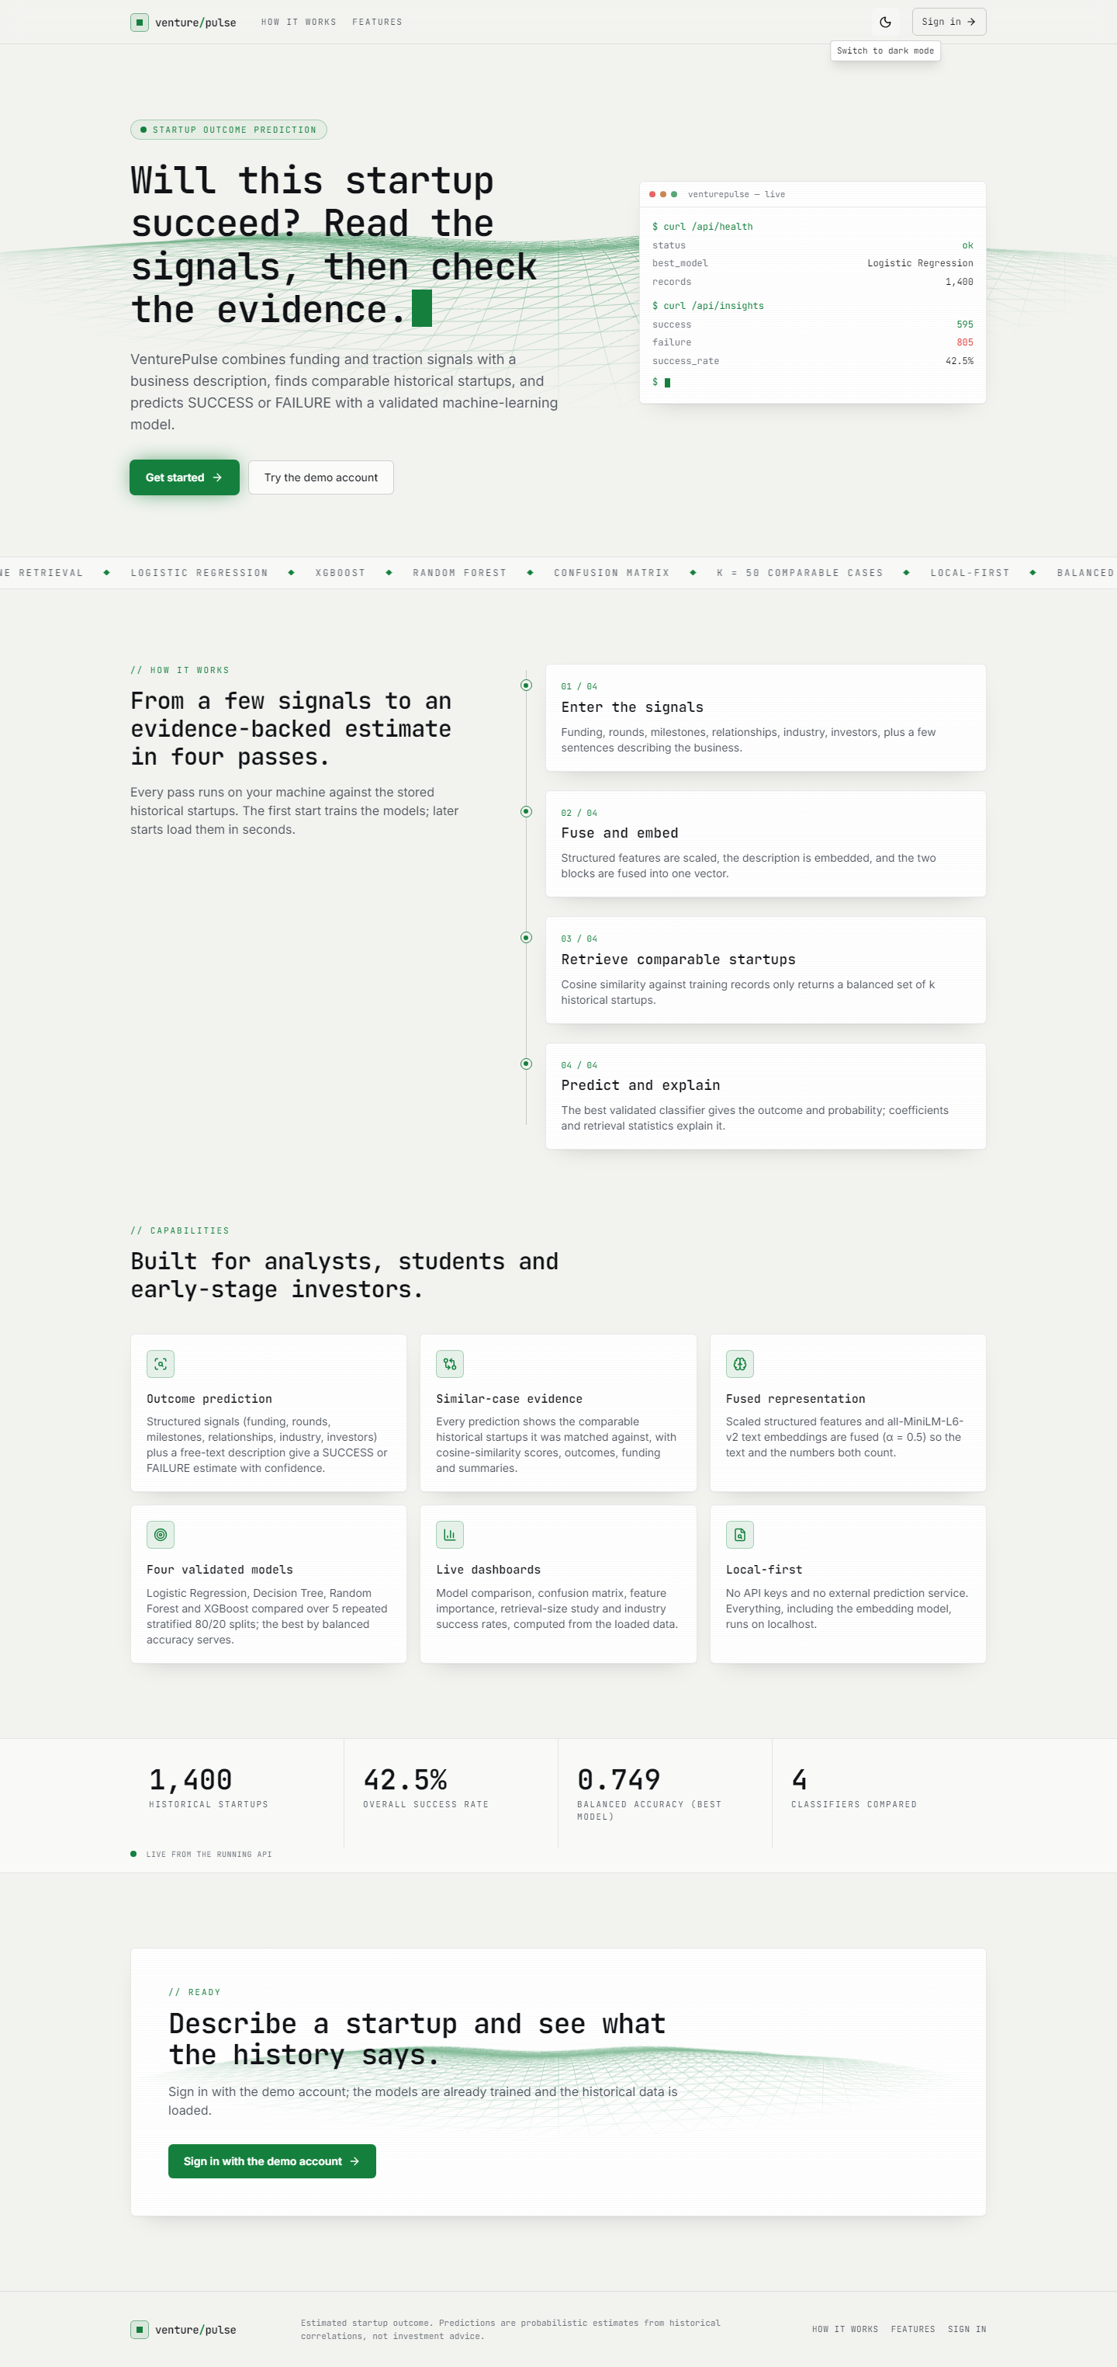  Figure 19: The same landing page in the light theme; the numbers (1,400 start-ups, 42.5 % success, 0.749) are read live from the API.

The landing page (first pair) explains the product in four passes: enter the signals, fuse and embed, retrieve comparable start-ups, predict and explain. The terminal card is filled by two live calls (/api/health and /api/insights) and the strip of counters near the bottom shows 1,400 historical start-ups, a 42.5 % success rate, the best balanced accuracy 0.749 and four classifiers compared. Both themes are supported and the choice is remembered.
Figure 20: Sign-in screen with the demo account prefilled: API online, model Logistic Regression, 1,400 records. | 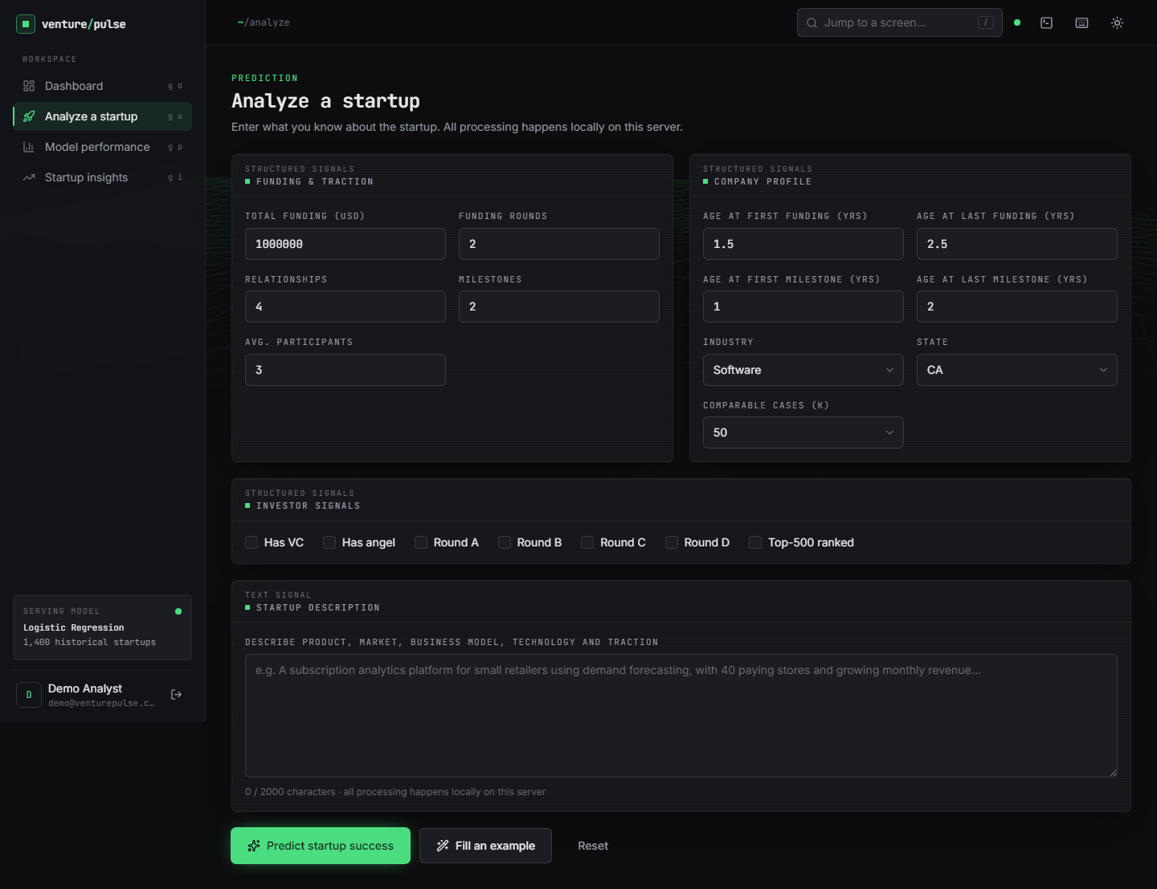  Figure 21: Analyze screen before anything is typed: funding and traction, company profile, investor signals and the description box.

Sign-in (left) uses the demo account; the left panel confirms that the API is online, which model is serving and how many historical records it holds, and the footer says the data is a synthetic sample. The analyze form (right) groups the inputs of Chapter 6: nine numeric fields, an industry and state selector, the number of comparable cases k (10, 20, 30 or 50), seven investor flags and a description of up to 2,000 characters with a live counter.

8.2.2 Dashboard

Figure 22: Dashboard: dataset counters, the selected model with its five validation scores, the class distribution, the model comparison chart and the pipeline configuration.
The dashboard opens after sign-in. It shows 1,400 historical start-ups (595 successful, 805 failed, a 42.5 % success rate), the best validated model Logistic Regression with balanced accuracy 0.749 ± 0.025, accuracy 0.751, precision 0.696, recall 0.739 and F1 0.716, a doughnut of the class distribution and a bar chart comparing the four models. An amber data note states that the public download was unavailable and the synthetic dataset is in use, so a reader cannot mistake these figures for real-world performance. The configuration card lists the 384-dimensional embedding, the structured weight 0.5, the default of 50 comparable cases and the class balance.

8.2.3 Analyze: the filled form and the result
Figure 23: Analyze screen filled with the submission used throughout this chapter (a software start-up in California with USD 2.5 million raised in two rounds).
The submission is the one described in Section 8.5. The form validates before sending: an empty description or a number outside its range is refused with a message, and all processing happens on the local server.

Figure 24: Result screen: SUCCESS with confidence 83.3 % (Lower risk), the five key contributing features, the 25 / 25 evidence split and the table of comparable historical start-ups.
The result screen answers in four blocks. The headline shows the estimated outcome SUCCESS, the confidence 83.3 % (the larger of the two probabilities, success 0.83 and failure 0.17), the model, a risk label (Lower risk, because the outcome is SUCCESS and the confidence is at least 0.70) and the disclaimer that the estimate is not a guarantee. The explanation lists five feature contributions of the Logistic Regression and two retrieval statistics. The doughnut shows the evidence split of the k = 50 comparable start-ups, 25 SUCCESS and 25 FAILURE, and the table lists them with similarity (best 0.580), outcome, industry, state, funding, rounds and summary, sortable and paged (5 pages of 10). The last block repeats the submitted inputs.

8.2.4 Model performance and insights
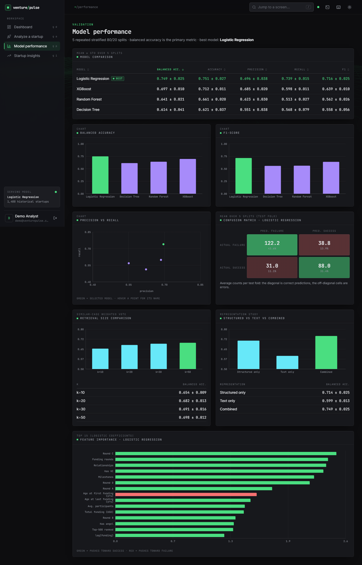
Figure 25: Model performance screen: comparison table of four models, bar charts, precision-recall scatter, the confusion matrix of Logistic Regression, retrieval-size and representation studies, and the top-15 coefficients.
The performance screen reproduces the evaluation of the shipped application on the synthetic table. The table ranks the models by balanced accuracy (Logistic Regression 0.749, XGBoost 0.697, Random Forest 0.641, Decision Tree 0.614); the confusion matrix gives the mean per test fold of 280 start-ups (122.2 true failures, 38.8 false successes, 31.0 missed successes, 88.0 true successes); the retrieval-size panel shows the weighted vote improving from 0.654 at k = 10 to 0.698 at k = 50; the representation panel shows structured only 0.714, text only 0.599 and combined 0.749; and the coefficient chart is led by round C, funding rounds, relationships and venture-capital backing. On the real table the order of the models is different (Section 8.3.1).
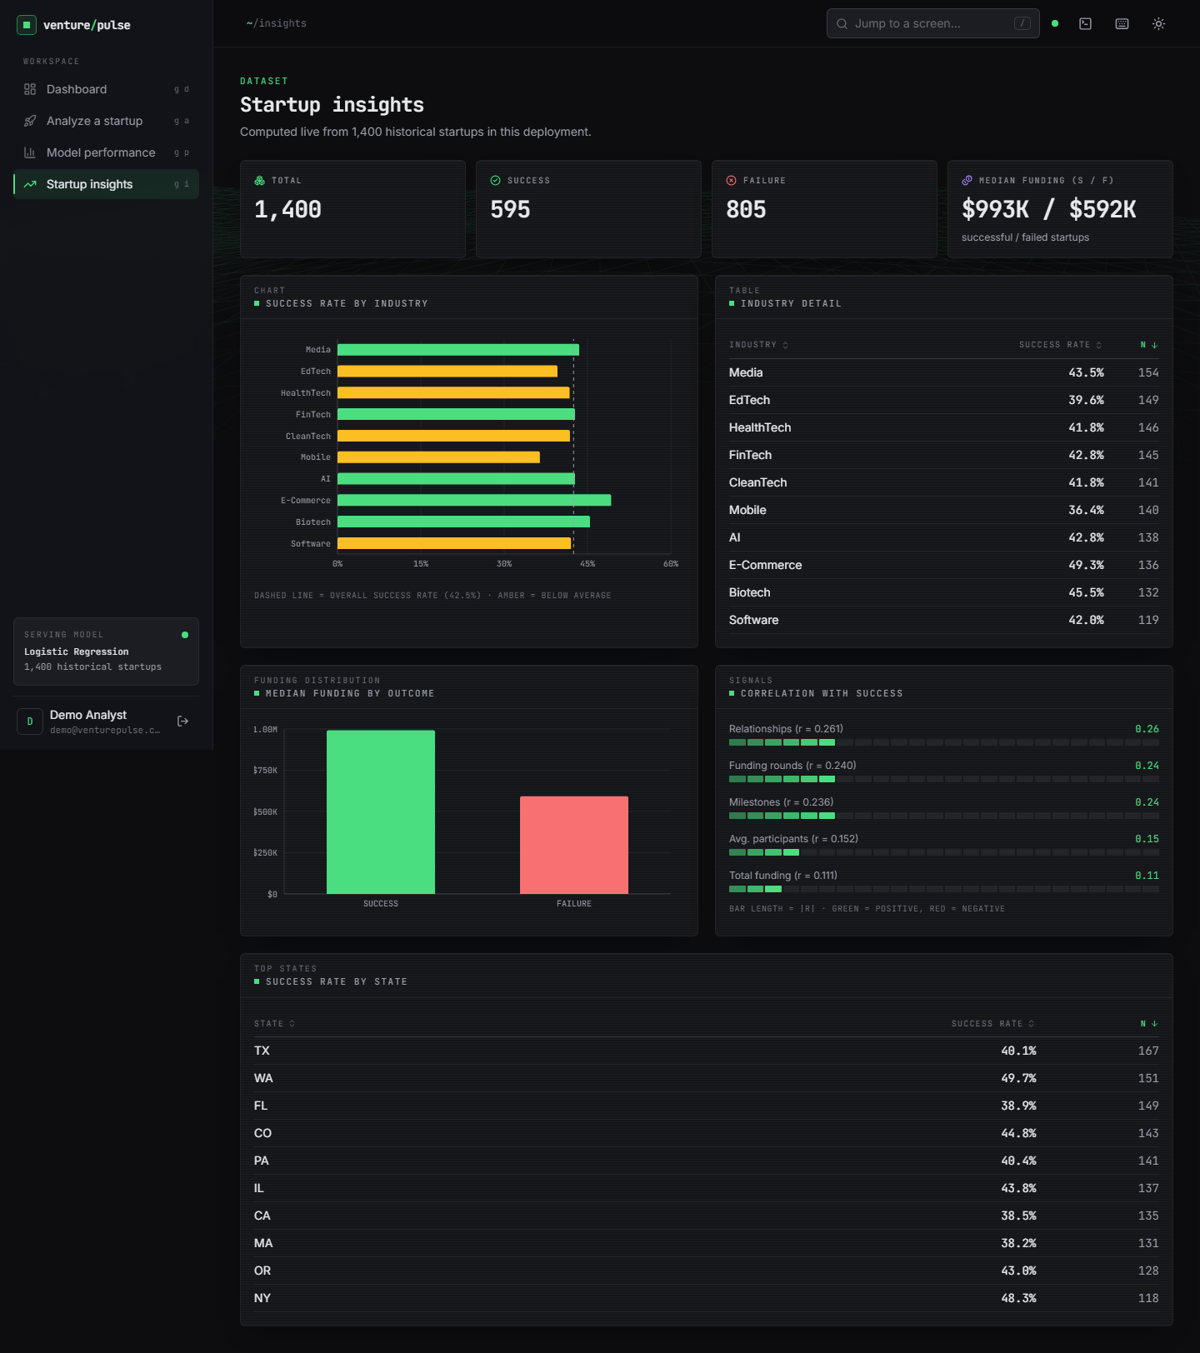
Figure 26: Startup insights screen: totals, success rate by industry, median funding by outcome, correlations with success and success rate by state, all computed from the 1,400 loaded records.
The insights screen is descriptive. Median funding is USD 993 K for successful and USD 592 K for failed start-ups; relationships (r = 0.261), funding rounds (0.240) and milestones (0.236) correlate most with success; industry success rates range from 36.4 % (Mobile) to 49.3 % (E-Commerce) and state rates from 38.2 % to 49.7 %. These are properties of the synthetic generator, not findings about real start-ups.

8.3 Model performance

8.3.1 Comparison of the models on the real table
The four classifiers of the application and HistGradientBoosting (a second boosting ensemble added for the study) were trained with the application's own preprocessing and hyper-parameters, class-weighted where the model supports it, on the structured features of the real table.
Table 33: Real table, 5 x 80/20 splits, structured features (mean ± std)
Model | Accuracy | Balanced acc. | Precision | Recall | F1 | ROC-AUC
Logistic Regression | 0.698 ± 0.024 | 0.709 ± 0.025 | 0.830 ± 0.021 | 0.673 ± 0.023 | 0.743 ± 0.021 | 0.789 ± 0.017
Decision Tree | 0.717 ± 0.033 | 0.703 ± 0.031 | 0.802 ± 0.021 | 0.748 ± 0.042 | 0.774 ± 0.029 | 0.742 ± 0.046
Random Forest | 0.773 ± 0.036 | 0.746 ± 0.031 | 0.817 ± 0.015 | 0.837 ± 0.048 | 0.826 ± 0.031 | 0.816 ± 0.022
XGBoost | 0.775 ± 0.031 | 0.746 ± 0.026 | 0.816 ± 0.015 | 0.843 ± 0.045 | 0.829 ± 0.026 | 0.806 ± 0.019
HistGradientBoosting | 0.761 ± 0.029 | 0.727 ± 0.023 | 0.800 ± 0.010 | 0.842 ± 0.047 | 0.820 ± 0.026 | 0.806 ± 0.018

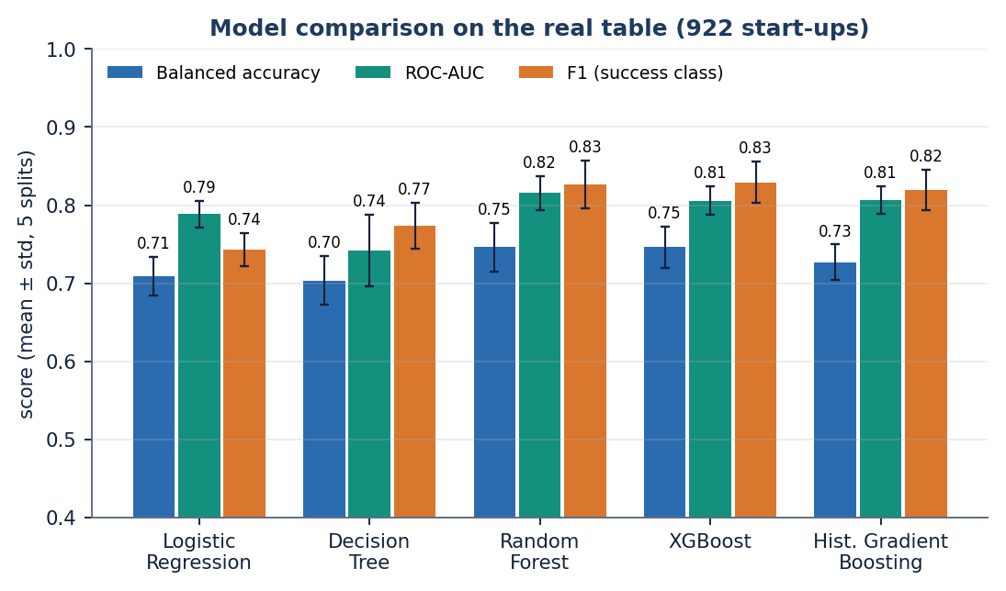
Figure 27: Balanced accuracy, ROC-AUC and F1 of the five models on the real table (error bars: standard deviation over five splits).
The tree ensembles lead: Random Forest and XGBoost reach balanced accuracy 0.746 ± 0.031 and 0.746 ± 0.026, accuracy 0.773 ± 0.036 and 0.775 ± 0.031, F1 0.826 ± 0.031 and 0.829 ± 0.026, with the best ROC-AUC for Random Forest (0.816 ± 0.022). Logistic Regression is clearly behind on accuracy (0.698 ± 0.024) but close on ROC-AUC (0.789 ± 0.017); the single Decision Tree has the worst ranking quality (0.742 ± 0.046). Random Forest, XGBoost and HistGradientBoosting are within one standard deviation of each other on every metric, so no ranking among the three should be claimed. The ensemble advantage over Logistic Regression is real but modest: about 0.04 in balanced accuracy and 0.02 to 0.03 in ROC-AUC.
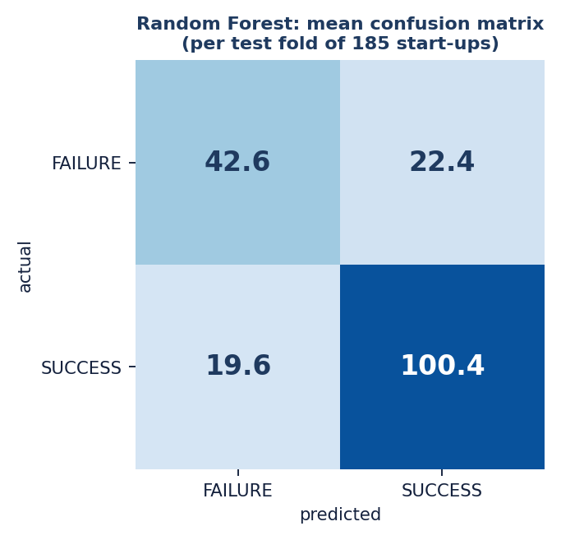
Figure 28: Random Forest, mean confusion matrix per test fold (rows: actual class, columns: predicted class).
For Random Forest the mean test fold of 185 start-ups holds 42.6 true failures, 22.4 false successes, 19.6 missed successes and 100.4 true successes: 84 % of the successes are found (recall 0.837) but only 66 % of the failures are recognised (42.6 of 65). Logistic Regression has the opposite balance, finding 74 % of the failures (48.4 of 65) but only 67 % of the successes (80.8 of 120).

8.3.2 The base-paper protocol: a single 70:30 split
The declared base paper [1] uses a 70:30 split. The same models were also run with a stratified 70:30 split repeated over five seeds.
Table 34: Real table, 70:30 split x 5 seeds (mean ± std)
Model | Accuracy | Balanced acc. | Precision | Recall | F1 | ROC-AUC
Logistic Regression | 0.729 ± 0.011 | 0.722 ± 0.022 | 0.820 ± 0.028 | 0.746 ± 0.027 | 0.781 ± 0.007 | 0.795 ± 0.024
Random Forest | 0.796 ± 0.013 | 0.755 ± 0.025 | 0.810 ± 0.024 | 0.897 ± 0.025 | 0.851 ± 0.007 | 0.828 ± 0.020
HistGradientBoosting | 0.786 ± 0.013 | 0.748 ± 0.027 | 0.809 ± 0.027 | 0.878 ± 0.022 | 0.842 ± 0.005 | 0.824 ± 0.020

Under this protocol Random Forest reaches accuracy 0.796 ± 0.013 and F1 0.851 ± 0.007, HistGradientBoosting 0.786 ± 0.013, and Logistic Regression 0.729 ± 0.011. The ensemble-over-linear ranking reported by the base paper is reproduced; its 85 to 92 % accuracy level is not (Section 8.4).

8.3.3 Handling the class imbalance
Objective 3 assumes that success is rare. In the real table the opposite is true: 64.6 % of the start-ups are successes, so failure is the minority class. Class weights and random oversampling of the minority were compared with no correction.
Table 35: Imbalance strategies on the real table (mean ± std)
Model | Strategy | Balanced acc. | Recall (success) | F1 | ROC-AUC
Logistic Regression | none | 0.714 ± 0.020 | 0.815 ± 0.030 | 0.805 ± 0.019 | 0.791 ± 0.016
Logistic Regression | class weights | 0.709 ± 0.025 | 0.673 ± 0.023 | 0.743 ± 0.021 | 0.789 ± 0.017
Logistic Regression | random oversampling | 0.712 ± 0.022 | 0.683 ± 0.019 | 0.749 ± 0.018 | 0.783 ± 0.019
Random Forest | none | 0.750 ± 0.025 | 0.878 ± 0.044 | 0.843 ± 0.025 | 0.820 ± 0.018
Random Forest | class weights | 0.746 ± 0.031 | 0.837 ± 0.048 | 0.826 ± 0.031 | 0.816 ± 0.022
Random Forest | random oversampling | 0.749 ± 0.026 | 0.858 ± 0.041 | 0.836 ± 0.026 | 0.816 ± 0.021

Neither correction changes balanced accuracy or ROC-AUC beyond the noise. They move the operating point: removing the correction gives the highest recall of the (majority) success class (0.815 for Logistic Regression, 0.878 for Random Forest) and the correction trades part of it for better recognition of failures. The correction is therefore a choice of error balance, not a gain in discrimination; the application keeps balanced class weights.

8.3.4 Decision threshold
Table 36: Logistic Regression: threshold sweep on the real table (pooled test predictions of the five splits)
Threshold on P(success) | Precision | Recall (success) | F1 | Balanced acc.
0.20 | 0.739 | 0.943 | 0.829 | 0.664
0.25 | 0.761 | 0.913 | 0.830 | 0.692
0.30 | 0.781 | 0.875 | 0.825 | 0.711
0.35 | 0.793 | 0.823 | 0.808 | 0.713
0.40 | 0.801 | 0.780 | 0.791 | 0.712
0.45 | 0.820 | 0.720 | 0.767 | 0.714
0.50 | 0.830 | 0.673 | 0.743 | 0.709
0.55 | 0.842 | 0.605 | 0.704 | 0.698
0.60 | 0.851 | 0.535 | 0.657 | 0.681
0.65 | 0.872 | 0.467 | 0.608 | 0.670
0.70 | 0.894 | 0.392 | 0.545 | 0.653
0.75 | 0.914 | 0.318 | 0.472 | 0.631
0.80 | 0.909 | 0.217 | 0.350 | 0.588

Balanced accuracy is flat (0.71) between thresholds 0.30 and 0.50 and falls beyond 0.55. Raising the threshold buys precision (0.83 at 0.50, 0.91 at 0.75) at the price of recall (0.67 and 0.32). An investor who wants few false successes would choose a high threshold and accept that most successes are missed; one who wants a broad shortlist would choose 0.30 (recall 0.875, precision 0.781). The application uses 0.5.

8.3.5 Size of the Random Forest
Table 37: Random Forest, number of trees (class-weighted, real table)
Trees | Balanced acc. | ROC-AUC
50 | 0.742 ± 0.024 | 0.803 ± 0.022
100 | 0.744 ± 0.025 | 0.813 ± 0.022
300 | 0.746 ± 0.031 | 0.816 ± 0.022
600 | 0.741 ± 0.025 | 0.815 ± 0.020

Going from 50 to 300 trees raises ROC-AUC from 0.803 to 0.816; 600 trees give no further gain. The application's 300 trees are therefore a sensible size.

8.3.6 How far the probability can be trusted
Table 38: Logistic Regression (class-weighted), reliability of the predicted P(success) on the real table
Predicted bin | Start-ups | Mean predicted | Observed success rate | Observed - predicted
0.0-0.1 | 48 | 0.061 | 0.083 | +0.022
0.1-0.2 | 111 | 0.151 | 0.270 | +0.119
0.2-0.3 | 94 | 0.252 | 0.436 | +0.184
0.3-0.4 | 88 | 0.348 | 0.648 | +0.300
0.4-0.5 | 97 | 0.448 | 0.660 | +0.212
0.5-0.6 | 110 | 0.550 | 0.755 | +0.205
0.6-0.7 | 114 | 0.649 | 0.754 | +0.105
0.7-0.8 | 120 | 0.750 | 0.875 | +0.125
0.8-0.9 | 71 | 0.851 | 0.887 | +0.036
0.9-1.0 | 72 | 0.953 | 0.931 | -0.022

The curve lies above the diagonal in every bin: balanced class weights pull the probabilities towards 0.5 whereas the real success share is 64.6 %, so a start-up scored 0.25 actually succeeded 44 % of the time. The ranking is informative (observed success rises from 8 % to 93 % across the bins) but the number shown as confidence is a score, not a frequency. Isotonic or Platt re-calibration was not applied.

8.3.7 Which features separate success from failure
Table 39: Top eight features on the real table
Rank | Random Forest permutation (drop in ROC-AUC) | Random Forest Gini | Logistic Regression |coefficient|
1 | relationships (0.060) | relationships (0.162) | state_OR (0.904)
2 | milestones (0.014) | age_last_milestone_year (0.110) | is_top500 (0.748)
3 | age_last_milestone_year (0.011) | age_first_milestone_year (0.084) | relationships (0.743)
4 | age_first_funding_year (0.009) | funding_total_usd (0.082) | industry_type_CleanTech (0.671)
5 | funding_total_usd (0.008) | log_funding_total_usd (0.082) | state_TX (0.557)
6 | is_top500 (0.006) | age_first_funding_year (0.079) | industry_type_HealthTech (0.512)
7 | log_funding_total_usd (0.005) | age_last_funding_year (0.076) | state_Other (0.452)
8 | industry_type_Software (0.003) | milestones (0.068) | industry_type_E-Commerce (0.450)

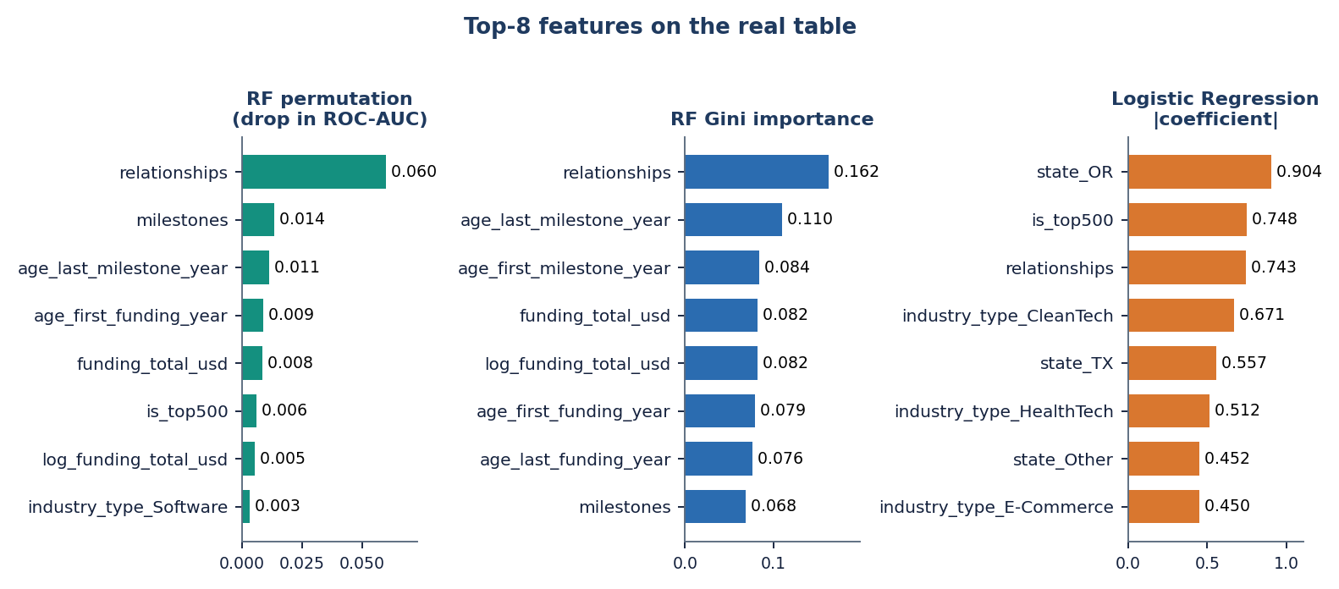
Figure 29: Three rankings of the most informative features on the real table.
Number of relationships comes first in both Random Forest rankings (Gini 0.162, permutation 0.060, four times the next feature). Milestones, the ages at the first and last milestone, total funding and the age at first funding follow. The linear model ranks differently: its largest coefficients belong to the state of Oregon, the top-500 flag, relationships and industry dummies, because a linear model spreads weight over many correlated and one-hot columns. Reading only one ranking would mislead; relationships and funding appear in all three. Objective 5 is met, with the caveat of Section 8.3.8.

8.3.8 Fields recorded after the outcome
Relationships, milestones and the two milestone-age fields are recorded around or after the outcome window in part, and the table has no dates that would allow them to be removed by time. The studies were repeated without these four fields.
Table 40: Effect of removing the four post-hoc fields (real table, 5 x 80/20)
Model | Balanced acc., all fields | Balanced acc., without | ROC-AUC, all fields | ROC-AUC, without
Logistic Regression | 0.709 ± 0.025 | 0.678 ± 0.017 | 0.789 ± 0.017 | 0.724 ± 0.020
Random Forest | 0.746 ± 0.031 | 0.677 ± 0.017 | 0.816 ± 0.022 | 0.719 ± 0.018
XGBoost | 0.746 ± 0.026 | 0.644 ± 0.033 | 0.806 ± 0.019 | 0.699 ± 0.023

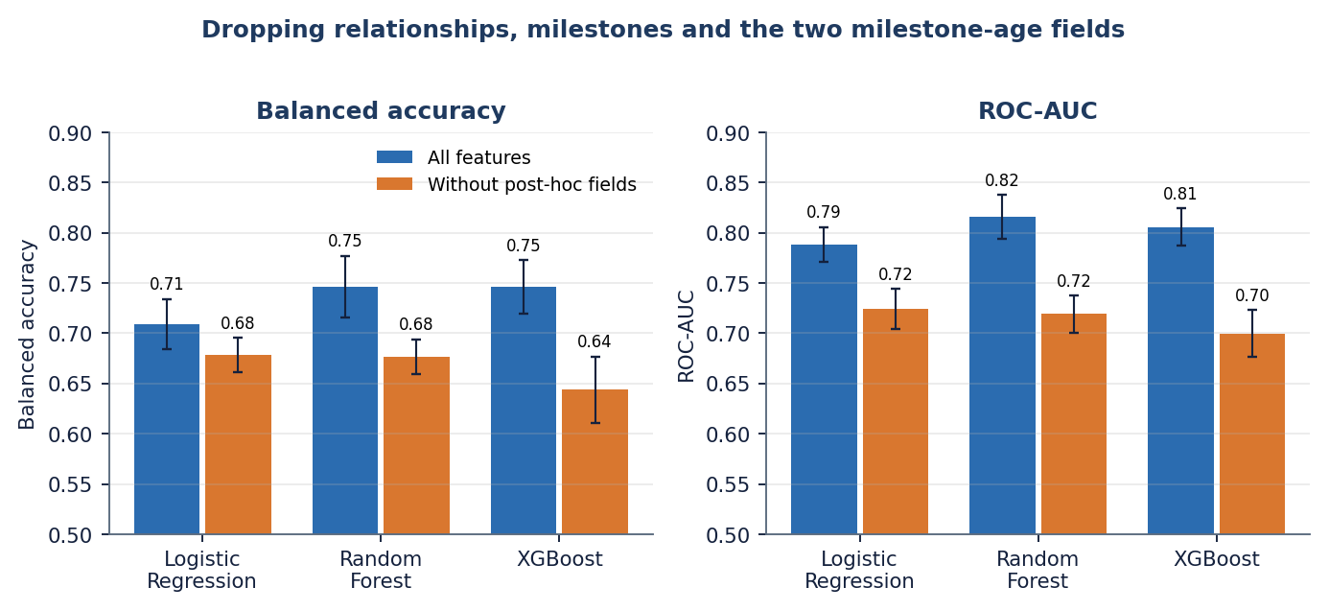
Figure 30: Balanced accuracy and ROC-AUC with and without relationships, milestones and the two milestone-age fields.
ROC-AUC drops from 0.789 to 0.724 for Logistic Regression, from 0.816 to 0.719 for Random Forest and from 0.806 to 0.699 for XGBoost, and the ensembles lose their advantage over the linear model. The headline real-data scores of Section 8.3.1 are therefore an upper bound for a true early-stage prediction. This is the look-ahead problem that the base paper itself cites [9] and that [3] avoids with temporal splits; this project could not, because the table has no dates [29].

8.3.9 Retrieval of comparable start-ups used as a classifier
The application retrieves a balanced set of k comparable start-ups from the training rows and shows them with their outcomes. To test whether that evidence is also predictive, the retrieved set was used on its own, with no trained model: the similarity-weighted vote of the k neighbours decides the outcome. On the real table only the structured half of the fused vector exists.
Table 41: Retrieval-only classifier on the real table (structured features, mean ± std)
k | Accuracy | Balanced acc. | Recall | F1 | ROC-AUC
10 | 0.750 ± 0.015 | 0.714 ± 0.014 | 0.837 ± 0.029 | 0.813 ± 0.013 | 0.769 ± 0.028
20 | 0.749 ± 0.008 | 0.706 ± 0.009 | 0.852 ± 0.019 | 0.815 ± 0.007 | 0.783 ± 0.024
30 | 0.745 ± 0.010 | 0.700 ± 0.015 | 0.852 ± 0.019 | 0.812 ± 0.008 | 0.787 ± 0.022
50 | 0.750 ± 0.015 | 0.703 ± 0.018 | 0.862 ± 0.024 | 0.817 ± 0.012 | 0.789 ± 0.021

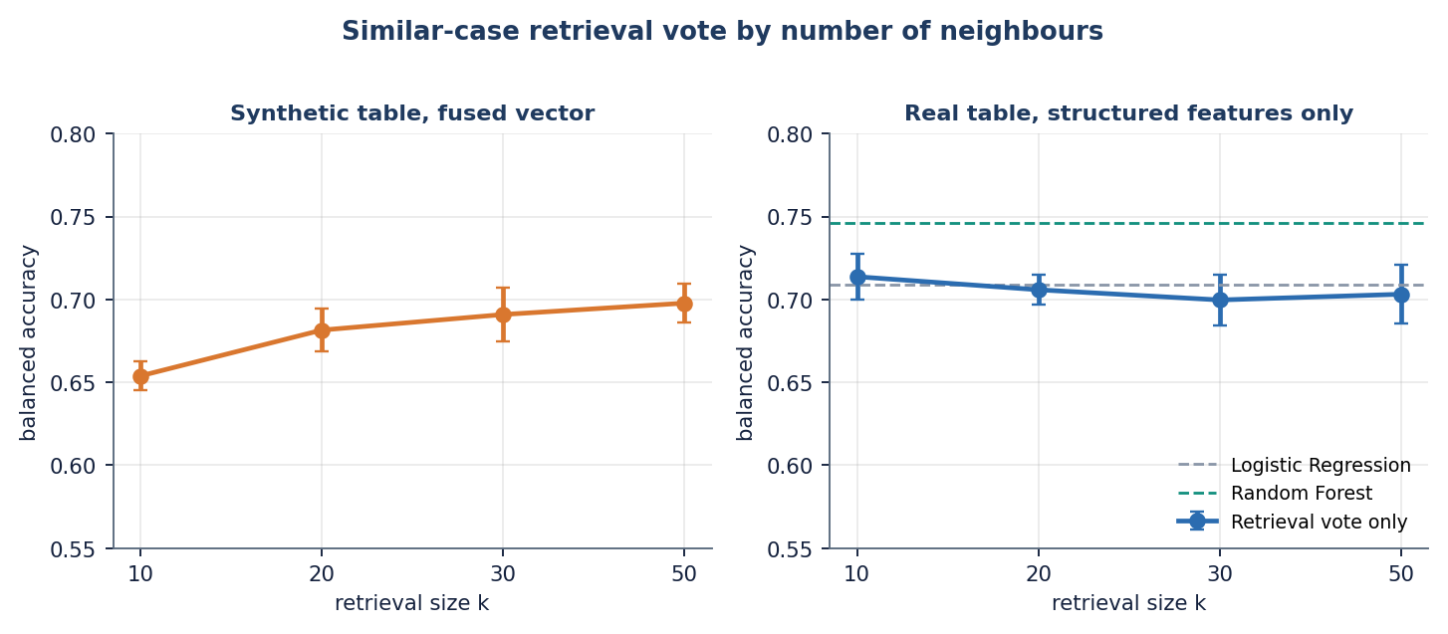
Figure 31: Retrieval vote by number of neighbours: synthetic table with the fused vector (left) and real table with structured features only (right).
Retrieval alone reaches balanced accuracy 0.70 to 0.71 and ROC-AUC 0.77 to 0.79: the same as Logistic Regression (0.709, 0.789) and below Random Forest and XGBoost (0.746). The comparable start-ups shown on the result screen are therefore not decoration; they carry about as much signal as the linear model. On the synthetic table the vote improves with k (0.654 at k = 10 to 0.698 at k = 50); on the real table k hardly matters, which is why the default of 50 is kept. The text half of the fusion could not be tested on real data.

8.3.10 The shipped application on its synthetic table
Table 42: Shipped application, synthetic table, fused features, 5 x 80/20 (mean ± std)
Model | Accuracy | Balanced acc. | Precision | Recall | F1
Logistic Regression (selected) | 0.751 ± 0.027 | 0.749 ± 0.025 | 0.696 ± 0.038 | 0.739 ± 0.015 | 0.716 ± 0.025
Decision Tree | 0.621 ± 0.037 | 0.614 ± 0.041 | 0.551 ± 0.038 | 0.568 ± 0.079 | 0.558 ± 0.056
Random Forest | 0.661 ± 0.020 | 0.641 ± 0.021 | 0.623 ± 0.030 | 0.513 ± 0.027 | 0.562 ± 0.026
XGBoost | 0.712 ± 0.011 | 0.697 ± 0.010 | 0.685 ± 0.020 | 0.598 ± 0.011 | 0.639 ± 0.010

On this table Logistic Regression is selected with balanced accuracy 0.749 ± 0.025 and the trees are worse, the opposite of the real-table order. The text-only model reaches 0.599 and the fused vector 0.749, a gain of 0.035 over structured features alone. Because the generated descriptions differ by class, this gain shows that the text channel can carry a label that was put there; it is not evidence that business descriptions help on real start-ups, where this was not tested. The ROC-AUC of the shipped fused model was not recorded by the application's own evaluation.

8.3.11 Synthetic table against real table, and transfer between them
Table 43: Same models, structured features only, on each table (5 x 80/20)
Model | Balanced acc., synthetic | Balanced acc., real | ROC-AUC, synthetic | ROC-AUC, real
Logistic Regression | 0.714 ± 0.025 | 0.709 ± 0.025 | 0.795 ± 0.019 | 0.789 ± 0.017
Decision Tree | 0.608 ± 0.007 | 0.703 ± 0.031 | 0.642 ± 0.014 | 0.742 ± 0.046
Random Forest | 0.687 ± 0.025 | 0.746 ± 0.031 | 0.777 ± 0.016 | 0.816 ± 0.022
XGBoost | 0.701 ± 0.018 | 0.746 ± 0.026 | 0.768 ± 0.020 | 0.806 ± 0.019

Table 44: Trained on all 1,400 synthetic rows, tested on all 922 real rows
Model | Accuracy | Balanced acc. | F1 | ROC-AUC
Logistic Regression | 0.671 | 0.673 | 0.724 | 0.745
Random Forest | 0.658 | 0.668 | 0.706 | 0.749

The synthetic generator is not a poor imitation of the real structured data: a model trained only on the synthetic rows ranks the real start-ups with ROC-AUC 0.745 to 0.749 and balanced accuracy 0.67, a little below models trained on real rows. That makes the synthetic fallback a usable stand-in for a demonstration, but not a substitute for the real table: the tree models behave differently on the two, and the synthetic table contains the label-leaking text.

8.4 Comparison with the base papers
The declared base paper [1] reports "85 to 92 %" accuracy for Random Forest and Gradient Boosting on a 70:30 split with ADASYN oversampling, but gives no dataset size, no table of per-model results and no ROC-AUC. The method on which the retrieval design builds, [2], uses 4,034 Crunchbase start-ups (1,418 successful, 35.15 %) with the same 5 x 80/20 protocol as this project, and reports balanced accuracy. [3] uses a Crunchbase firm-quarter panel for 2010 to 2023 with temporal splits and reports ROC-AUC. The datasets, labels and protocols differ, so the numbers below are placed side by side for orientation only.
Table 45: Reported results of the papers and of this project
Work | Data and protocol | Reported result | Note
Panjwani et al. [1] | Crunchbase / Kaggle data, size not stated; 70:30; ADASYN | Accuracy 85 to 92 % for the best ensembles | No table, no ROC-AUC; not reproducible from the paper
Maarouf et al. [2] | 4,034 Crunchbase start-ups, 35.15 % successful; 5 x 80/20; text and structured data | Balanced accuracy: kNN-ICL (k = 50) 0.713, Logistic Regression 0.631, Random Forest 0.634, XGBoost 0.618; fused LLM trained on 20,172 start-ups 0.743 | Needs an LLM; descriptions are available
Mashhadi et al. [3] | Crunchbase panel 2010-2023, temporal splits, SMOTE-NC and inverse weights | AUROC 0.872 (exit, 36 months, Random Forest), 0.817 (next funding), 0.921 (patents) | Different target and horizon; temporal validation
This project, real table | 922 US start-ups, 64.6 % successful; 5 x 80/20; structured only | Balanced accuracy 0.746 (RF, XGBoost); ROC-AUC 0.816 (RF); accuracy 0.775 (XGBoost); retrieval-only 0.70 to 0.71 | No dates, no text; four post-hoc fields included
This project, real table, base-paper protocol | 70:30 x 5 seeds | Random Forest accuracy 0.796 ± 0.013, Logistic Regression 0.729 ± 0.011 | Closest like-for-like with [1]
This project, shipped application | 1,400 synthetic rows, fused features | Balanced accuracy 0.749 (Logistic Regression) | Synthetic; text leaks the label

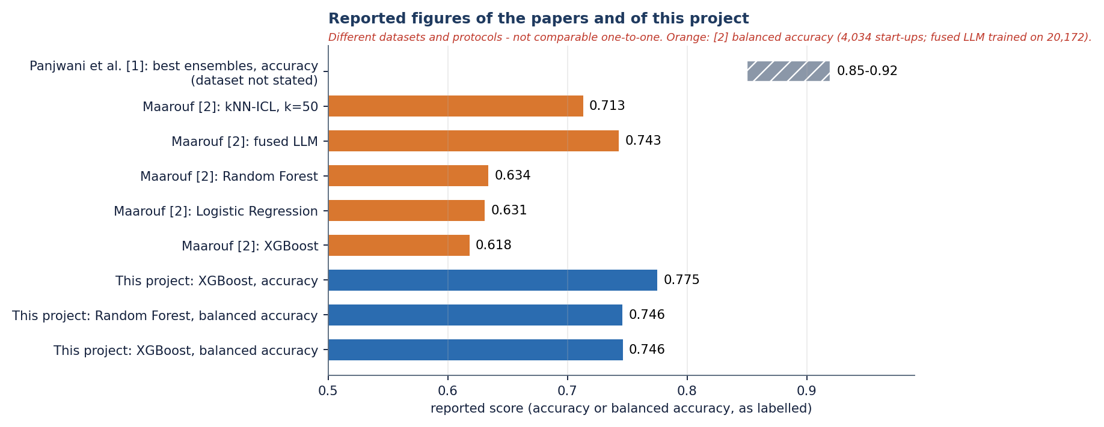
Figure 32: Reported figures of the papers and of this project; datasets and protocols differ, so the bars are not comparable one to one.
What can be said: (1) the base paper's qualitative finding, that ensembles beat Logistic Regression, is reproduced on the real table, by 0.06 to 0.08 in accuracy depending on the protocol and the model; (2) its 85 to 92 % level is not reproduced by any real-data run here (best 0.775 on 80/20 and 0.796 on 70:30), and because the paper does not state its dataset or list its results the gap cannot be explained, though look-ahead fields and a different table are possible reasons; (3) the balanced accuracy of 0.746 is above the 0.62 to 0.63 that the supervised baselines of the method paper reach and just above its retrieval-augmented language model (0.713), but that paper uses a different, text-based and larger dataset and the comparison is only indicative; (4) the temporal-split study reaches higher AUROC for patents but a similar level for exits (0.87 against 0.82 here), on much larger panel data with a leakage-safe design. This project's contribution lies in the end-to-end application with evidence and drivers, and in the honest benchmark of Sections 8.3.1 to 8.3.11, not in a higher score.

8.5 Sample input and output
One real submission was used for the screens. The inputs below are those of the filled form in Section 8.2.3.
Table 46: Sample input
Field | Value
Industry, state | Software, CA
Total funding, rounds | USD 2,500,000 across 2 rounds
Age at first / last funding (years) | 1.5 / 2.5
Age at first / last milestone (years) | 1 / 2
Relationships, milestones, average participants | 6, 3, 3
Investor flags | Has VC, Round A
Comparable cases k | 50
Description | A subscription analytics platform for small retailers using demand forecasting, with 40 paying stores and growing monthly revenue. (130 characters)

Table 47: Sample output (JSON fields of POST /predict, as shown on the result screen)
Field | Value
outcome | SUCCESS
probability_success / probability_failure | 0.83 / 0.17
confidence | 0.833 (83.3 %)
model | Logistic Regression
risk | Lower risk
similar_counts | 25 SUCCESS, 25 FAILURE (k = 50)
explanation | has_roundC (0.00): weight 2.495, supports FAILURE; funding_rounds (-0.07): 2.401, supports FAILURE; relationships (0.72): 2.380, supports SUCCESS; has_VC (1.00): 2.348, supports SUCCESS; milestones (0.58): 2.243, supports SUCCESS; retrieval statistics (top similarity 0.580; mean similarity to SUCCESS 0.492, to FAILURE 0.456)

Table 48: The five most similar historical start-ups returned for this input (from the result screen)
Similarity | Outcome | Industry | State | Funding | Rounds
0.580 | SUCCESS | Software | CO | USD 1.07 M | 1
0.553 | SUCCESS | Software | CA | USD 4.06 M | 4
0.537 | FAILURE | Media | FL | USD 862 K | 1
0.534 | SUCCESS | Software | CA | USD 1.34 M | 0
0.530 | FAILURE | Software | CA | USD 1.29 M | 0

Two properties of this output are worth noting. First, the evidence split is 25 / 25 by construction, because retrieval draws half of the cases from each class; the split itself says nothing about the likely outcome, and the informative statistics are the similarities (0.492 to SUCCESS cases against 0.456 to FAILURE cases, a small margin). Second, the explanation ranks features by the size of the coefficient, not by its contribution for this input: a flag that is absent (has_roundC = 0) is listed first and labelled as supporting FAILURE, although its contribution is zero. The retrieved start-ups and the estimate agree here, but the list of drivers is a description of the model, not of this case.

8.6 Success and failure analysis

8.6.1 Where the system works
• It ranks start-ups usefully: ROC-AUC 0.82 for Random Forest and 0.79 for Logistic Regression on the real table, and the observed success rate rises from 8 % to 93 % across the probability bins of Section 8.3.6.
• It finds most of the successes with the ensemble models (recall 0.84 to 0.88) at precision about 0.82.
• The whole path, from the form to the explained result, takes about 0.15 to 0.2 s at the median on a CPU-only PC (Chapter 7), and comparable start-ups give a second, independent view of the estimate that matches a linear model in accuracy.
• Success and failure rates of the larger industry groups are predicted well: on one test split Media is right for 31 of 35 start-ups (0.89) and Software for 77 of 106 (0.73).

8.6.2 Where it fails
Table 49: Random Forest accuracy by industry, one test split (seed 42, 185 start-ups)
Industry | Start-ups | Share successful | Accuracy
Biotech | 6 | 0.50 | 0.33
CleanTech | 6 | 0.50 | 0.50
Media | 35 | 0.66 | 0.89
Mobile | 10 | 0.60 | 0.70
Other | 14 | 0.71 | 0.79
Software | 106 | 0.66 | 0.73

• Failures are the harder class for the ensembles: only 66 % of the closed start-ups are recognised by Random Forest (42.6 of 65 per fold), so about one verdict in five that says SUCCESS is wrong (precision 0.82).
• Small segments are unreliable: Biotech (6 start-ups, accuracy 0.33) and CleanTech (6, 0.50) are too few to read, and the model has seen only a few of them.
• Without the four post-hoc fields the ensembles drop to balanced accuracy 0.64 to 0.68, so genuinely early-stage predictions are weaker than the headline numbers.
• The displayed confidence is conservative on the real table (Section 8.3.6): a score of 0.25 corresponds to a 44 % success rate.
• The explanation lists features by coefficient size, not by contribution, and an absent flag can appear as a driver (Section 8.5).
• Founder experience, team size and market conditions, named in the abstract, are not in either dataset and cannot influence any estimate.

8.7 Limitations of the results
• The application serves a model trained on synthetic data; its dashboard scores (balanced accuracy 0.749) are not real-world performance.
• The real table has 922 start-ups, one country, a 185-row test fold and a single family of random splits; the standard deviations over splits understate the true uncertainty and no significance test was run.
• No temporal split is possible, so look-ahead bias cannot be excluded; Section 8.3.8 shows that it matters.
• The text channel and the fused representation could not be evaluated on real data; the synthetic text leaks the label.
• Base-paper figures cannot be compared like for like because the declared paper states neither its dataset nor its per-model results.
• HistGradientBoosting appears only in the study, not in the application; ROC-AUC was not recorded for the shipped fused model; no SHAP analysis was made.
The 29 edge cases and 51 automated checks of Chapter 7 show that the software behaves as specified; they say nothing about whether the estimates are right. The latency of 148 to 199 ms per prediction (median) was measured with a warm model on one machine.

8.8 Objectives against outcomes
Table 50: Objectives of the project and what was achieved
# | Objective | Outcome | Status
1 | Collect a startup dataset covering funding history, team background, sector, location and outcome | The public table (922 start-ups) was obtained and analysed; the application ships a synthetic fallback with the same schema. Team background and market data are not in either dataset | Partly met
2 | Clean the data and engineer features capturing funding velocity, team experience and market context | Cleaning, imputation, scaling, one-hot coding and log funding done; funding velocity only approximated by the ages at first and last funding and the number of rounds; no team-experience or market feature exists | Partly met
3 | Address class imbalance between successful and failed startups | Balanced class weights in the application; oversampling compared on real data (Section 8.3.3). On the real table failure, not success, is the minority and neither correction improves ROC-AUC | Met
4 | Train and compare Logistic Regression, Decision Tree, Random Forest and boosting ensembles | All four plus HistGradientBoosting compared with 5 x 80/20 and 5 x 70:30 splits (Sections 8.3.1 and 8.3.2) | Met
5 | Identify the features that most strongly separate successful from failed startups | Three rankings (Section 8.3.7): relationships, milestones and funding stand out; four fields may be recorded after the outcome (Section 8.3.8) | Met, with a caveat
6 | Evaluate using accuracy, precision, recall, F1-score and ROC-AUC | All five measured on the real table; the shipped fused model's own evaluation records balanced accuracy, accuracy, precision, recall and F1 but not ROC-AUC | Met

In summary, the system is built and works end to end, the ensemble ranking of the base paper is reproduced on a real table, and the benchmark shows how much of the real-data score depends on fields that may not be available early. The application's estimates should be read as a transparent, evidence-backed screening aid and not as a prediction that has been validated on future start-ups.

CHAPTER 9: CONCLUSION

9.1 Summary
The project set out to predict, from historical startup data, whether an early-stage company is more likely to succeed or fail, to compare the standard classifiers on that task and to name the factors behind each prediction. The system was built and works end to end as VenturePulse: it accepts structured inputs and an optional description, returns a SUCCESS or FAILURE estimate with probabilities and a risk label, lists the main feature terms and shows the comparable historical startups that support the estimate.
The report measured the system honestly. The model that the application serves was trained on a 1,400-row synthetic fallback and scores 0.749 balanced accuracy on it; that number is a pipeline check. On the real public table of 922 startups, under five repeated 80/20 splits, Random Forest reaches a balanced accuracy of 0.746 ± 0.031 and a ROC-AUC of 0.816 ± 0.022, XGBoost 0.746 ± 0.026 and 0.806 ± 0.019, and Logistic Regression 0.709 ± 0.025 and 0.789 ± 0.017.

9.2 Objectives achieved
Table 51: The six objectives and what was achieved
No. | Objective | Outcome
1 | Collect a startup dataset | Partly: the real 922-row public table was obtained and analysed (funding, sector, location, outcome); team background is missing; the shipped app runs on a synthetic fallback of the same schema
2 | Clean the data and engineer features | Partly: cleaning, imputation, scaling, one-hot encoding and log funding done; funding velocity only approximated by ages and rounds; no team-experience or market-context feature exists
3 | Address class imbalance | Achieved: balanced class weights in the application and a comparison with oversampling on real data; no ROC-AUC gain, success is the majority class here
4 | Train and compare LR, DT, RF and boosting | Achieved: four models in the application and HistGradientBoosting in the study, under 5 x 80/20 splits
5 | Identify separating features | Achieved: Random Forest Gini and permutation importance and logistic-regression weights; relationships ranks first in both tree measures
6 | Evaluate with accuracy, precision, recall, F1, ROC-AUC | Achieved on real data; ROC-AUC of the shipped fused model was not recorded

9.3 Key findings
1. On real startups the tree ensembles rank above logistic regression (balanced accuracy 0.746 and 0.746 against 0.709), as the base paper claims, but at an accuracy of 0.775 and not at the 85-92 % it reports; Random Forest, XGBoost and HistGradientBoosting lie within one standard deviation of one another.
2. The table leaks: removing relationships, milestones and the two milestone-age fields lowers ROC-AUC from 0.816 to 0.719 for Random Forest and from 0.806 to 0.699 for XGBoost, and the ensembles lose their lead.
3. Retrieval alone is competitive: balanced top-k voting with no trained model reaches balanced accuracy 0.714 to 0.703 and ROC-AUC 0.769 to 0.789, equal to logistic regression, and the retrieved startups give a user something to inspect.
4. Imbalance handling changes recall, not ranking: class weights or oversampling leave ROC-AUC at about 0.816 and balanced accuracy at 0.75 for Random Forest; the logistic-regression balanced accuracy is flat between thresholds 0.30 and 0.50 (0.71) while recall of success falls from 0.88 to 0.67.
5. The text channel is untested on real startups: the real table has no descriptions, and the synthetic descriptions leak the class, so the 0.749 of the shipped fused model must not be read as real-world performance.
6. The software is sound: 51 automated checks pass and a prediction takes a median of 148 to 198 ms on a CPU.

9.4 Practical applications
• A screening aid that gives a first, evidence-backed view of a startup profile and shows which comparable companies and features drive it.
• A teaching and demonstration tool for a complete tabular machine-learning workflow: imbalance, model comparison, threshold choice, calibration and leakage checks.
• A starting point for a team with its own labelled startup data and time stamps, where the same pipeline can be retrained and validated out of time.
• It is not investment advice and not a replacement for due diligence.

9.5 Known limitations
The main limitations are the synthetic training data of the served model (L1), the leakage-like fields (L2), the lack of a temporal split (L3), the small single-country table with 185-row test folds (L4), the untested text channel (L5), the missing founder and market data (L6) and uncalibrated probabilities (L8). The full list L1 to L10 is given in the document on scope and limitations.

CHAPTER 10: FUTURE SCOPE

10.1 Improvements to the model
1. Validate out of time: obtain founding and event dates, train on earlier cohorts and test on later ones, and drop fields recorded after the outcome window, as the reference study does with a leakage-safe temporal panel [3] (untested here).
2. Add the missing inputs: founder and team experience, team size and composition, and market context, which the abstract names and the base paper's features include [1] (no data yet).
3. Test the text channel on real startups: collect genuine company descriptions (for example from a public company directory under its licence) and measure the fused representation and retrieval against the structured baseline.
4. Calibrate the probabilities (Platt or isotonic scaling with class priors) and report Brier score and reliability curves, because the class-weighted logistic regression is visibly miscalibrated on real data (L8).
5. Add SHAP-based explanations for the tree ensembles [33] in place of coefficient and importance terms, and compare them with the Gini and permutation rankings.
6. Tune each model (grid or Bayesian search), tune alpha and k, and compare the served model choice with the study's best model; add significance tests over many more splits or repeated cross-validation.
7. Report PR-AUC next to ROC-AUC, as the reference study does [27, 3], and evaluate cost-sensitive decision thresholds chosen by an investor's own costs.

10.2 Improvements to the application
• Let the application select the served model from the real-data results and show its ROC-AUC on the Performance screen (L9).
• Warn the user when the inputs lie outside the range of the training data or when the confidence is low, and show the calibrated confidence.
• Accept a CSV of many startups and return a ranked list with downloadable results.
• Save each analysis (inputs, outcome, comparable startups) for later review, with a proper user store replacing the demo token.
• Show the retrieval evidence as a chart of outcomes among the nearest startups, per industry and funding stage.

10.3 Scalability and deployment
• Serve the backend with several worker processes behind a reverse proxy, add real authentication and rate limits, and store models and analyses in a database (L10).
• Cache the embedding of repeated descriptions and pre-compute the training-matrix similarity index (for example approximate nearest neighbours) so that retrieval stays fast with hundreds of thousands of startups.
• Run a load test and a memory profile; only sequential requests were timed here.
• Package the application as a container image (a Dockerfile exists but was not exercised in this report) for one-command deployment.

10.4 Further research
• Compare the retrieval-based approach with a language model that reads the retrieved startups, as in the method anchor [2], on the same data and protocol.
• Extend to richer outcome horizons (next funding, patenting, exit) as in the reference study, and to survival analysis for time-to-exit.
• Study fairness and bias across regions, sectors and founder groups, since a model trained on a US table may disadvantage other ecosystems.
• Run a user study with founders and investors on whether comparable-startup evidence and feature drivers change their decisions.

REFERENCES
[1] M. Panjwani, P. Shrivastava, P. Hande, G. Meshram, N. Verma and D. Gotmare, "Startup success prediction using machine learning and ensemble techniques," Int. J. Res. Appl. Sci. Eng. Technol. (IJRASET), vol. 14, no. IV, Apr. 2026, doi: 10.22214/ijraset.2026.80226.
[2] A. Maarouf, A. Bakiaj and S. Feuerriegel, "Predicting startup success using large language models: A novel in-context learning approach," arXiv:2601.16568, Jan. 2026.
[3] S. Mashhadi, A. Saghezchi and V. G. Kashani, "Interpretable machine learning for predicting startup funding, patenting, and exits," arXiv:2510.09465, 2026.
[4] A. Krishna, A. Agrawal and A. Choudhary, "Predicting the outcome of startups: Less failure, more success," Northwestern University, 2016.
[5] D. Camelo Martinez, "Startup success prediction in the Dutch startup ecosystem," M.S. thesis, Delft University of Technology, Delft, The Netherlands, 2019.
[6] H. B. G, A. Kumar and R. Kumar, "Startup success prediction using machine learning algorithms," JNNCE J. Eng. Manage., 2024.
[7] M. Razaghzadeh Bidgoli, I. Raeesi Vanani and M. Goodarzi, "Predicting the success of startups using a machine learning approach," J. Innov. Entrepreneurship, vol. 13, 2024.
[8] J. Li, "Prediction of the success of startup companies based on support vector machine and random forest," in Proc. Int. Workshop Artif. Intell. Educ. (WAIE), 2020.
[9] K. Zbikowski and P. Antosiuk, "A machine learning, bias-free approach for predicting business success using Crunchbase data," Inf. Process. Manage., vol. 58, no. 2, 2021.
[10] S. M. A. Jafari, A. M. Dehkordi and E. Chitsaz, "A quantitative meta-analysis of AI-based predictors for startup success," 2024.
[11] G. Ross, S. Das, D. Sciro and H. Raza, "CapitalVX: A machine learning model for startup selection and exit prediction," J. Finance Data Sci., vol. 7, pp. 94-114, 2021.
[12] S. Tomy and E. Pardede, "From uncertainties to successful start-ups: A data analytic approach to predict success in technological entrepreneurship," Sustainability, vol. 10, no. 3, 2018.
[13] Y. Choi, "Startup success prediction with PCA-enhanced machine learning models," J. Technol. Manage. Innov., vol. 19, no. 4, 2024.
[14] A. Maarouf, S. Feuerriegel and N. Prollochs, "A fused large language model for predicting startup success," Eur. J. Oper. Res., 2025.
[15] M. Bonaventura, V. Ciotti, P. Panzarasa, S. Liverani, L. Lacasa and V. Latora, "Predicting success in the worldwide start-up network," Sci. Rep., vol. 10, 2020.
[16] L. Gius, "Disagreement predicts startup success: Evidence from venture competitions," Strategy Sci., vol. 10, no. 2, pp. 93-108, Jun. 2025, doi: 10.1287/stsc.2024.0169.
[17] I. B. Bhandari, "Impact of venture capital on startup success and economic growth in Nepal," Nepalese J. Finance, vol. 12, no. 1, Jan. 2025.
[18] L. Breiman, "Random forests," Mach. Learn., vol. 45, no. 1, pp. 5-32, Oct. 2001.
[19] T. Chen and C. Guestrin, "XGBoost: A scalable tree boosting system," in Proc. 22nd ACM SIGKDD Int. Conf. Knowl. Discovery Data Mining, San Francisco, CA, USA, 2016, pp. 785-794.
[20] J. H. Friedman, "Greedy function approximation: A gradient boosting machine," Ann. Statist., vol. 29, no. 5, pp. 1189-1232, Oct. 2001.
[21] F. Pedregosa et al., "Scikit-learn: Machine learning in Python," J. Mach. Learn. Res., vol. 12, pp. 2825-2830, 2011.
[22] H. He and E. A. Garcia, "Learning from imbalanced data," IEEE Trans. Knowl. Data Eng., vol. 21, no. 9, pp. 1263-1284, Sep. 2009.
[23] N. V. Chawla, K. W. Bowyer, L. O. Hall and W. P. Kegelmeyer, "SMOTE: Synthetic minority over-sampling technique," J. Artif. Intell. Res., vol. 16, pp. 321-357, 2002.
[24] H. He, Y. Bai, E. A. Garcia and S. Li, "ADASYN: Adaptive synthetic sampling approach for imbalanced learning," in Proc. IEEE Int. Joint Conf. Neural Netw. (IJCNN), Hong Kong, 2008, pp. 1322-1328.
[25] N. Reimers and I. Gurevych, "Sentence-BERT: Sentence embeddings using Siamese BERT-networks," in Proc. Conf. Empirical Methods Natural Lang. Process. (EMNLP-IJCNLP), Hong Kong, 2019, pp. 3982-3992.
[26] W. Wang, F. Wei, L. Dong, H. Bao, N. Yang and M. Zhou, "MiniLM: Deep self-attention distillation for task-agnostic compression of pre-trained transformers," in Advances in Neural Information Processing Systems, vol. 33, 2020, pp. 5776-5788.
[27] T. Saito and M. Rehmsmeier, "The precision-recall plot is more informative than the ROC plot when evaluating binary classifiers on imbalanced datasets," PLoS ONE, vol. 10, no. 3, Art. no. e0118432, 2015.
[28] T. Fawcett, "An introduction to ROC analysis," Pattern Recognit. Lett., vol. 27, no. 8, pp. 861-874, Jun. 2006.
[29] S. Kaufman, S. Rosset, C. Perlich and O. Stitelman, "Leakage in data mining: Formulation, detection, and avoidance," ACM Trans. Knowl. Discovery Data, vol. 6, no. 4, Art. no. 15, 2012.
[30] T. Cover and P. Hart, "Nearest neighbor pattern classification," IEEE Trans. Inf. Theory, vol. 13, no. 1, pp. 21-27, Jan. 1967.
[31] T. B. Brown et al., "Language models are few-shot learners," in Advances in Neural Information Processing Systems, vol. 33, 2020, pp. 1877-1901.
[32] M. KC, "Startup success prediction," Kaggle dataset (public domain), https://www.kaggle.com/datasets/manishkc06/startup-success-prediction.
[33] S. M. Lundberg and S.-I. Lee, "A unified approach to interpreting model predictions," in Advances in Neural Information Processing Systems, vol. 30, 2017, pp. 4765-4774.
[34] "Impact of venture capital on startup success rates across industry: An empirical study," Eur. Econ. Lett., 2024. [Listed in the batch literature survey; authors not verified.]
[35] "The role and impact of SICTIC in the Swiss startup ecosystem," book chapter, 2026. [Listed in the batch literature survey; authors and publisher not verified.]

APPENDIX A: IMPORTANT CODE
Excerpts from the repository (8.ProjectCode), copied without change from the state in which the results of this report were measured; the complete files are in app/. A line holding only # ... marks omitted lines.

A.1 Fused representation and balanced retrieval (`app/ml/retrieval.py`)
def fuse(structured: np.ndarray, text_emb: np.ndarray, alpha: float = ALPHA) -> np.ndarray:
s = np.asarray(structured, dtype=np.float64)
t = np.asarray(text_emb, dtype=np.float64)
s = l2norm(s.astype(np.float32)).astype(np.float64)
t = l2norm(t.astype(np.float32)).astype(np.float64)
fused = np.hstack([alpha * s, (1.0 - alpha) * t])
# final L2 normalize so cosine similarity is well-behaved
n = np.linalg.norm(fused, axis=1, keepdims=True)
n[n == 0] = 1.0
return (fused / n).astype(np.float32)

def retrieve_similar(target_fused: np.ndarray, train_fused: np.ndarray,
train_df: pd.DataFrame, k: int = 50) -> pd.DataFrame:
sims = cosine_similarity(target_fused.reshape(1, -1), train_fused)[0]
order = np.argsort(-sims)
# balanced selection: quotas half/half where possible
k = int(max(1, min(k, len(order))))
quota_s = k // 2
quota_f = k - quota_s
labels = train_df["label"].to_numpy()
picked: list[int] = []
c_s = c_f = 0
for idx in order:
lab = int(labels[idx])
if lab == 1 and c_s < quota_s:
picked.append(int(idx)); c_s += 1
elif lab == 0 and c_f < quota_f:
picked.append(int(idx)); c_f += 1
if len(picked) >= k:
break
# fill remainder if a class ran short
if len(picked) < k:
chosen = set(picked)
for idx in order:
if int(idx) not in chosen:
picked.append(int(idx))
if len(picked) >= k:
break
# sort picked by similarity desc for display
picked = sorted(picked, key=lambda i: -sims[i])
out = train_df.iloc[picked].copy()
out["similarity"] = [float(sims[i]) for i in picked]
return out

A.2 Cleaning and the preprocessing pipeline (`app/ml/preprocessing.py`)
def prepare_frame(df: pd.DataFrame) -> pd.DataFrame:
df = df.copy()
df = df.drop_duplicates()
df["label"] = map_target(df["status"])
df = df.dropna(subset=["label"])
df["label"] = df["label"].astype(int)
# numeric coercion
for c in NUMERIC_FEATURES + BINARY_FEATURES:
if c in df.columns:
df[c] = pd.to_numeric(df[c], errors="coerce")
# categorical normalization
for c in CATEGORICAL_FEATURES:
if c in df.columns:
df[c] = df[c].astype(str).str.strip()
df[c] = df[c].replace({"nan": "Unknown", "None": "Unknown", "": "Unknown"})
df[c] = df[c].fillna("Unknown")
# log funding to tame outliers (kept as extra derived col)
df["log_funding_total_usd"] = np.log1p(df["funding_total_usd"].fillna(0).clip(lower=0))
if "description" not in df.columns:
df["description"] = ""
df["description"] = df["description"].fillna("").astype(str).apply(clean_text)
# outcome text mapping
df["outcome"] = df["label"].apply(lambda v: "SUCCESS" if v == 1 else "FAILURE")
return df

def build_preprocessor() -> ColumnTransformer:
numeric = NUMERIC_FEATURES + ["log_funding_total_usd"]
binary = BINARY_FEATURES
cat = CATEGORICAL_FEATURES
num_pipe = Pipeline([
("imputer", SimpleImputer(strategy="median")),
("scaler", StandardScaler()),
])
bin_pipe = Pipeline([("imputer", SimpleImputer(strategy="most_frequent"))])
cat_pipe = Pipeline([
("imputer", SimpleImputer(strategy="constant", fill_value="Unknown")),
("onehot", OneHotEncoder(handle_unknown="ignore")),
])
pre = ColumnTransformer([
("num", num_pipe, numeric),
("bin", bin_pipe, binary),
("cat", cat_pipe, cat),
])
return pre

A.3 The classifiers (`app/ml/models.py`)
def get_models():
models = {
"Logistic Regression": LogisticRegression(solver="lbfgs", class_weight="balanced", max_iter=1000, C=1.0),
"Decision Tree": DecisionTreeClassifier(max_depth=8, min_samples_split=10, min_samples_leaf=5,
class_weight="balanced", random_state=42),
"Random Forest": RandomForestClassifier(n_estimators=300, class_weight="balanced",
min_samples_leaf=2, n_jobs=-1, random_state=42),
}
try:
from xgboost import XGBClassifier
models["XGBoost"] = XGBClassifier(
n_estimators=400, max_depth=6, learning_rate=0.05,
subsample=0.8, colsample_bytree=0.8, reg_lambda=1.0,
eval_metric="logloss", n_jobs=-1, random_state=42)
except Exception:
from sklearn.ensemble import HistGradientBoostingClassifier
models["XGBoost (fallback HGB)"] = HistGradientBoostingClassifier(
max_iter=400, max_depth=6, learning_rate=0.05, l2_regularization=1.0, random_state=42)
return models

A.4 Prediction, explanation and risk label (`app/services/predictor.py`)
def predict_one(payload: dict, state: dict, k: int = DEFAULT_K) -> dict:
model = state["model"]
pre = state["pre"]
train_fused = state["train_fused"]
train_df = state["train_df"]
meta = state["metadata"]
k = int(max(1, min(int(k or DEFAULT_K), len(train_df))))

inp = build_input_row(payload)
S = pre.transform(inp)
T, backend = embed_texts([inp.iloc[0]["description"] or f"{inp.iloc[0]['industry_type']} startup"])
F = fuse(S, T, ALPHA)

proba = None
if hasattr(model, "predict_proba"):
proba = model.predict_proba(F)[0]
pred = int(np.argmax(proba))
conf = float(np.max(proba))
else:
pred = int(model.predict(F)[0])
conf = 0.5
proba = np.array([1 - conf, conf]) if pred == 1 else np.array([conf, 1 - conf])
# ...
# deterministic explanation from feature importance / coefficients + retrieval
bullets = []
try:
fnames = meta.get("feature_names_structured", [])
svals = np.asarray(S[0]).ravel()
if hasattr(model, "feature_importances_"):
imp = np.asarray(model.feature_importances_, dtype=float)[: len(svals)]
order = np.argsort(-imp)[:5]
for i in order:
name = fnames[int(i)] if int(i) < len(fnames) else f"feature_{i}"
bullets.append(f"{name}: value {svals[int(i)]:.2f} (scaled), importance {imp[int(i)]:.3f}")
elif hasattr(model, "coef_"):
coef = np.asarray(model.coef_).ravel()[: len(svals)]
order = np.argsort(-np.abs(coef))[:5]
for i in order:
name = fnames[int(i)] if int(i) < len(fnames) else f"feature_{i}"
direction = "supports SUCCESS" if coef[int(i)] * svals[int(i)] > 0 else "supports FAILURE"
bullets.append(f"{name}: value {svals[int(i)]:.2f} (scaled), weight {coef[int(i)]:.3f} — {direction}")
except Exception:
pass
# ...
risk = "Lower risk" if (pred == 1 and conf >= 0.7) else ("Moderate risk" if conf >= 0.55 else "Higher uncertainty")

A.5 Request validation (`app/main.py`)
class PredictPayload(BaseModel):
funding_total_usd: float = Field(default=1000000, ge=0, le=1e10)
funding_rounds: float = Field(default=2, ge=0, le=20)
age_first_funding_year: float = Field(default=1.5, ge=0, le=30)
age_last_funding_year: float = Field(default=2.5, ge=0, le=30)
age_first_milestone_year: float = Field(default=1.0, ge=0, le=30)
age_last_milestone_year: float = Field(default=2.0, ge=0, le=30)
relationships: float = Field(default=4, ge=0, le=200)
milestones: float = Field(default=2, ge=0, le=50)
avg_participants: float = Field(default=3.0, ge=0, le=50)
# ...
@field_validator("description")
@classmethod
def check_desc(cls, v: str) -> str:
v = (v or "").strip()
if len(v) > MAX_DESC_LEN:
raise ValueError(f"Description must be under {MAX_DESC_LEN} characters.")
return v

@field_validator("k")
@classmethod
def check_k(cls, v: int) -> int:
if v not in RETRIEVAL_KS:
raise ValueError(f"k must be one of {RETRIEVAL_KS}.")
return v

APPENDIX B: INSTALLATION AND USER GUIDE

B.1 Requirements and start
• A Windows PC (the measurements in this report were made on: Intel Core i5-12500 (6 cores, 12 threads), 15.7 GB RAM, Windows 11 Pro, CPU only (no GPU)); a GPU is not needed. Python 3.10 or newer (3.11 recommended), Node.js 18 or newer, a current Chrome or Edge, and internet access for the first installation (packages and the 90 MB text-embedding model sentence-transformers/all-MiniLM-L6-v2).
• Double-click run.bat in 8.ProjectCode. It checks Python and Node.js, creates or rebuilds .venv, installs requirements.txt and the frontend packages, starts the FastAPI backend in a second window and the React app in the first, and opens http://localhost:5410. The backend listens on http://127.0.0.1:8410 and also serves the original pages (/dashboard, /predict, /performance, /insights). Ports are set in .env (BACKEND_PORT, FRONTEND_PORT).
• On the first start the models are trained if they are missing (a few minutes); later starts load the saved artefacts from models/ in seconds. If the public CSV is placed in data/raw/ it is used; otherwise the synthetic fallback with the same schema is used and recorded in models/metadata.json.
• Demo sign-in: demo@venturepulse.com / Demo@1234 (the sign-in page has a click-to-fill button); change it with DEMO_EMAIL and DEMO_PASSWORD in .env.
python -m venv .venv
.venv\Scripts\activate
pip install -r requirements.txt
python -m uvicorn app.main:app --host 127.0.0.1 --port 8410 # terminal 1, backend
cd frontend && npm install && npm run dev # terminal 2, frontend
docker build -t venturepulse:latest . && docker run --rm -p 8000:8000 venturepulse:latest # backend and original pages only

B.2 Using the screens
1. Sign in with the demo account.
2. Dashboard: dataset counters, the serving model with its scores, class distribution and model comparison.
3. Analyze a startup: enter funding, rounds, the ages at first and last funding and milestone, relationships, milestones, average participants, industry, state, the investor flags, the number of comparable cases k (10, 20, 30 or 50) and a description of up to 2,000 characters ("Fill an example" loads a sample); press "Predict startup success". Read the outcome, confidence and risk label, the key contributing features, the evidence split and the table of comparable historical start-ups.
4. Model performance: model comparison, confusion matrix, retrieval-size and representation studies, feature importance. Startup insights: industry, state, funding and correlation summaries.
5. Press / for the command palette and g followed by d, a, p or i to jump between screens.
Remember that the screens describe the model trained on the data in data/ (the synthetic fallback unless the public CSV is present) and that every estimate is an analytical aid, not investment advice.

B.3 Checks and troubleshooting
python -m pytest tests -q (7 tests), python scripts/smoke_test.py (15 checks), python scripts/edge_tests.py (29 cases), python scripts/ui_checks.py (browser checks), python scripts/capture_screens.py (screenshots, application running), python scripts/run_experiments.py and python scripts/extra_experiments.py (real-data studies, need data/real/startup_data.csv), python scripts/measure_latency.py (server running), python scripts/train.py (retrain the models).
Table 52: Common problems
Symptom | Cause and remedy
python or node is not recognised | Install them and enable "Add python.exe to PATH"; reopen the terminal
The page says "Cannot reach the VenturePulse API" | The backend window is not running or crashed: start it again with run.bat and read the error
HTTP 500 and "model files may be missing or incompatible" | The saved models were written by other library versions: run python scripts/train.py, then restart
HTTP 422 from /predict | A value is outside its range (for example funding above 1e10, k not in 10, 20, 30, 50, description over 2,000 characters)
Port already in use | Change BACKEND_PORT / FRONTEND_PORT in .env
First prediction is slow | The embedding model is loaded on the first request (11 s in one measured run); later requests take about 0.15 to 0.2 s

APPENDIX C: ADDITIONAL SCREENS
Enlarged parts of the screens of Chapter 8, cropped without change from the original 1440-pixel captures. They show the synthetic-trained model serving the application, with the real submission of Section 8.5 on the result screen.
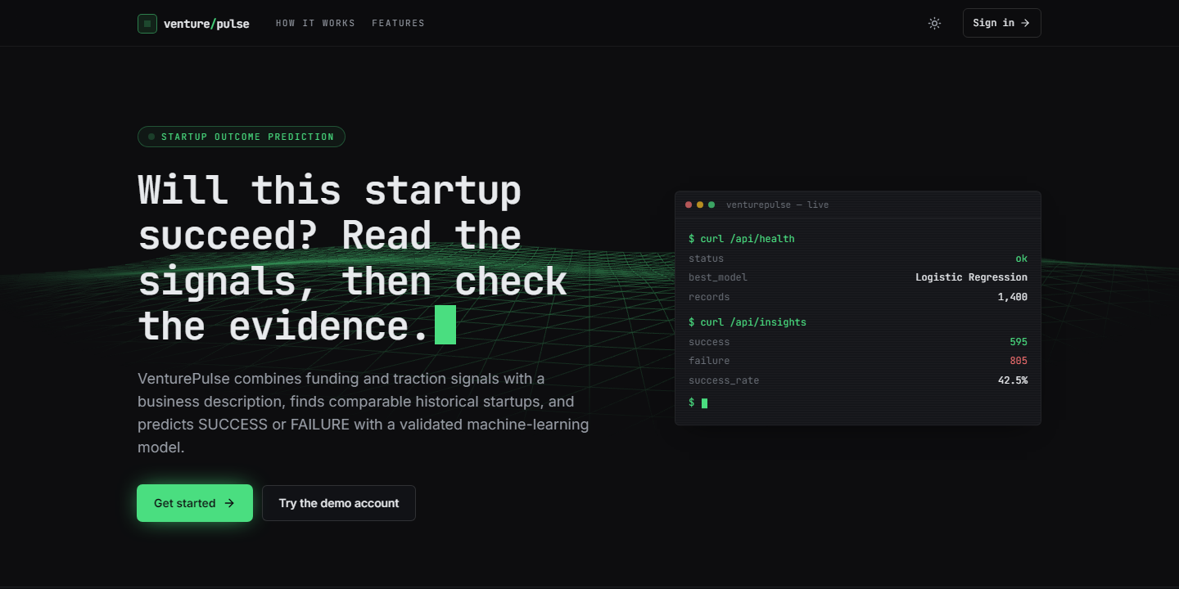  Figure 33: Landing page, top: headline, calls to action and the live terminal card (dark theme). | 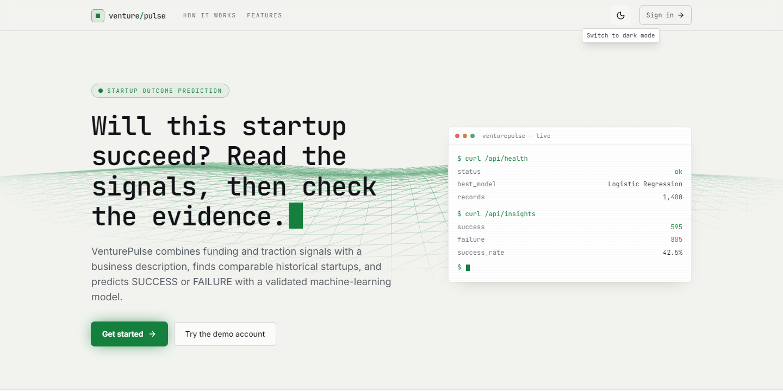  Figure 34: The same top section in the light theme.

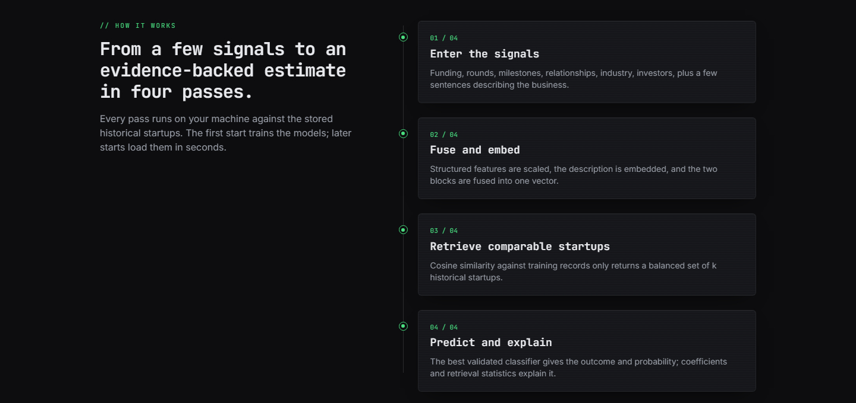
Figure 35: Landing page, "How it works": the four passes from entering the signals to an explained estimate.
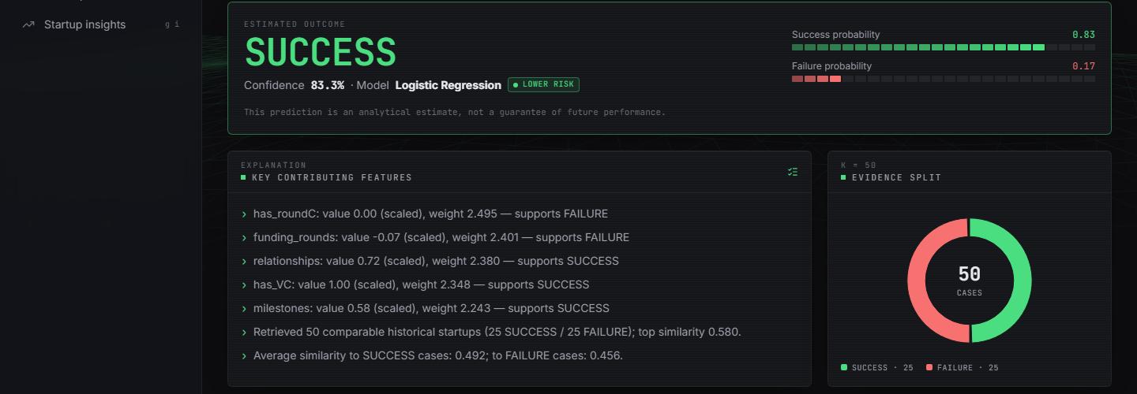
Figure 36: Result screen, top: outcome SUCCESS, confidence 83.3 %, Lower risk, the key contributing features and the 25 / 25 evidence split (k = 50).
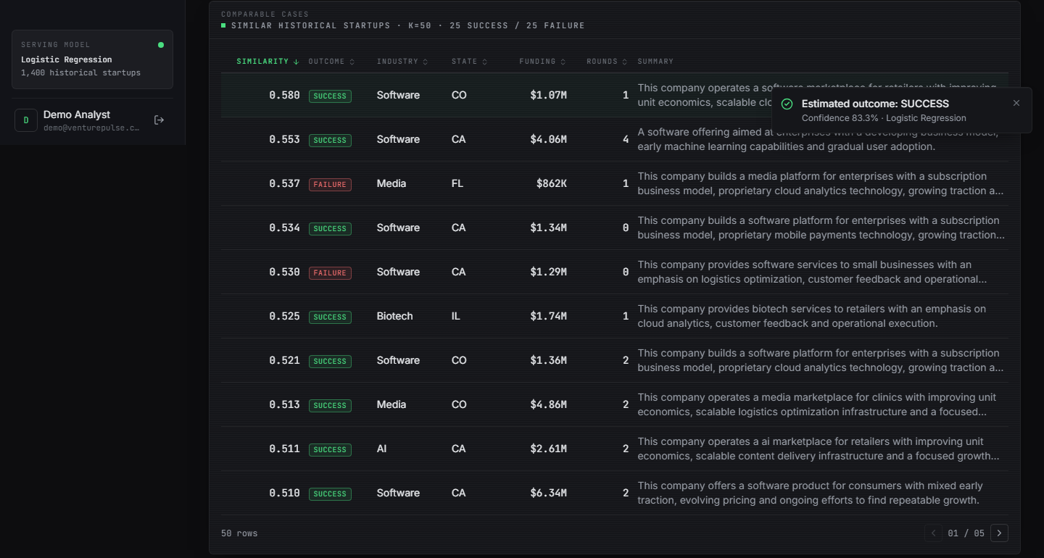
Figure 37: Result screen: table of comparable historical start-ups with similarity, outcome, industry, state, funding, rounds and summary, and the submitted inputs below it.
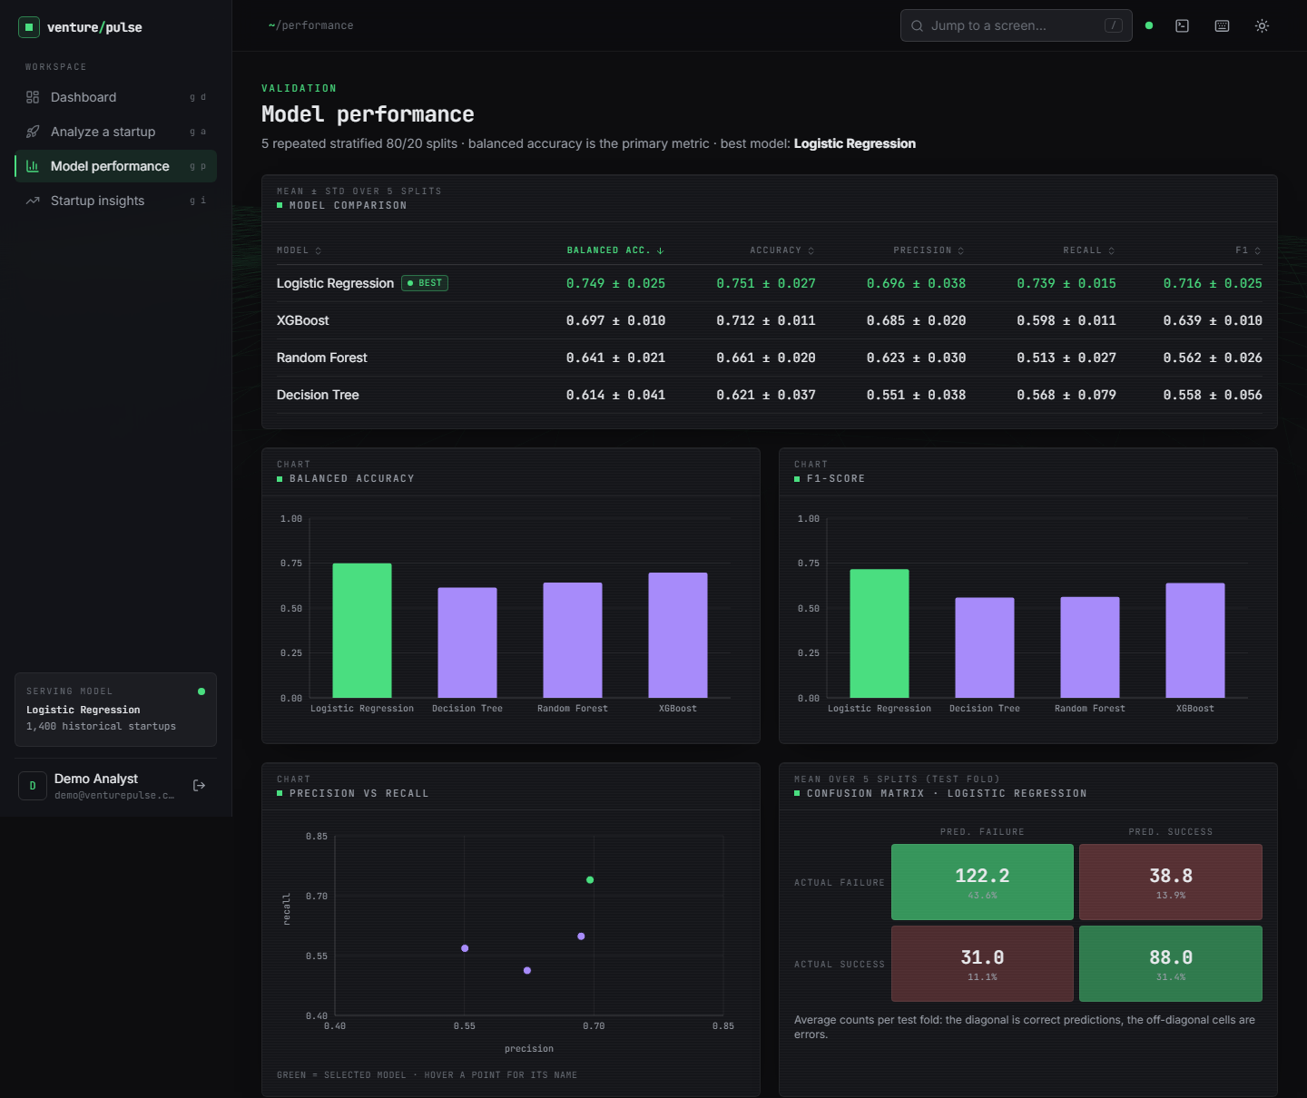
Figure 38: Model performance, upper part: comparison table of the four models with the best marked, balanced accuracy and F1 bars, the precision-recall scatter and the confusion matrix of Logistic Regression.
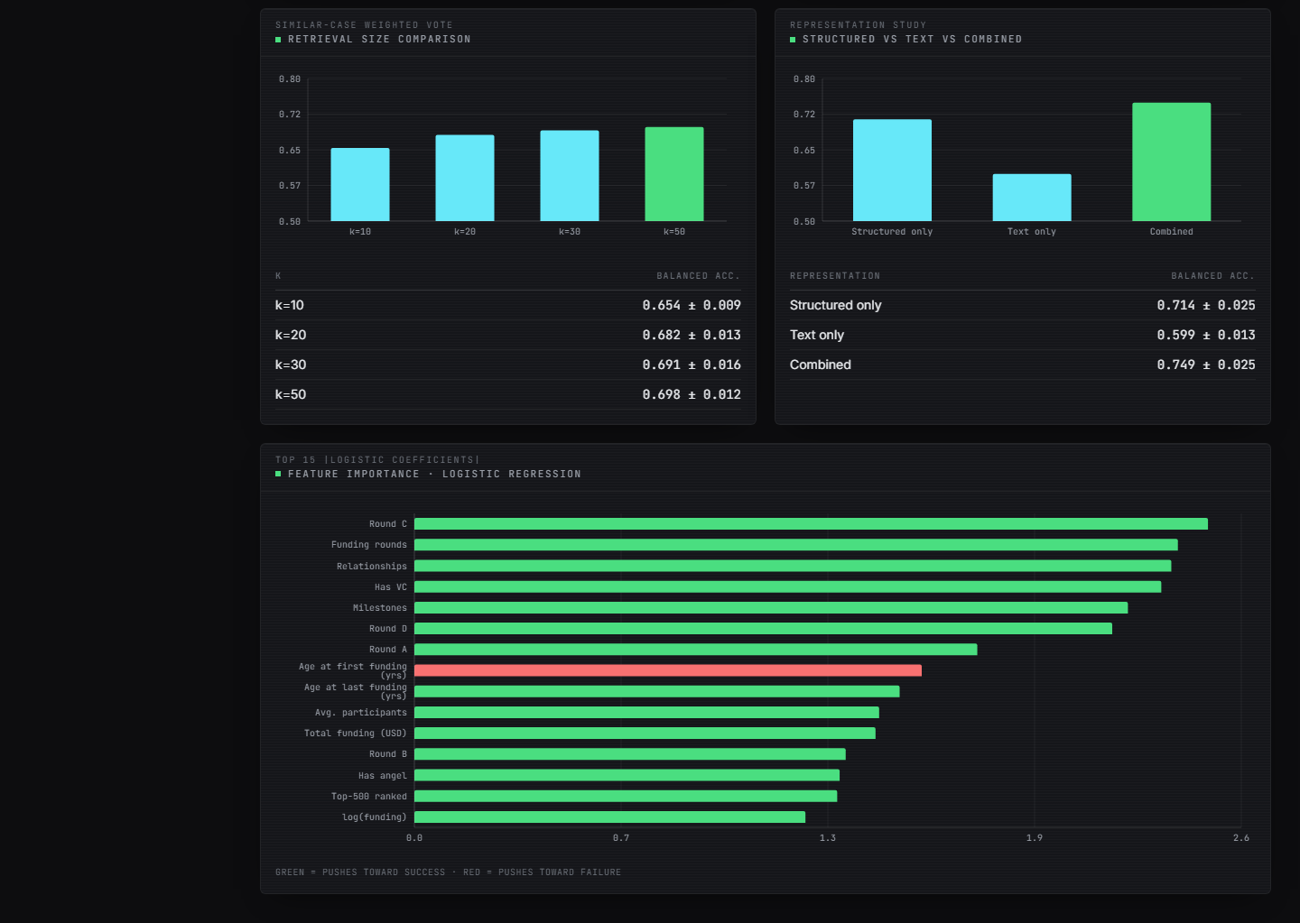
Figure 39: Model performance, lower part: retrieval-size comparison, structured-versus-text-versus-combined representation study and the top-15 coefficients (green pushes towards SUCCESS, red towards FAILURE).

